Caribbean Ecosystem Status Report
Gulf of Mexico Integrated Ecosystem Assessment Program
2025-01-07
Table of contents

Executive Summary
Lorem ipsum dolor sit amet, consectetur adipiscing elit. Integer commodo gravida justo consectetur condimentum. Proin eget felis non nunc tristique malesuada vel ut tortor. Vivamus lacinia aliquet lorem in congue. In hac habitasse platea dictumst. Etiam non felis iaculis, efficitur libero in, porta nunc. Sed sit amet nisi non justo scelerisque feugiat. Pellentesque porta consectetur sapien, porttitor iaculis ligula fermentum ac. Pellentesque fermentum elementum lacus non tempus. Aenean eu leo lobortis, vulputate mi at, varius sapien. In congue consectetur ultricies. Maecenas volutpat facilisis arcu, eget sodales tellus consequat nec. Integer ullamcorper ex nec leo aliquam tempus. Orci varius natoque penatibus et magnis dis parturient montes, nascetur ridiculus mus. Nunc dui massa, facilisis at aliquet eu, malesuada vel neque. Donec fermentum elit eu tortor euismod, sed mollis lacus blandit.

1. Introduction

1.1 About this report
The purpose of this report is to synthesize diverse information sources to assist with implementation of ecosystem-based fisheries management in the U.S. Caribbean region. A suite of indicators that span physical, biological, social and economic elements of the ecosystem are reported with the goal of helping the Caribbean Fishery Management Council (CFMC) and other resource managers measure progress toward fishery management objectives. The report relied on both previously identified proposed indicators as well as expert vetting to select a suite of indicators that best address the fishery management plan (FMP) objectives for the U.S. Caribbean. Information in this report is organized into two sections: 1) tracking performance toward predefined fishery management objectives, and 2) potential risks to meeting fishery management objectives.

1.2 Indicator selection
The CFMC’s Science and Statistical Committee, as well as the region’s Ecosystem-Based Fishery Management Technical Advisory Panel (EBFM TAP), recently completed a series of conceptual models linking key components of the ecosystem and human activities related to fishing (Seara et al. 2024). This report used these conceptual models as a starting list of proposed indicators and matched the indicators to answer FMP objectives when possible. For those objectives that did not have an immediate conceptual model-identified indicator, this report used a decision matrix process for expert vetting (Figure 1.1).
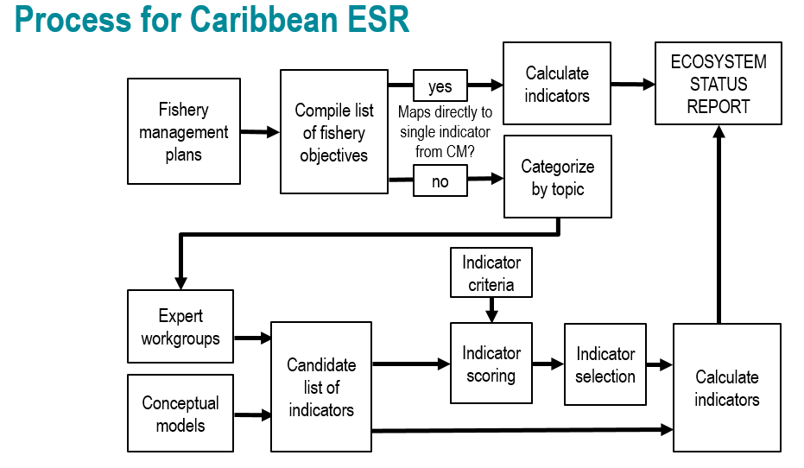
Figure 1.1: Process for selecting indicators for the U.S. Caribbean Ecosystem Status Report.
This decision matrix was composed of a list of proposed indicators compiled from the conceptual models as well as proposed indicators provided via expert input. These potential indicators were vetted and edited by expert small working groups, who then scored a decision matrix (Figure 1.1) of potential indicators against the following decision criteria: long term data availability, measurability, sensitivity to environmental changes, specificity, spatial and temporal scalability, relevance to specific FMP objectives, and responsiveness to management actions.

1.3 Notes on interpreting time series figures
Time series data are plotted in a standardized format for ease of interpretation (e.g., Figure 1.2). The x-axis represents the temporal dimension, which may be monthly, yearly, or irregular time steps, and the y-axis represents the indicator value in units specified in the axis label. Measures of uncertainty in the indicator values are also shown, when available. The dashed horizontal line represents the mean indicator value across the entire time series, and the solid horizontal lines denote the mean plus or minus one standard deviation. Red shaded areas and green shaded areas show years for which the indicator value is below or above one standard deviation from the mean, respectively. The blue vertical shaded box highlights the last five years of indicator values, over which additional metrics are calculated. Black circles to the right of each figure indicate whether the indicator values over the last five years are greater (plus sign), less than (minus sign), or within (solid circle) one standard deviation from the mean of the overall time series. Arrows to the right of each figure indicate whether the least squares linear fit through the last five years of data produces a positive or negative slope that is greater than one standard deviation (upward or downward arrows respectively), or less than one standard deviation (left-right arrow).
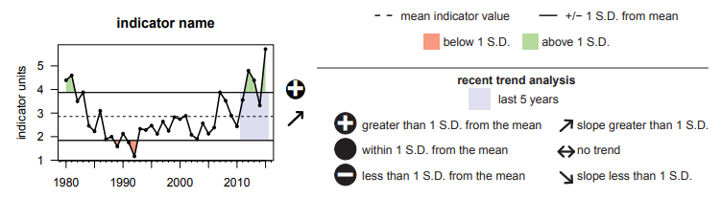
Figure 1.2: Example time series plot, showing an indicator plotted with its mean and standard deviation, and trend analysis for the most recent five years of data. See text for more detailed description of specific calculations.

2. Risks to meeting fishery management objectives
In this section, we report indicators that capture identified risks to the ecosystem that could impact the ability to meet Fishery Management Plan objectives. Unless otherwise specified, physical indicators reported for the U.S. Caribbean region were calculated over a bounding box with limits of longitude 68 degrees W to 64.5 degrees W and latitude 17.5 degrees N to 18.75 degrees N.

2.1 Sea surface temperature
Ocean temperatures affect species distributions and other aspects of population dynamics, and have impacts on habitats such as coral reefs. Monthly mean, minimum, and maximum sea surface temperatures were calculated based on the 1/4 Degree Daily Optimum Interpolation Sea Surface Temperature (OISST) Analysis (Reynolds et al. 2007). Mean temperatures in the U.S. Caribbean region have been increasing at an average rate of 0.25 degrees Celsius per decade. In the last five years, minimum temperatures have been well above average, while there has been no long-term or recent trend in maximum temperatures experienced (Figure 2.1).
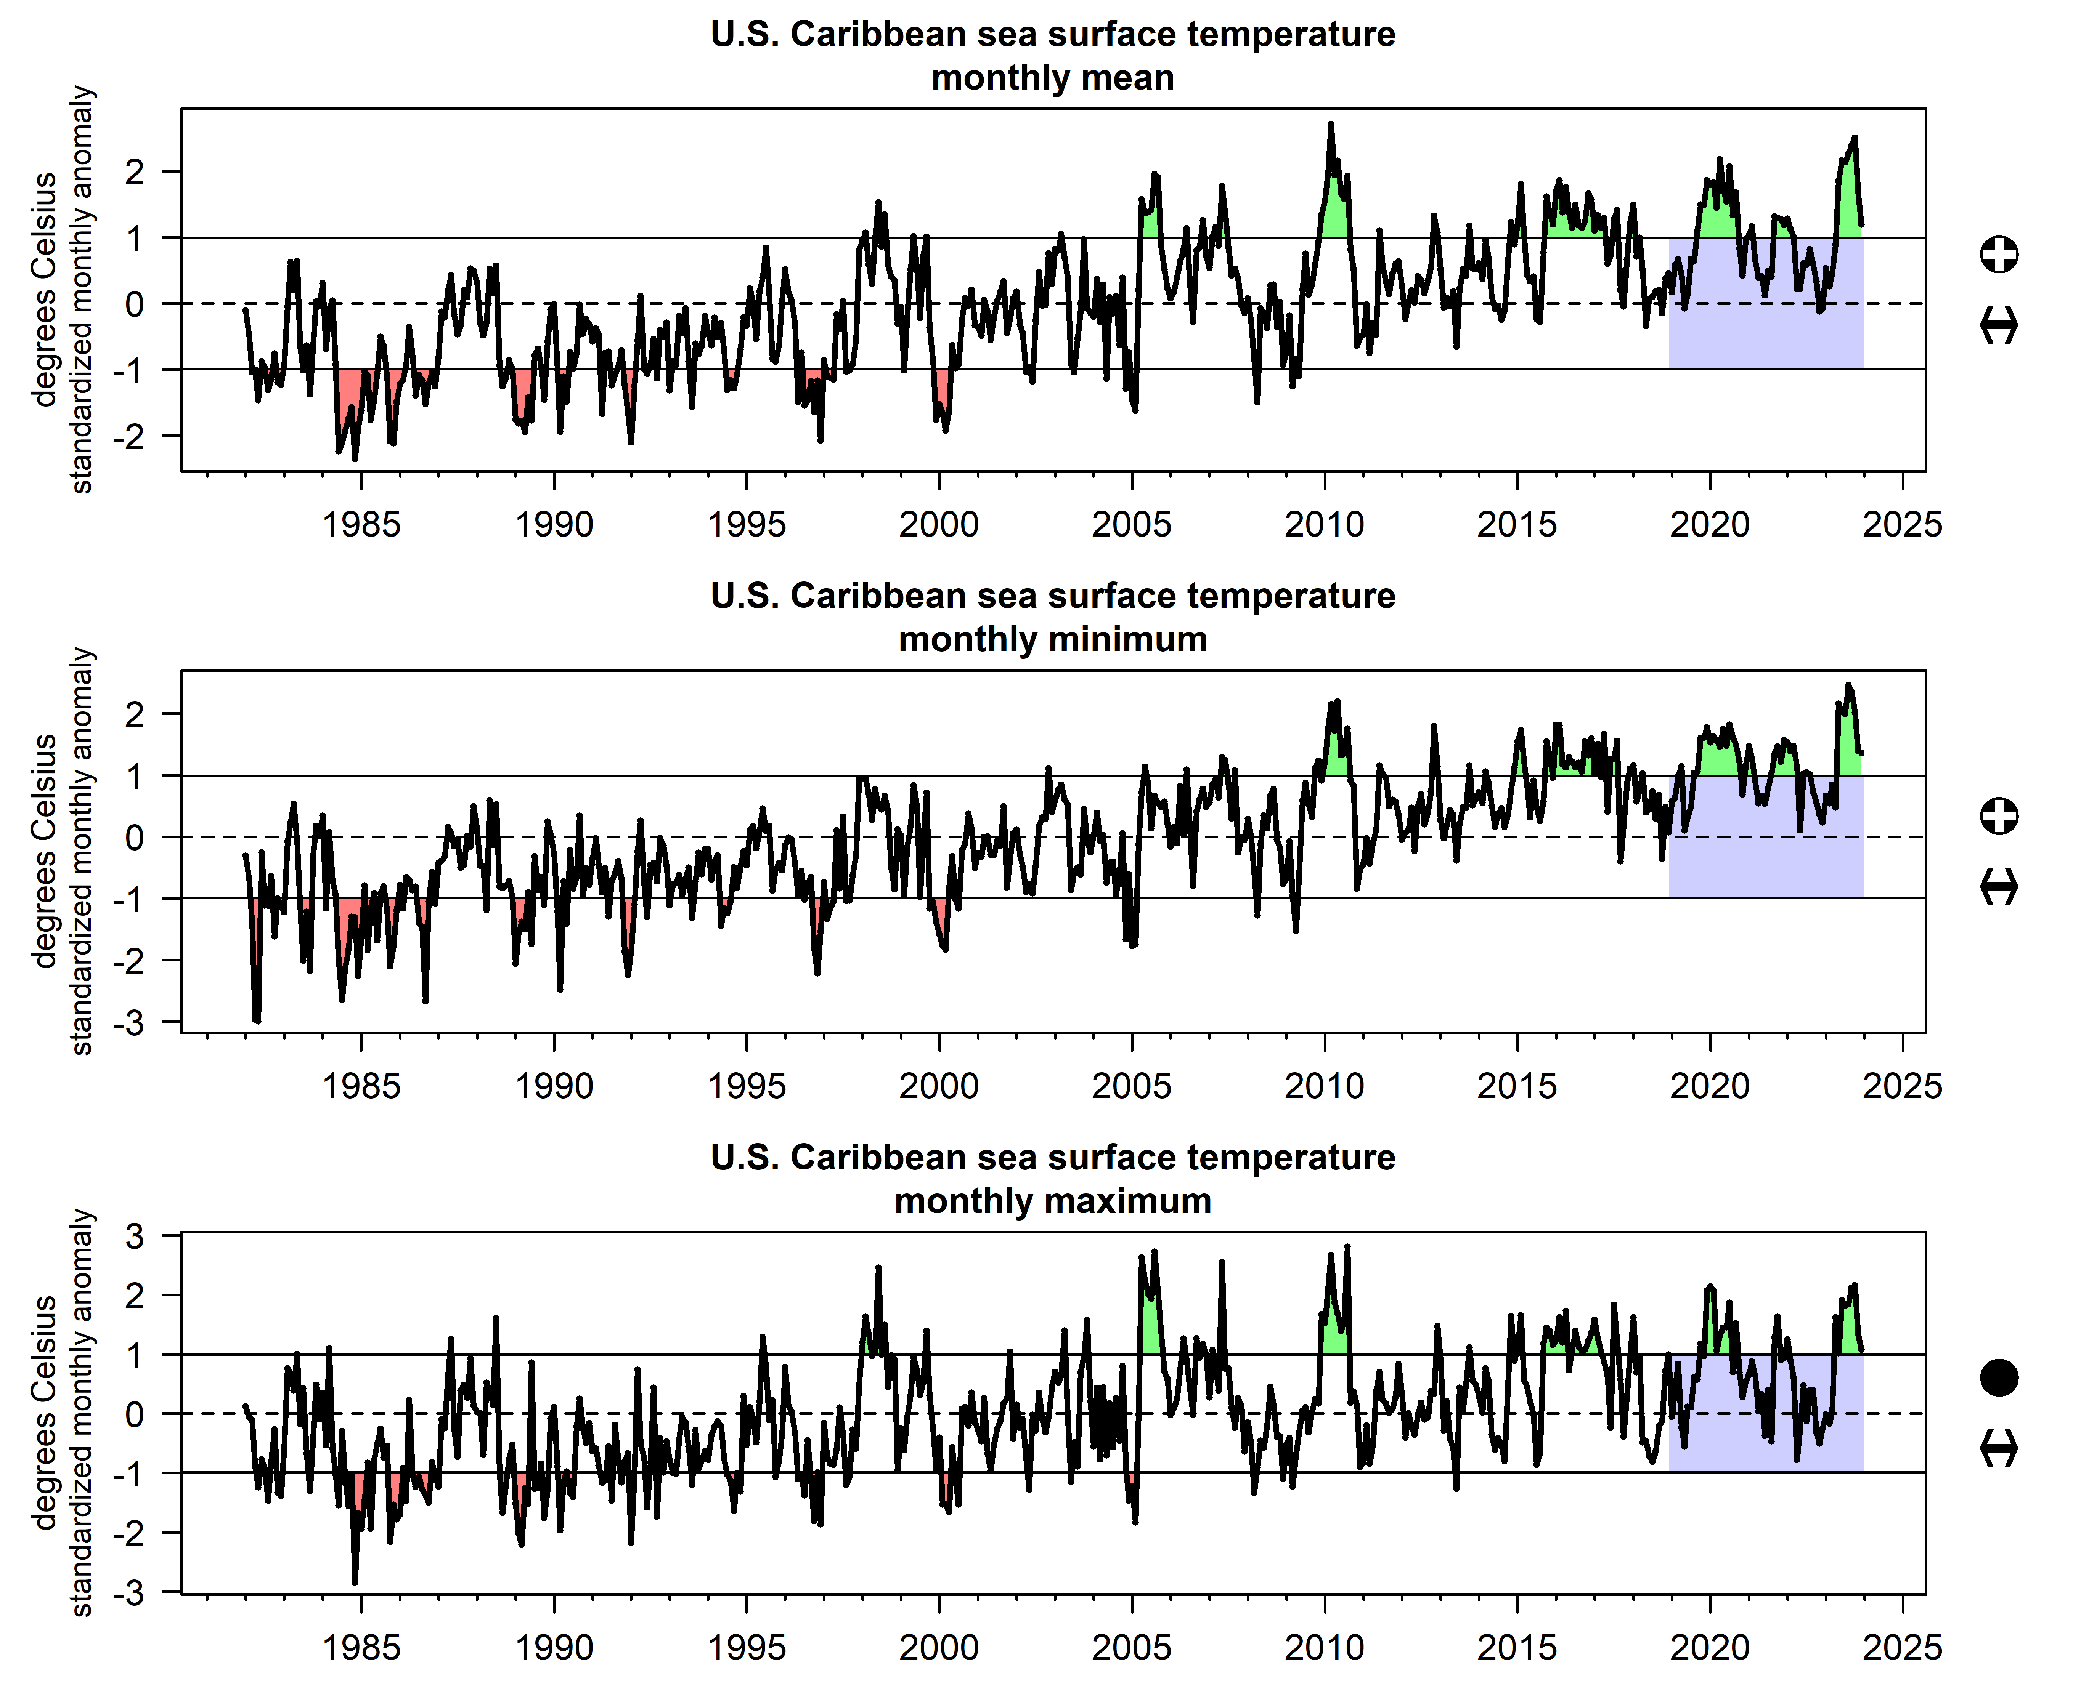
Figure 2.1: Monthly mean (top), minimum (middle), and maximum (bottom) sea surface temperature standardized anomalies, calculated over the U.S. Caribbean region.

2.2 Coral bleaching stress
Accumulated heat stress, which can lead to coral bleaching and death, is measured by summing degree heating weeks for the previous 12-week period from sea surface temperature data (NOAA Coral Reef Watch 2019). Bleaching stress was generally below average prior to the mid-2000s, when a sudden bleaching event occurred in 2005; this event is now the second most severe event in the time series. In 2024, a bleaching event of unprecedented severity occurred across the U.S. Caribbean and beyond (Figure 2.2).
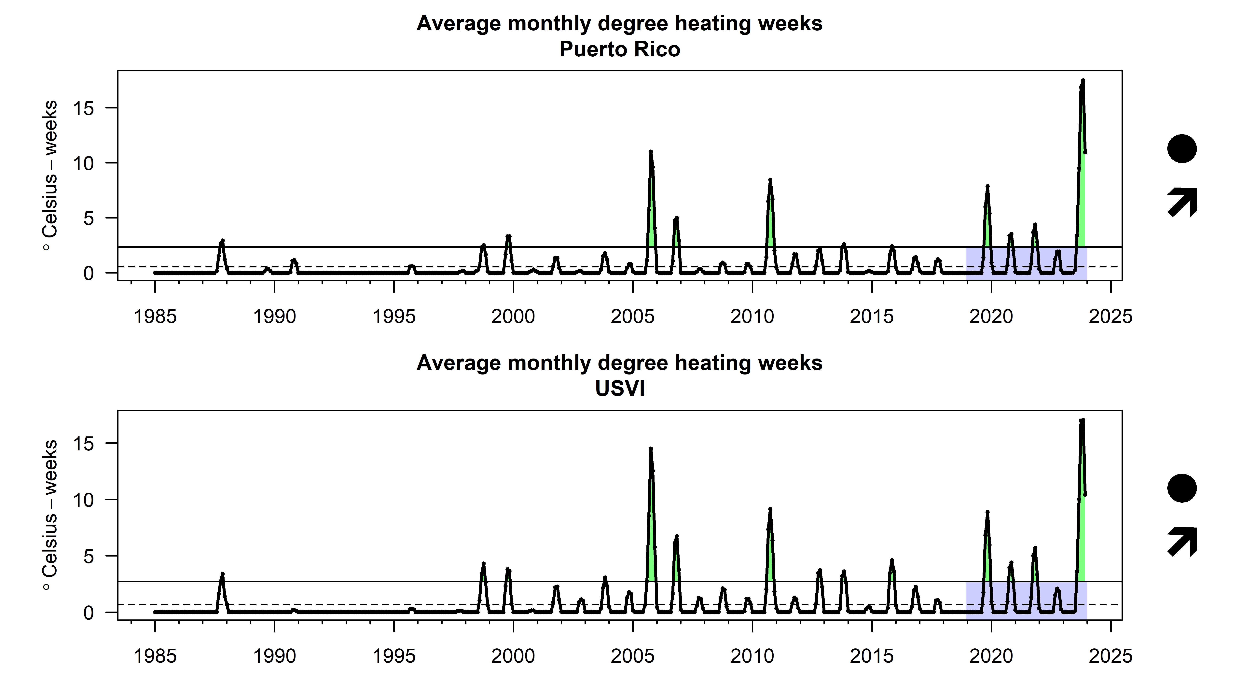
Figure 2.2: Average monthly degree heating week values as reported by NOAA Coral Reef Watch Virtual Stations for Puerto Rico (top) and USVI (bottom).

2.3 Ocean acidification
Ocean and coastal acidification can impact organisms directly or indirectly; a decrease in aragonite saturation state can weaken the structure of coral reefs and other calcifying organisms. In-situ measurements of aragonite saturation states are scarce, and a synoptic long-term view is only available from modeled products. Aragonite saturation state was derived for the U.S. Caribbean region from the MOM-TOPAZ hindcast (cite). An overall negative trend occurs, with an acceleration of this trend apparent after 2008 (Figure 2.3).
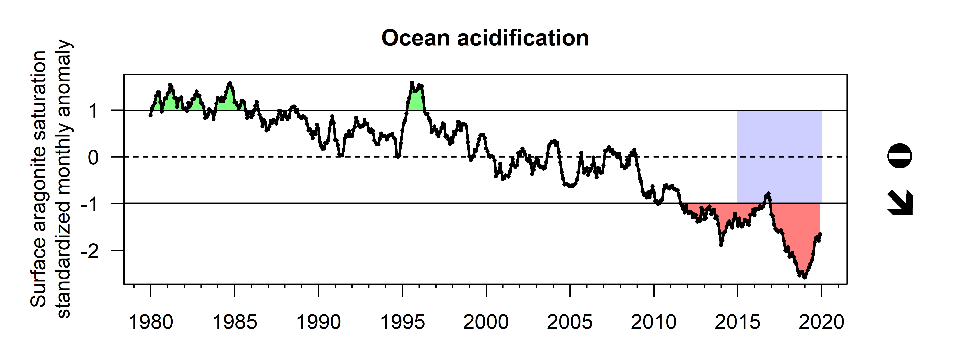
Figure 2.3: Ocean acidification as measured by modeled surface aragonite saturation state, showh as standardized monthly anomalies for the U.S. Caribbean region.

2.4 Hurricane activity
Hurricane activity can be captured by the accumulated cyclone energy (ACE) index, a measure of overall tropical cyclone activity measured as the sum of squared wind speeds. The ACE index was calculated for storms tracks within the U.S. Caribbean region as documented by the International Best Track Archive for Climate Stewardship database (Knapp et al. 2010). The index has fluctuated throughout the past seven decades, with multiple notable peaks (Figure 2.4). During the year 2017, hurricane activity was at an unprecedented high, due to two major hurricanes that struck the islands: Irma and Maria.
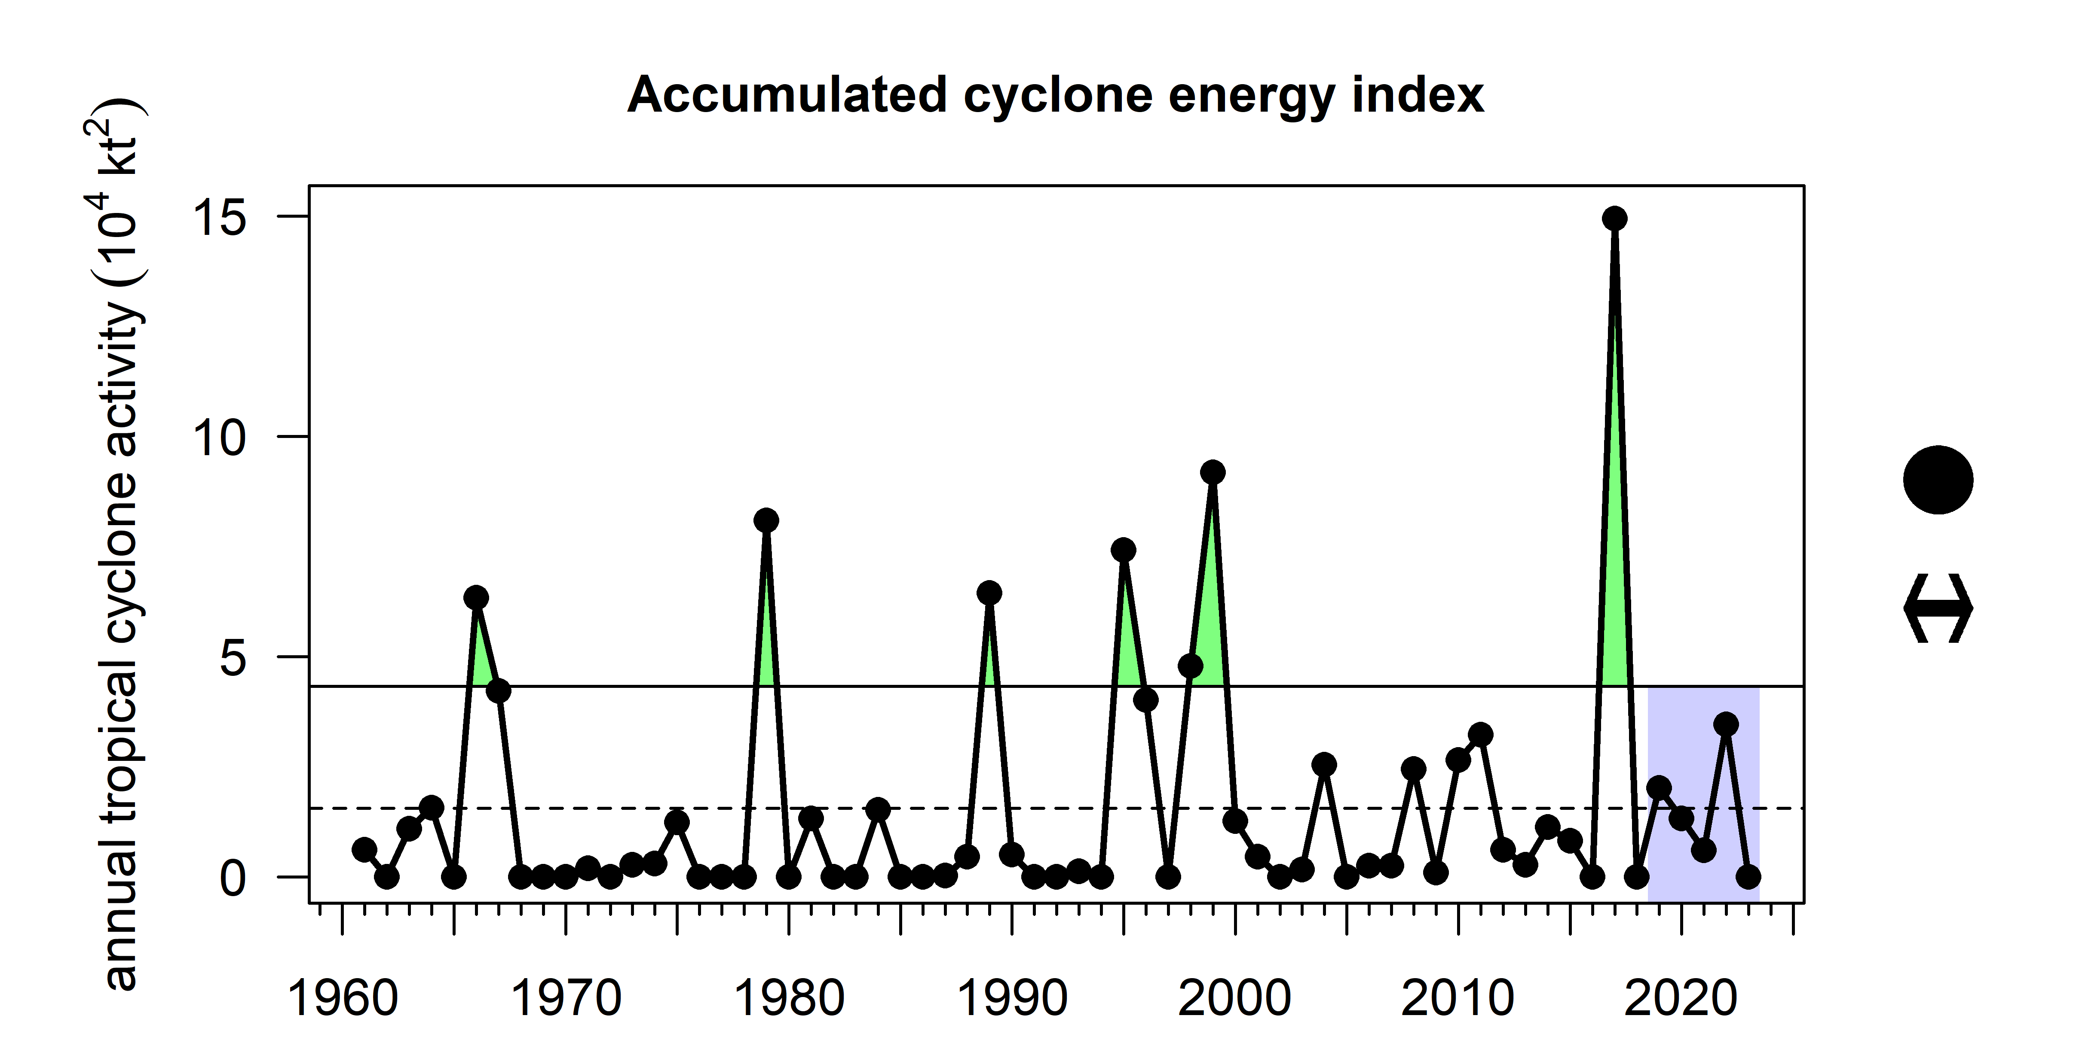
Figure 2.4: Annual accumulated cyclone energy index, calculated as the sum of squared 6-hourly reported wind speeds for storms tracking through the U.S. Caribbean region.

2.5 Earthquake activity
Earthquakes in Puerto Rico can induce landslides and cause impacts to infrastructure including homes and the electrical grid, and can be a source of stress in the affected human population (Agar et al. 2022). Individual seismic events are reported by the USGS in near real-time (Sumy, Welti, and Hubenthal 2020). A major earthquake swarm occurred in Southwest Puerto Rico in early 2020; in this year there were over 400 events of greater than 3.5 magnitude on the Richter scale (Figure 2.5).
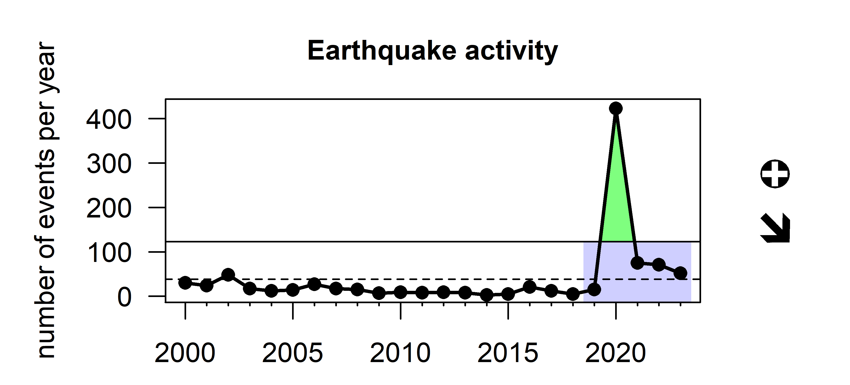
Figure 2.5: Number of seismic events of >3.5 magnitude occurring annually in the U.S. Caribbean.

2.6 Point source pollution
Impacts from terrestrial pollution can be captured from several databases maintained by the Environmental Protection Agency. These databases provide information on companies that have been issued permits to discharge wastewater into rivers, on the release of toxic chemicals and waste management activities at facilities, and on the declaration of Superfund sites. The number of pollution sites reported increased in the 2000s, but has decreased slightly in both Puerto Rico and USVI in recent years (Figure 2.6). Note that this indicator does not represent the timing of when pollution was impacting the ecosystem, but rather the timing of investigation and registration in EPA’s monitoring program or attention to the environmental impacts of pollution.
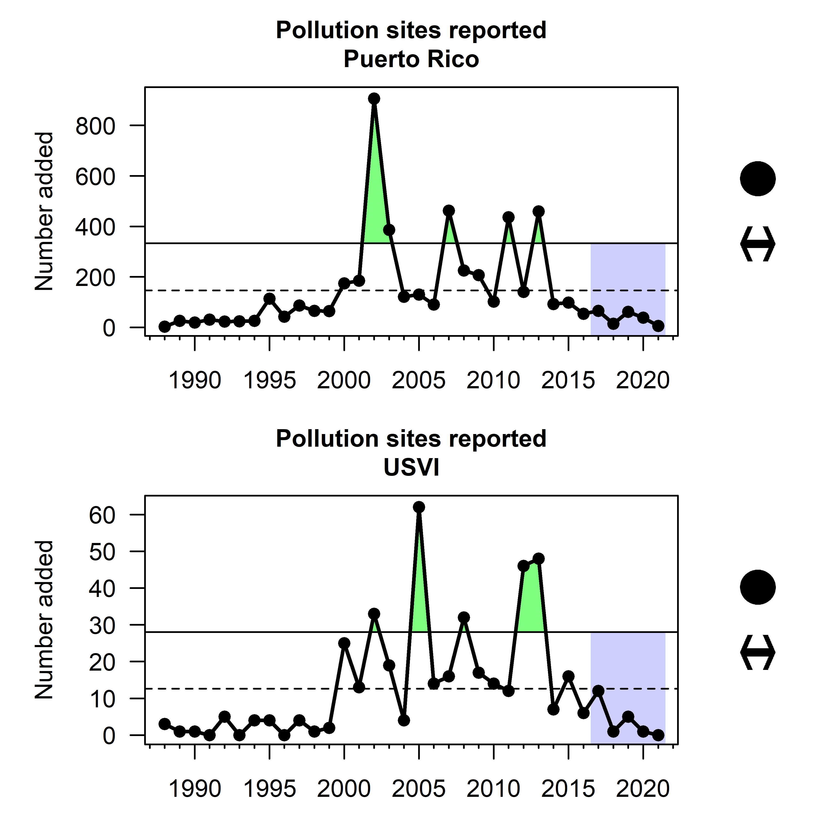
Figure 2.6: Annual count of identified point source polluters in the U.S. Caribbean based on TRI sites (Toxic Release Inventory), Superfund sites (Superfund Enterprise Management System), National Compliance Database listed sites, and Brownfield sites identified in Puerto Rico (top) and the USVI (bottom).

2.7 Turbidity
Coastal pollution, runoff, and water quality issues are of major concern to fishing-dependent communities in the U.S. Caribbean (Seara et al. 2024). Water clarity can be measured by the diffuse attenuation coefficient, which indicates how strongly light intensity is attenuated within the water column; however, satellite sensors cannot differentiate between organic and inorganic water particles contributing to water clarity. NOAA’s Coastwatch program provides estimates of the attenuation coefficient for penetration of light at 490nm (Wang, Son, and Harding Jr. 2009) based on multiple satellite sensors. No overall trend is apparent in any of the U.S. Caribbean islands, although there is increasing variability in turbidity values over time. Elevated anomalies in Puerto Rico in the year 2017 are likely due to hurricane activity.
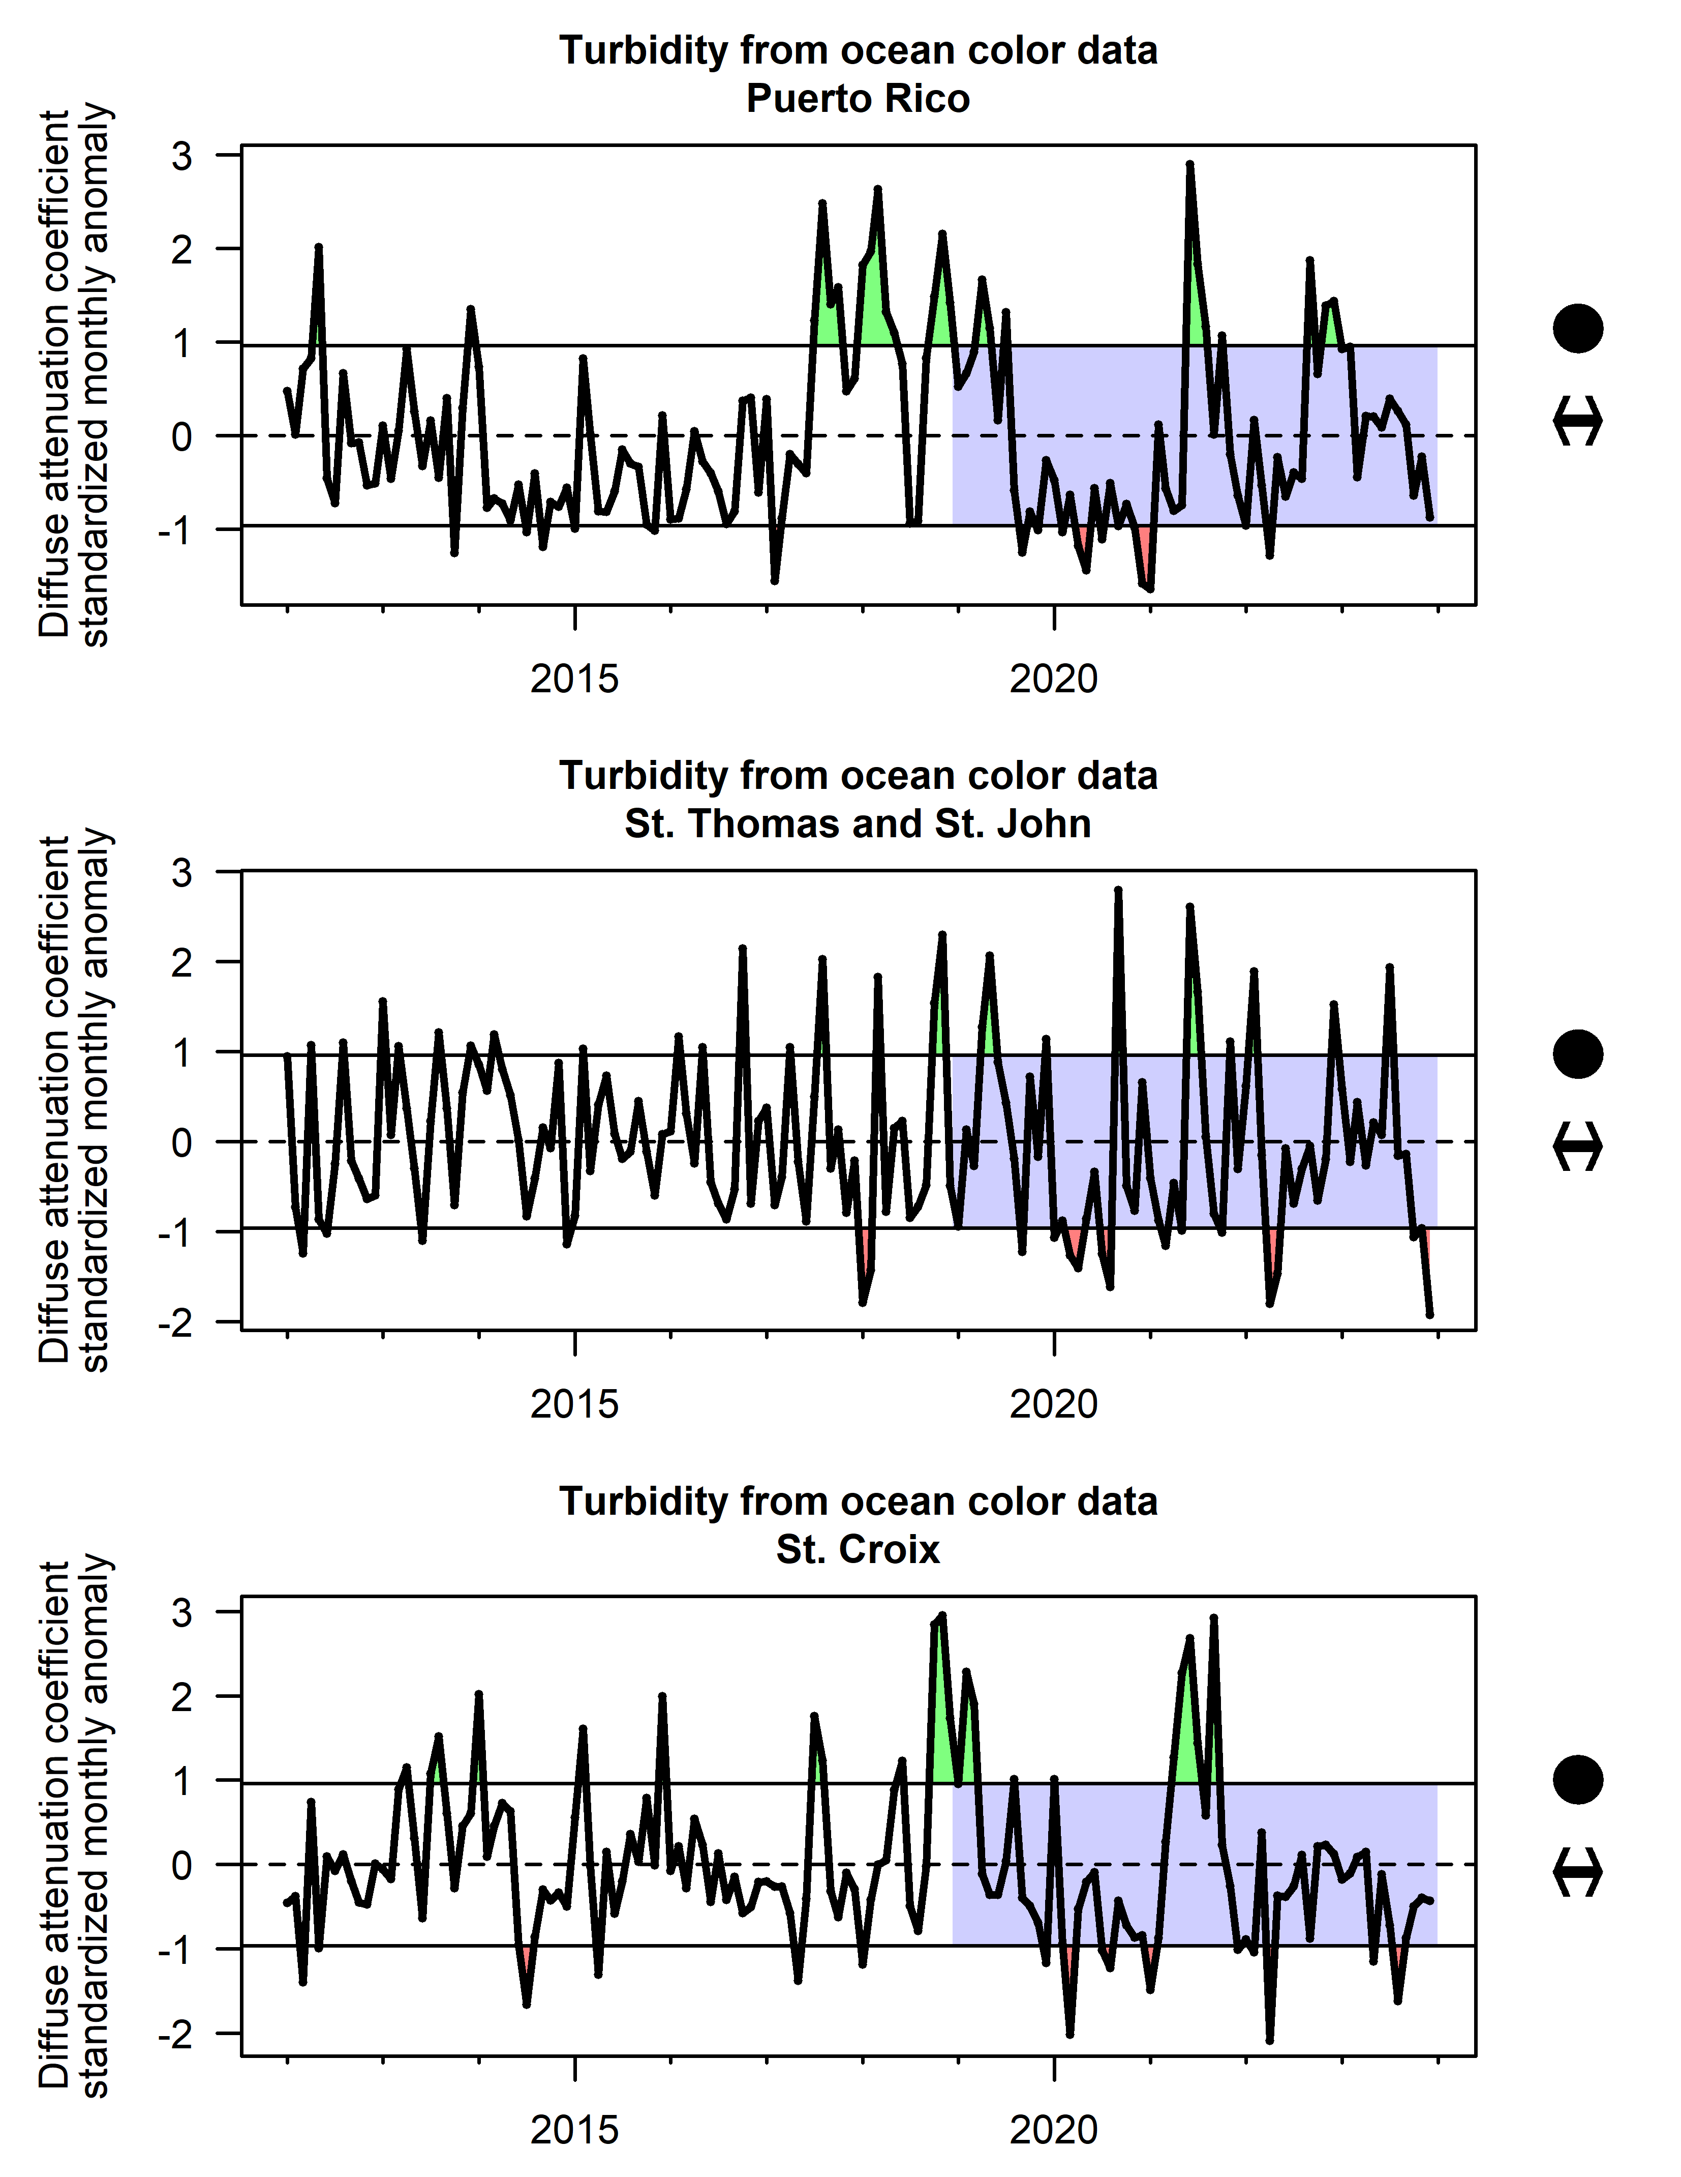
Figure 2.7: Standardized monthly anomalies of water turbidity as measured by the diffuse attenuation coefficient, for waters surrounding Puerto Rico (top), St. Thomas and St. John (middle) and St. Croix (bottom).

2.8 Water quality
The presence of enterococci bacteria in water samples is used as a primary indicator of fecal contamination, which poses both environmental and human health risks (United States Environmental Protection Agency 2024). Water quality, biological, and physical data collected by the United States Geological Survey (USGS), the Environmental Protection Agency (EPA), and over 400 state, federal, tribal, and local agencies are publicly available via the EPA Water Quality Portal (https://www.waterqualitydata.us/). Data on enterococci abundance in beach samples throughout Puerto Rico and the USVI were downloaded and daily counts were averaged annually. Throughout the Caribbean region, there has been a substantial increase in the enterococcus count over time, with particularly high measured levels since 2015 in Puerto Rico and since 2020 in USVI Figure 2.8.
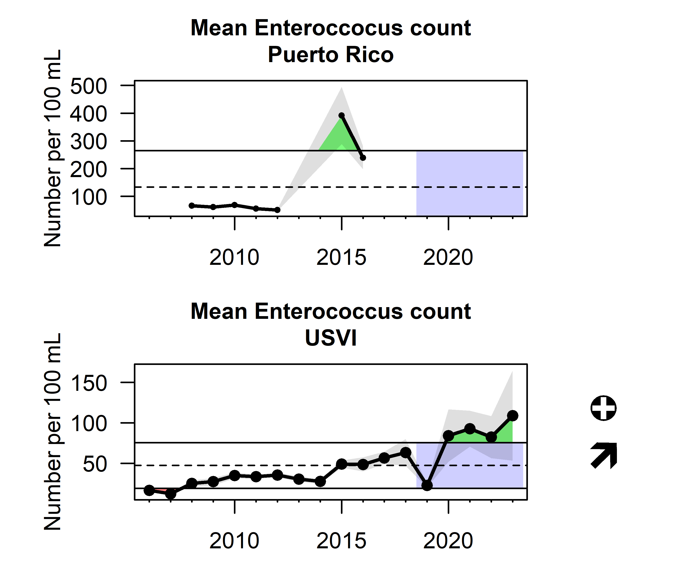
Figure 2.8: Water quality as measured by average enterococcus counts (+/- 1 S.E.) from beach water quality sampling at sites in Puerto Rico (top) and the USVI (bottom).

2.9 Coastal development
Impervious surfaces such as pavement, sidewalks, roofs and roads, as well as other forms of development, reduce the infiltration of water into the ground. Impervious surfaces often contribute to higher storm water runoff, greater sediment yields into coastal areas, and increased pollutant loads, all of which can degrade water quality (NOAA Digital Coast). This indicator influences water quality and turbidity in nearshore coastal habitat areas. The highest amount of impervious surfaces is seen in the San Juan metropolitan area (Figure 2.9).
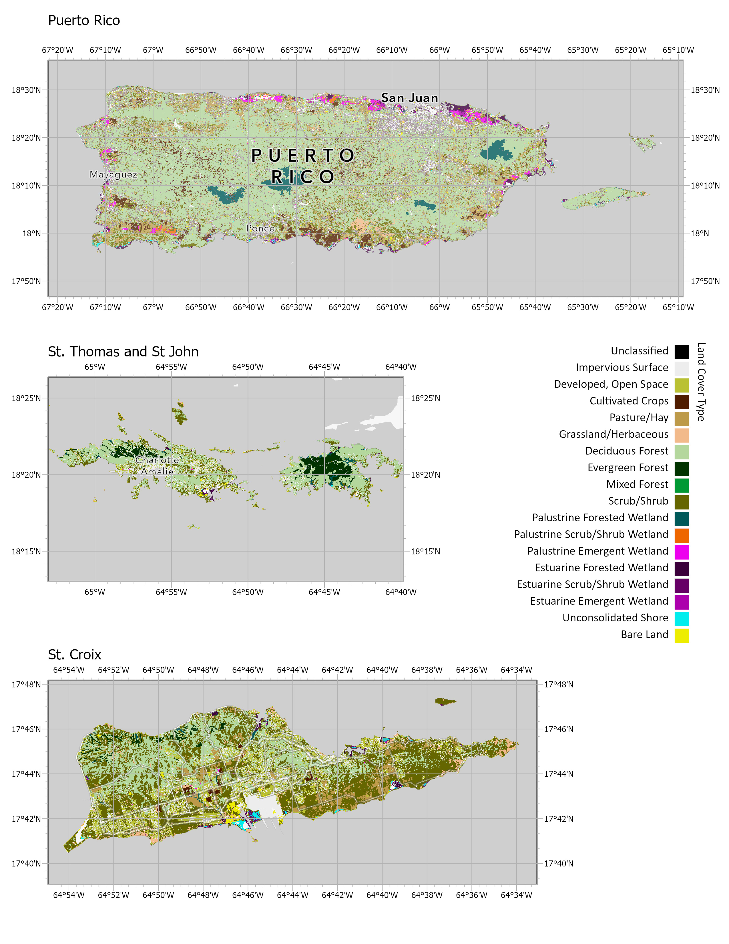
Figure 2.9: Impervious surfaces from development in the U.S. Caribbean.

2.10 Primary productivty
Primary productivity is a measure of the total energy available in an ecosystem, and is closely correlated with chlorophyll a concentrations. Average chlorophyll a concentrations are derived from the European Space Agency Climate Change Initiative’s Ocean Colour product, which provides a bias-corrected composite of measurements merged from multiple satellite sensors (Hu, Lee, and Franz 2012). Concentrations are plotted as standardized monthly anomalies as there is a seasonal signal that could mask long-term trends. Estimates show a decadal cyclical pattern, with no overall or recent trend apparent (Figure 2.10).
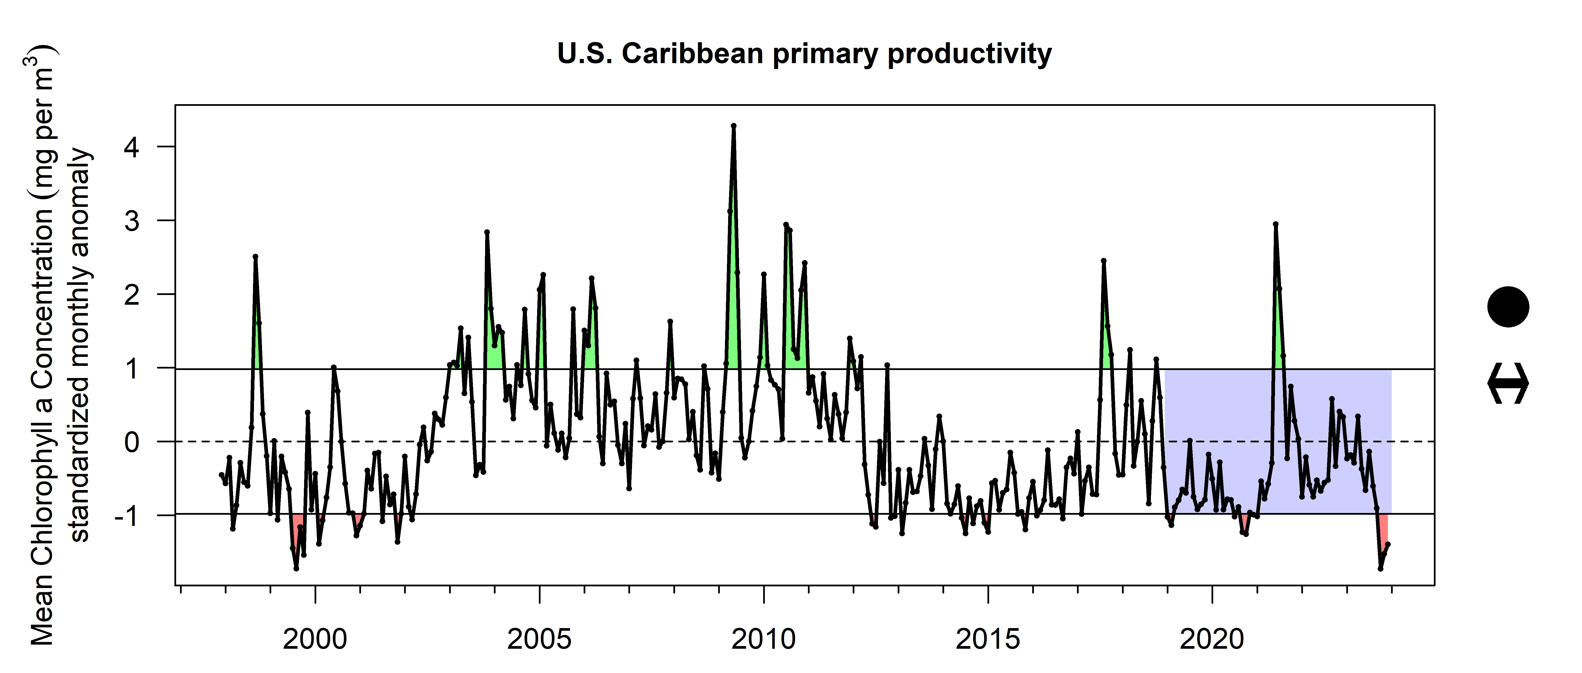
Figure 2.10: Changes in ocean color showing mean chlorophyll a levels (standardized monthly anomalies) in the U.S. Caribbean region.

2.11 Sargassum inundation
Sargassum (brown macroalgae S. Fluitains and S. natans) is a designated essential fish habitat important for many pelagic fish and protected species; however, when large blooms collect in nearshore environments they can reduce oxygen, suffocate beaches and have detrimental impacts on marine species. Mean monthly Sargassum wet biomass is estimated from satellite measurements using the algorithm of Wang et al. (2019). Sargassum blooms were largely absent from the U.S. Caribbean prior to 2011, but bloom activity has been generally increasing since that year (Figure 2.11). Major inundation events occurred in 2018 and 2021.
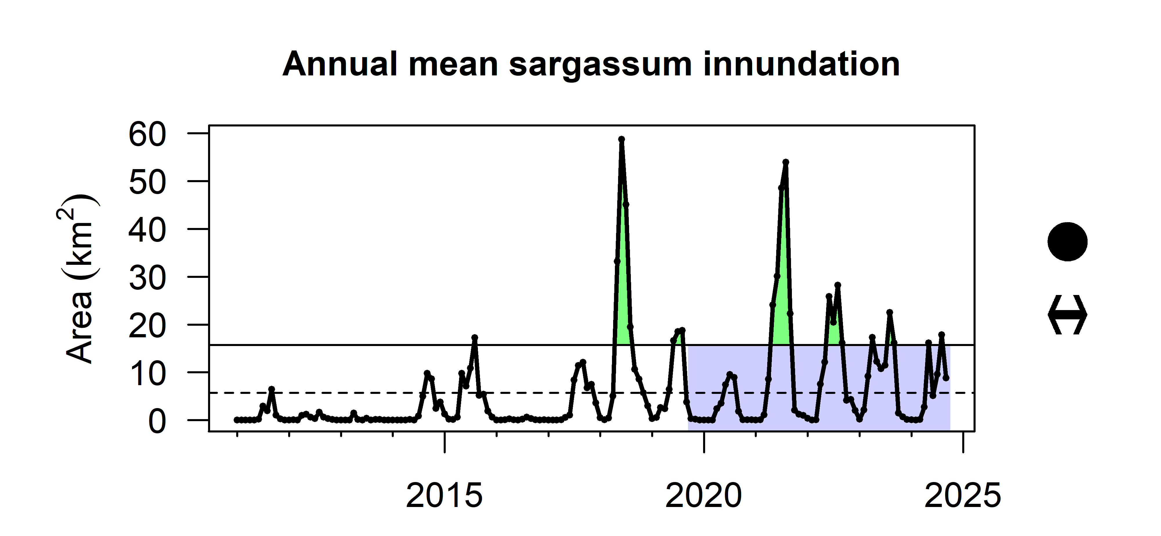
Figure 2.11: Annual mean sargassum inundation in square km of cover in the U.S. Caribbean.

2.12 Market disturbances
Alterations to typical fishing patterns can be quantified by analyzing the seasonality of how fishing activity is distributed throughout the year and detecting deviations from average patterns. A market disturbance indicator was developed by calculating the proportion of landings in each month of the year, and summing the square of deviations between those monthly proportions from the mean proportions across all years:
$D_{y}=\sum_{m=1}^{12}{{\left(P_{m,y}−{\overline{P}}_{m}\right)}^{2}}$
This calculation was carried out for the species with highest landings that have not been subject to seasonal closures; the mean and standard deviation are calculated for the disturbance indicator across those species. In Puerto Rico, there is little trend in the disturbance indicator; however there were higher disturbance indicator values in 2005 and 2020-2021. In St. Thomas, the indicator increases throughout time and detects a major disturbance in the 2017-18 fishing season. In St. Croix, disturbance levels were high in 2017-18 and also 2019-20 (Figure 2.12).
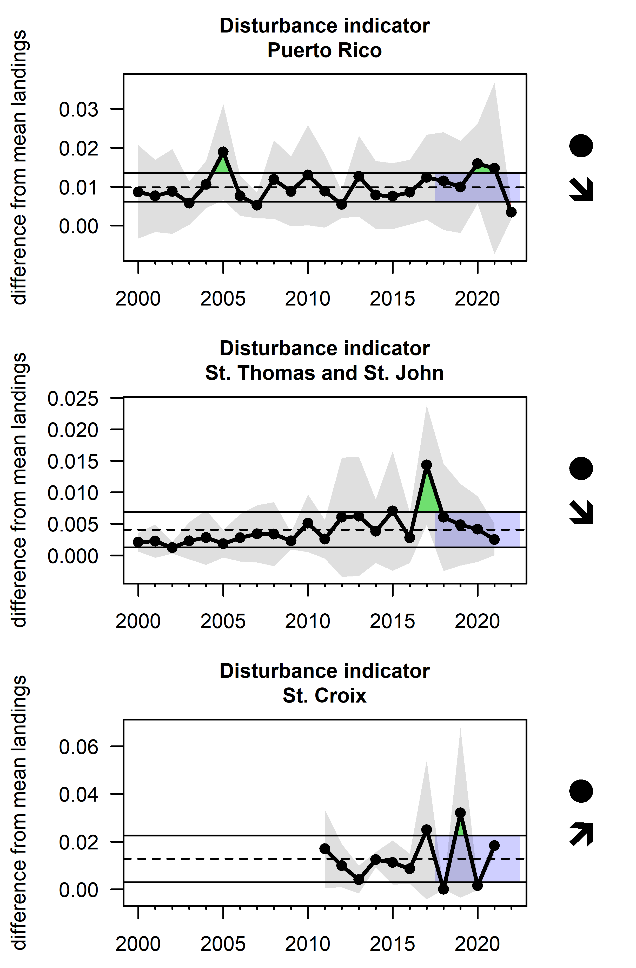
Figure 2.12: Disturbance level (+/- 1 S.D.), calculated as the departure from mean seasonal landings patterns for top species in Puerto Rico (top), St. Thomas and St. John (middle) and St. Croix (bottom). Note that the years in the USVI are fishing years (July 1st to June 30th of the following year).

2.13 Human activity
Human activity has an impact on the marine ecosystem indirectly through its influence on coastal development and pollution, as well as directly through marine tourism, fishing and demand for seafood. Human activity is exerted by the local population as well as the extensive tourism industry that exists in the U.S. Caribbean. Total population estimates are reported by the U.S. Census Bureau and tourism activity can be measured through hotel occupancy rates (data from the Puerto Rico Tourism Company and U.S.V.I. Bureau of Economic Research) and the number of air and cruise passengers (data from the Puerto Rico Ports Authority and U.S.V.I. Bureau of Economic Research). Human population in the U.S. Caribbean has been declining gradually since 2000 (Figure 2.13). Tourism has fluctuated over time, with major decreases in air and cruise passengers 2017 and 2020 but recovery to normal or above-normal levels since (Figure 2.14). A similar decline in hotel registrations in 2020 is apparent in the Puerto Rico data, following a general recovery. The total hotel guest count in USVI however declined in 2018 and has not recovered (Figure 2.15).
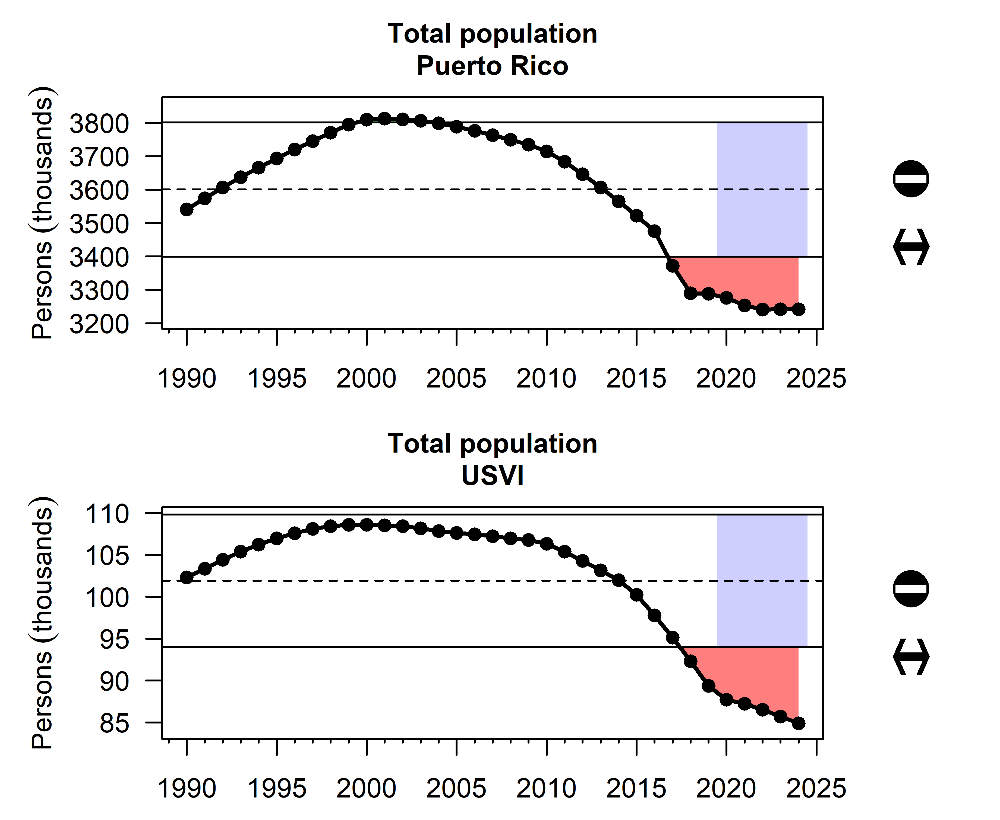
Figure 2.13: Population change in Puerto Rico (top) and USVI (bottom) according to census data.

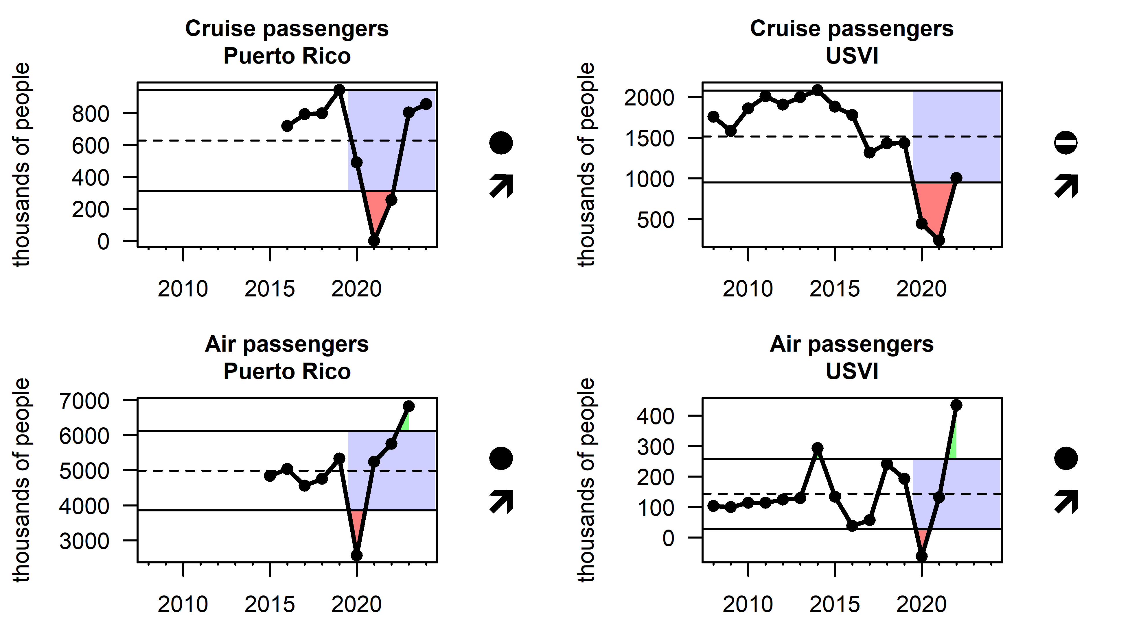
Figure 2.14: Annual tourism activity in Puerto Rico (left) and USVI (right) as indicated by the number of cruise and air passengers visiting the islands.

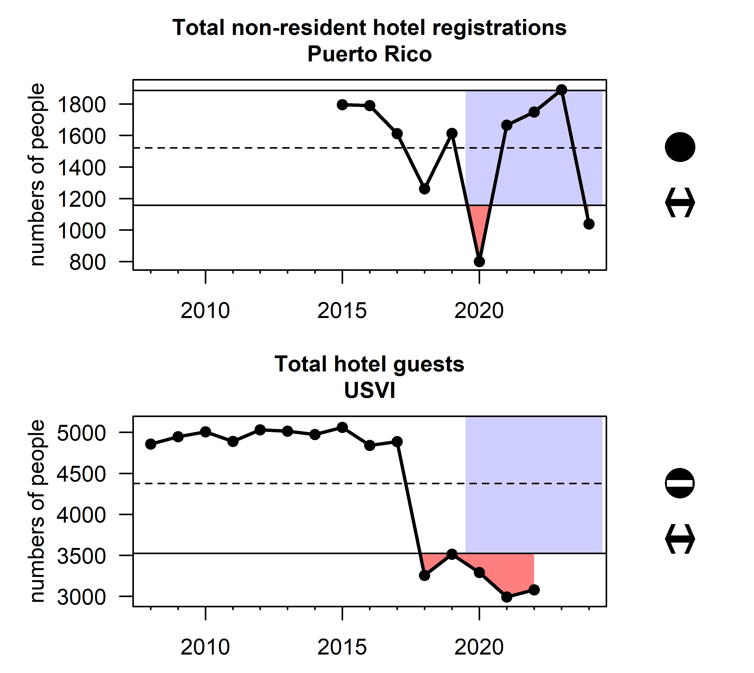
Figure 2.15: Annual tourism activity in Puerto Rico and USVI as indicated by the number of hotel registrations (guests). Note that Puerto Rico data only include non-resident hotel registrations while for USVI data were only available for all hotel registrations.

3. Tracking performance toward fishery management objectives
In this section, we report indicators that are intended to capture progress towards meeting Fishery Management Plan objectives related to food production, socioeconomic health, equity, engagement and participation, bycatch reduction, governance and protection of ecosystems.

3.1 Food production

3.1.1 Abundance of economically important species
Fishery-independent surveys are conducted to understand relative abundance trends in economically important fish species. The Southeast Fisheries Science Center, in collaboration with many academic and private partners, has been conducting a visual survey of reef fish species in the Florida Keys since 1978, and the survey was expanded to the U.S. Caribbean in 2001 (Smith et al. 2011). Six target fish species (mutton snapper, yellowtail snapper, red hind, queen triggerfish, redband parrotfish, and stoplight parrotfish) were selected as key indicators for the condition of living resources in the U.S. Caribbean, due to their status as targeted species by recreational and commercial fishers. Trends in fish density for these species of interest are highly variable, but density has been at or above the time series average in recent years for most species. A notable exception is stoplight parrotfish, which have gradually declined over time in all regions and density is currently below average in St. Croix (Figure 3.1, Figure 3.2, Figure 3.3).
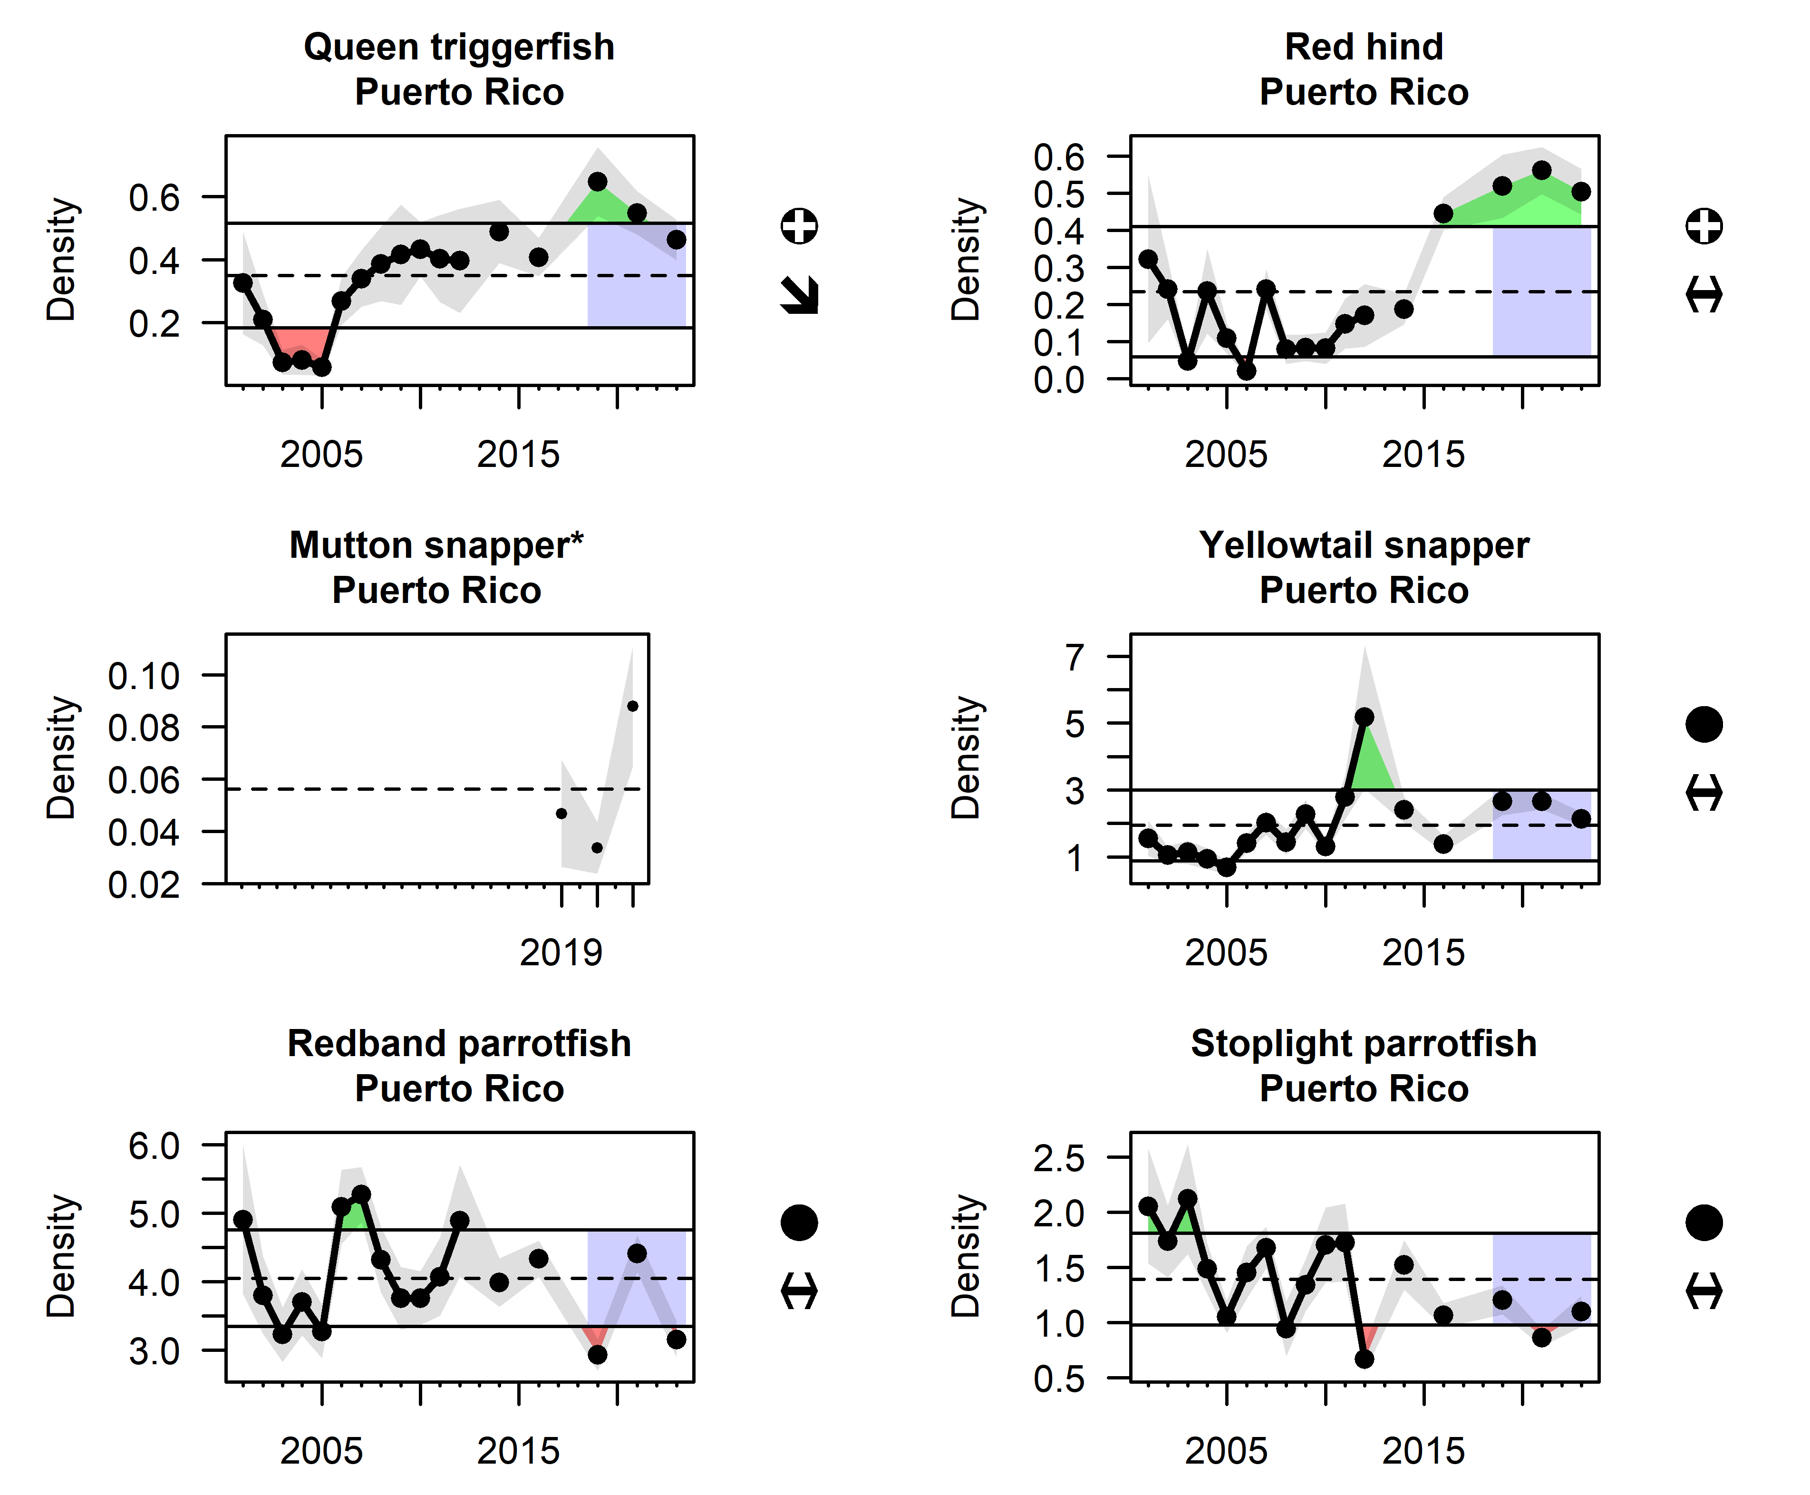
Figure 3.1: Average density of queen triggerfish, red hind, mutton snapper, yellowtail snapper, redband parrotfish, and stoplight parrotfish in Puerto Rico from the National Coral Reef Monitoring Program Reef Visual Census data. A change in sampling methodology occured in 2019, and at the time of publication the mutton snapper time series had not been calibrated, so data are only available from 2019 onward.

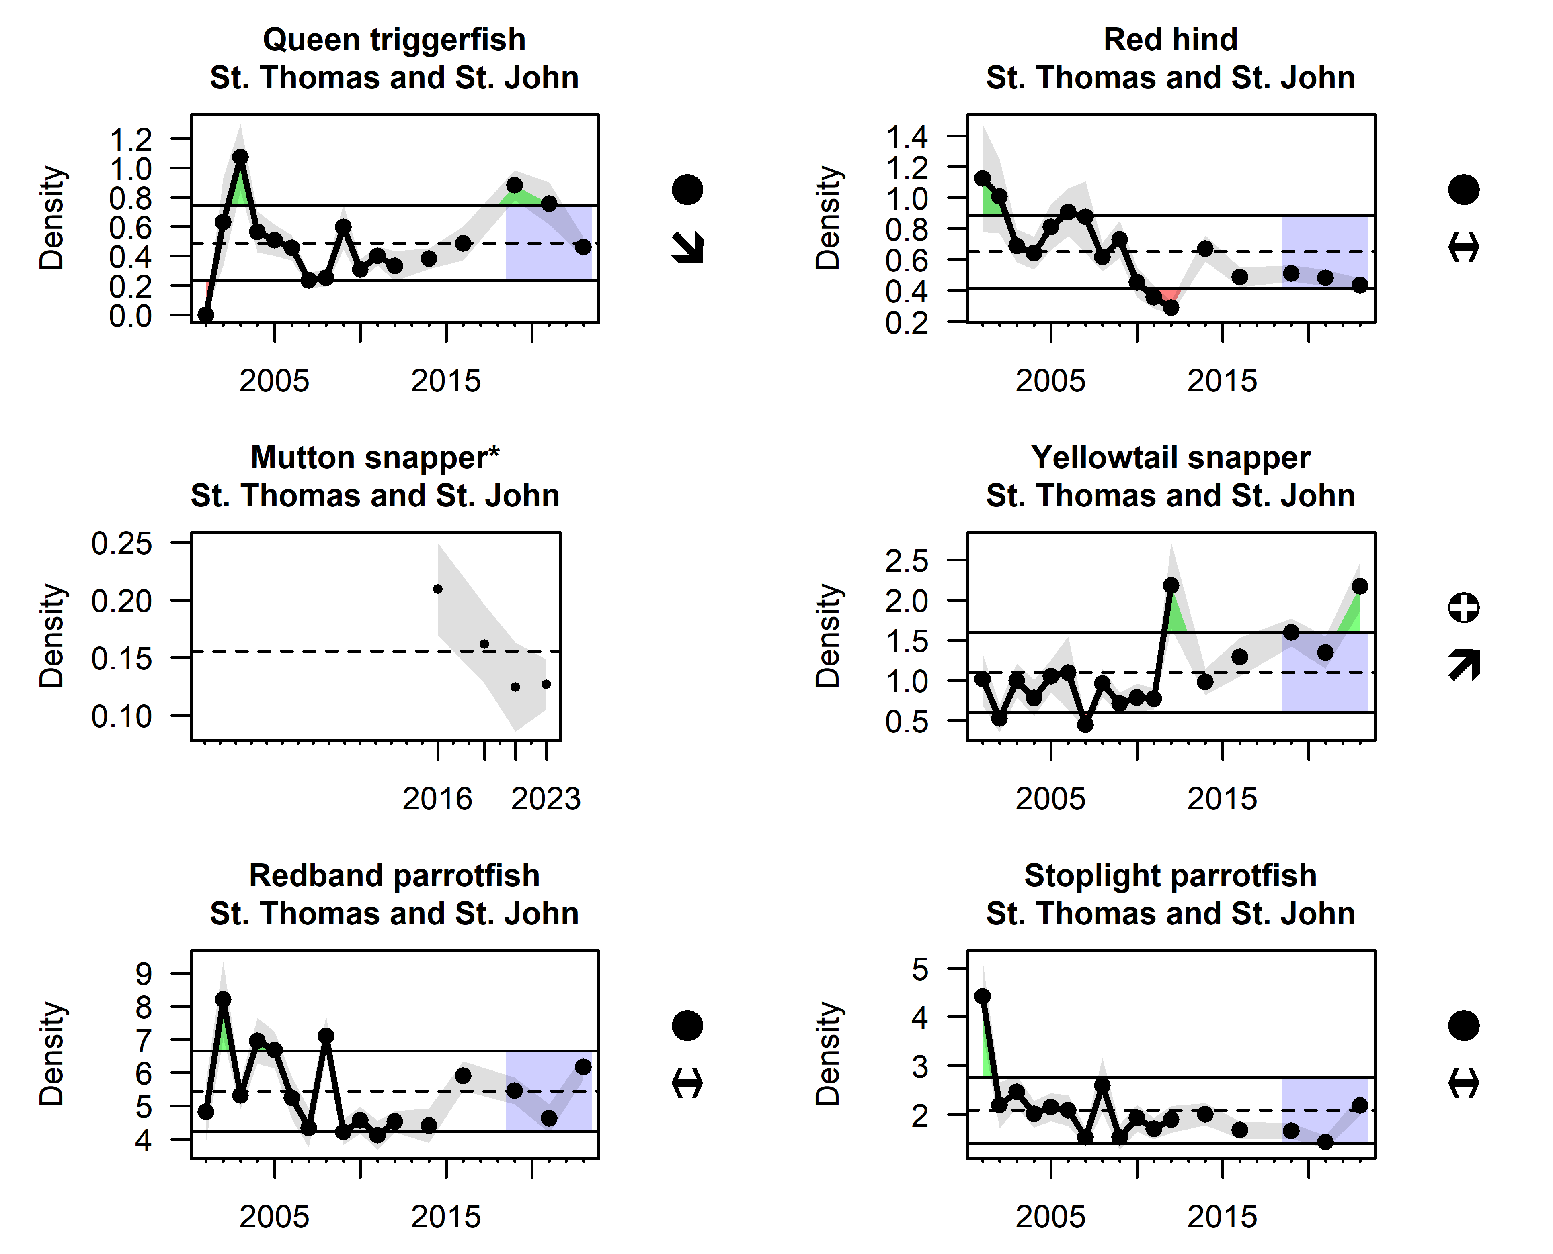
Figure 3.2: Average density of queen triggerfish, red hind, mutton snapper, yellowtail snapper, redband parrotfish, and stoplight parrotfish in St. Thomas and St. John from the National Coral Reef Monitoring Program Reef Visual Census data. A change in sampling methodology occured in 2019, and at the time of publication the mutton snapper time series had not been calibrated, so data are only available from 2019 onward.

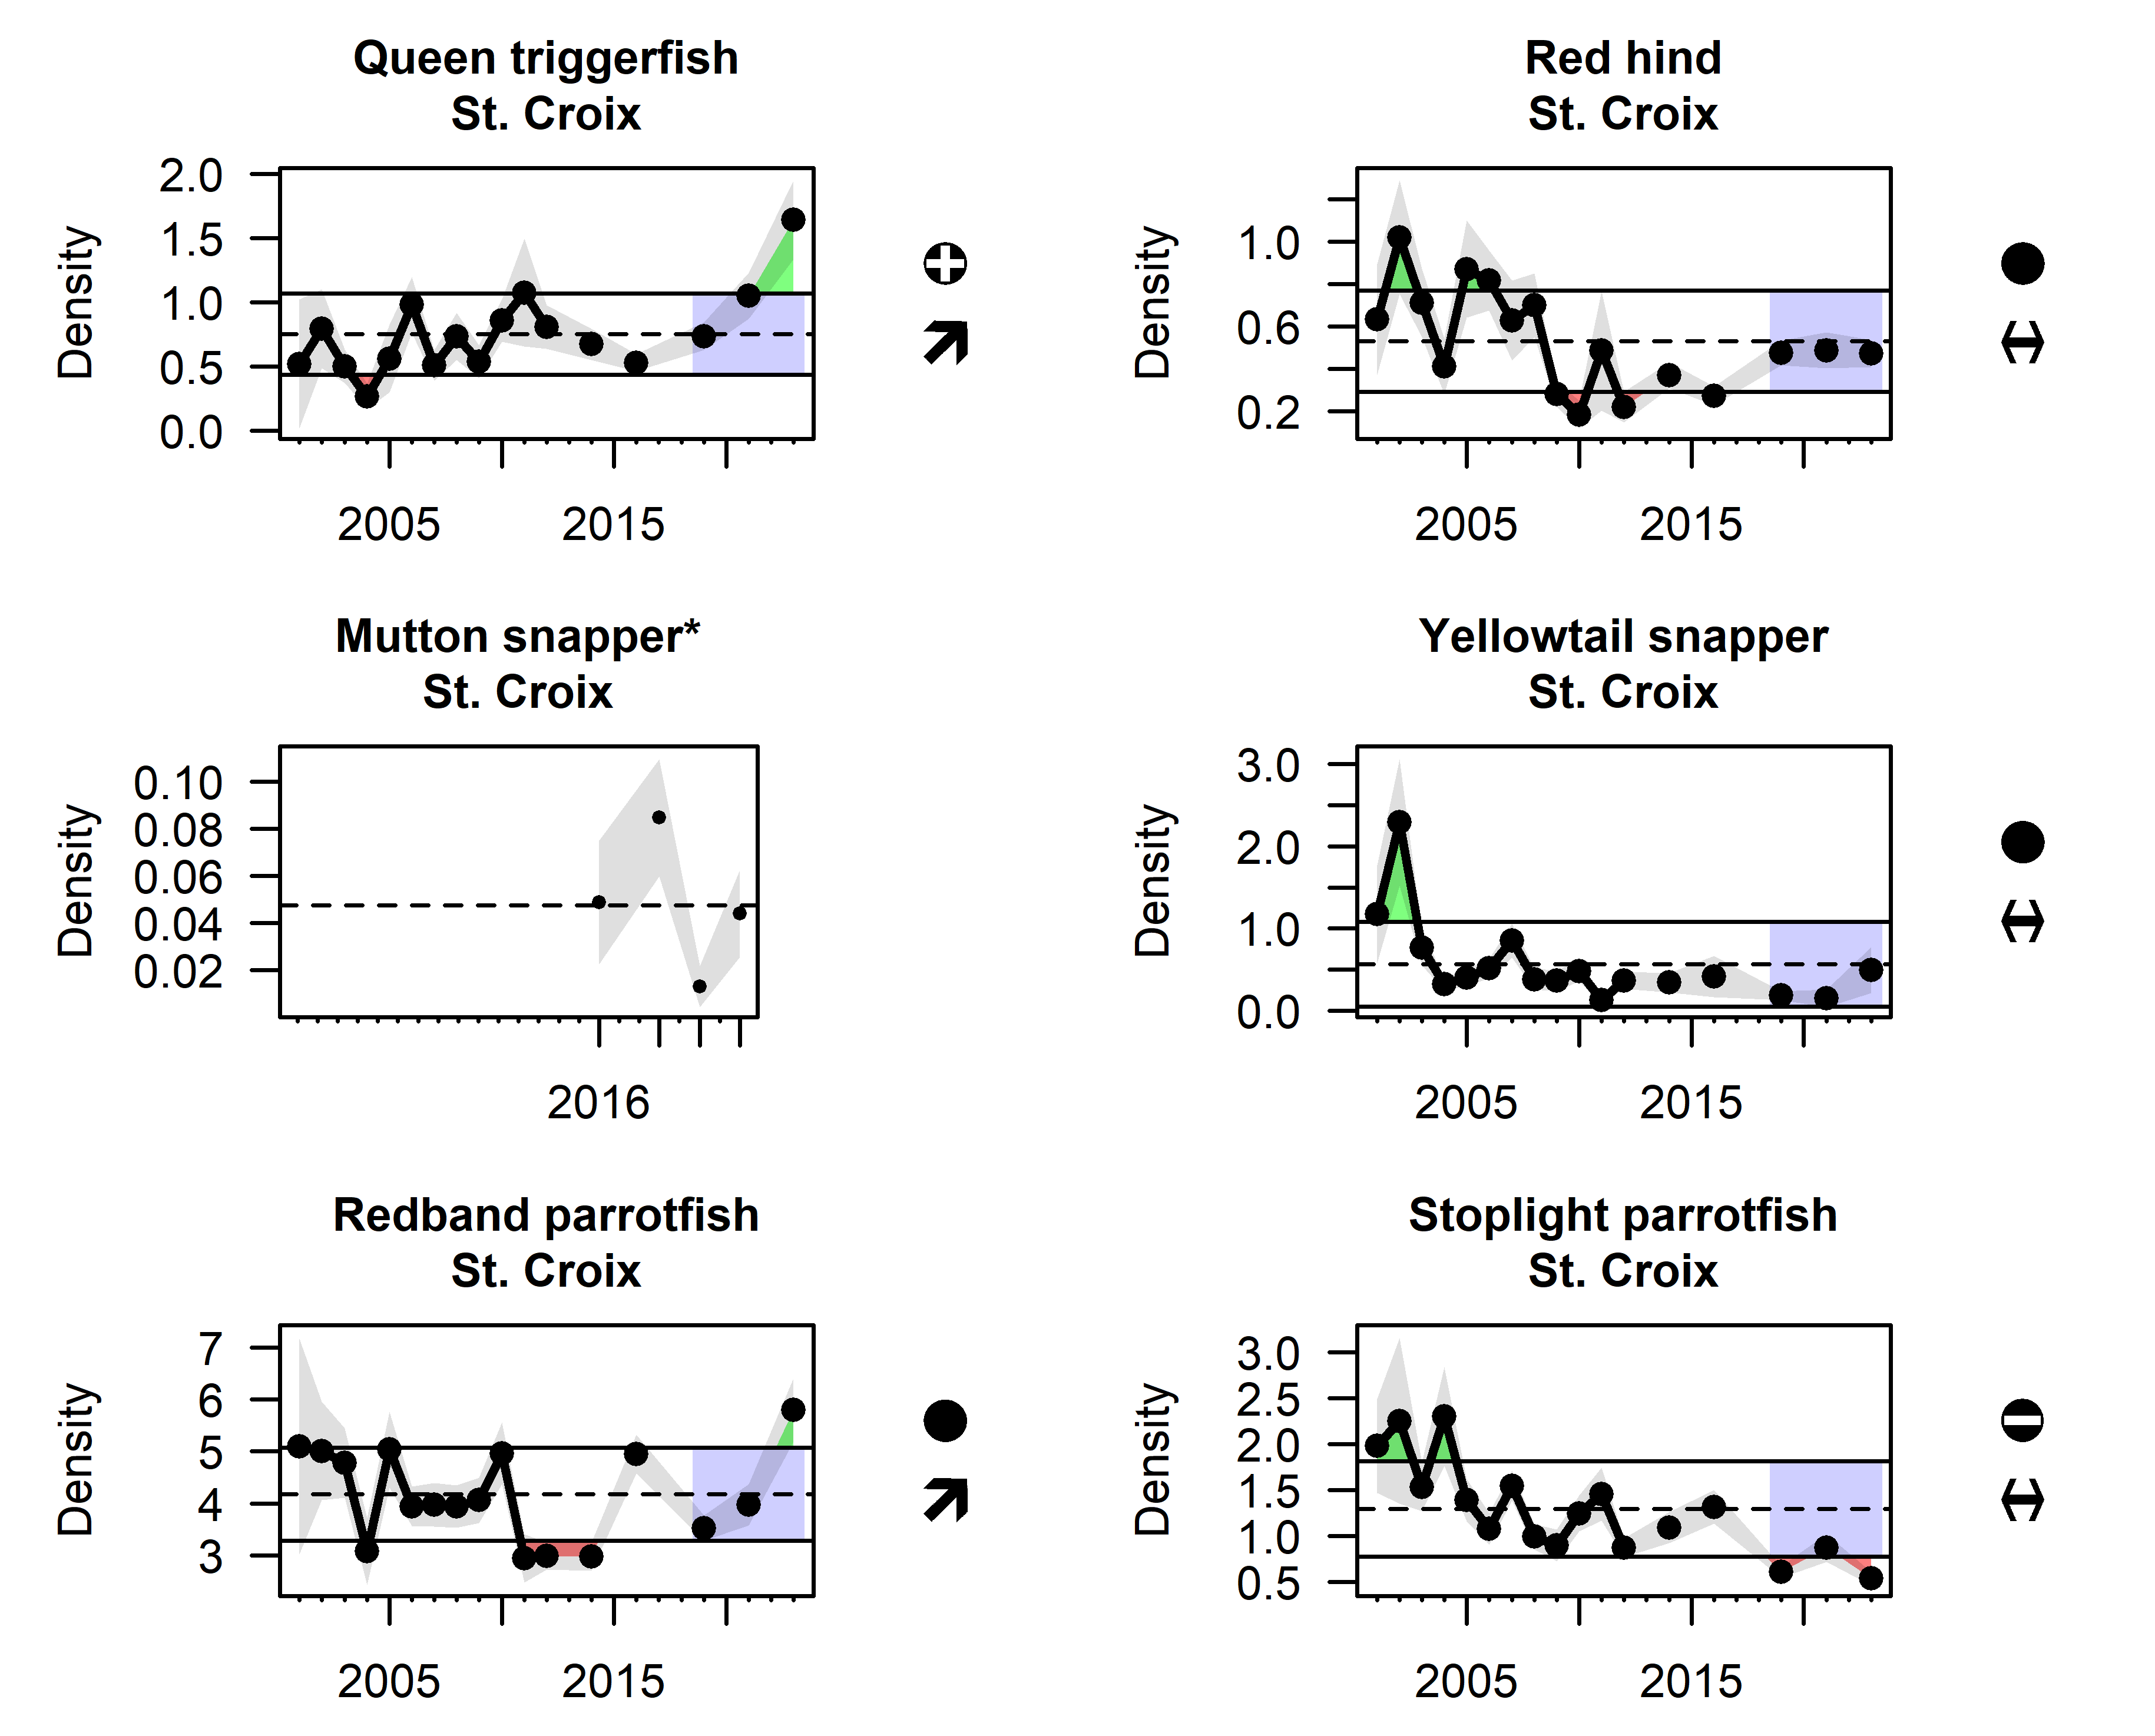
Figure 3.3: Average density of queen triggerfish, red hind, mutton snapper, yellowtail snapper, redband parrotfish, and stoplight parrotfish in St. Croix from the National Coral Reef Monitoring Program Reef Visual Census data. A change in sampling methodology occured in 2019, and at the time of publication the mutton snapper time series had not been calibrated, so data are only available from 2019 onward.
Fishery-independent surveys can be used to look at changes in the overall fish community and understand processes affecting multiple suites of species. The Puerto Rico Long-Term Coral Reef Monitoring Program (PRCRMP) has conducted annual surveys of fish and benthic organisms since 1999 (Natural and Environmental Resources 2019). Similarly, the USVI Territorial Coral Reef Monitoring Program (TCRMP) conducts annual to semi-annual surveys of coral health, fish community structure and coral health (https://www.vitcrmp.org/). Commercial fish density is calculated by taking the average number of commercial fish per transect over time. The slope of the size spectrum is calculated by binning all observed commercial fish lengths into size categories and then fitting a linear regression through the log-transformed histogram; a more negative slope represents relatively fewer large fish and potentially increased fishing impacts. In Puerto Rico, average commercial fish density fluctuates but is stable over time; insufficient data were available with which to estimate the slope of the size spectra. In the USVI, commercial fish density was stable over time with a large peak in 2011; the slope of the size spectrum was also relatively stable with a sudden decrease in 2011. Together these indicators convey the sudden appearance of many small fish, suggestive of a large recruitment event across multiple species (Figure 3.4).
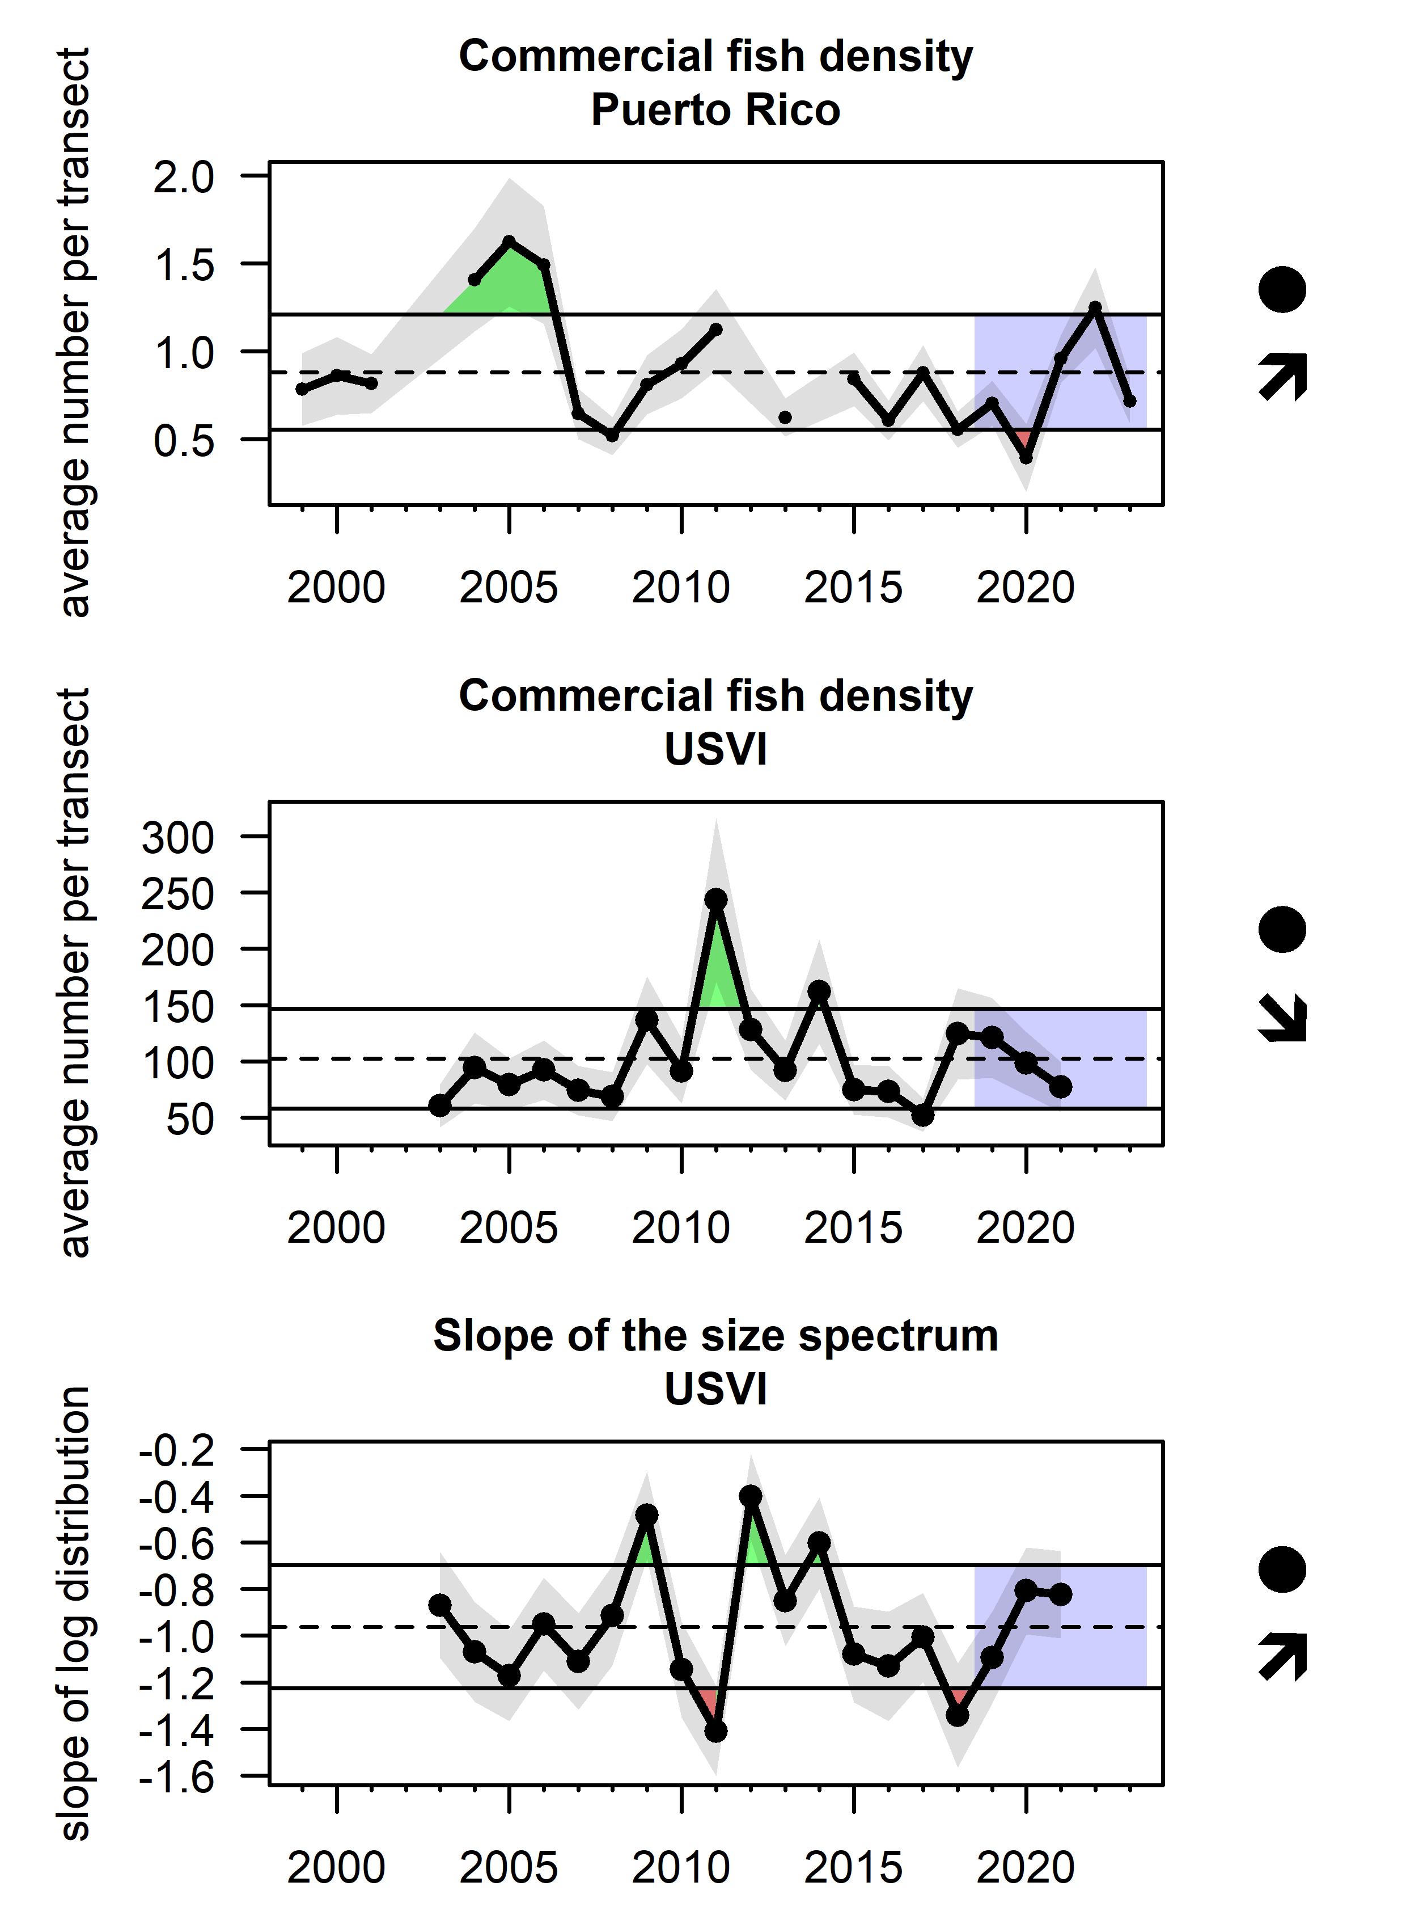
Figure 3.4: Commercial fish density from PRCRMP fishery-independent surveys in Puerto Rico (top), commercial fish density from TCRMP fishery-independent surveys in the USVI (middle), and the slope of the log-transformed size spectrum from TCRMP surveys in the USVI (bottom).

3.1.2 Pelagic:demersal ratio of landings
The ratio of pelagic to demersal species is thought to be responsive to nutrient inputs and the quality of benthic habitat in marine ecosystems (Leiva Moreno et al. 2000); in the context of small islands in the tropical seas, it may convey the availability and productivity of pelagic habitats relative to the size of the shelf and productivity of coral reef habitats. Ratios of pelagic to demersal landings were calculated based on total pounds reported in the Caribbean Commercial Landings data, following a classification of all species based on their reported ecology in FishBase (Froese and Pauly 2024). In St. Croix, the pelagic-demersal ratio is much higher than the other islands, due to the small shelf area and limited availability of reef habitat; interannual fluctuations for this island are largely influenced by landings of dolphinfish and tunas. In Puerto Rico, the pelagic-demersal ratio has increased in recent years; this may be partially due to changes in reporting that occurred in 2020 (logbook to e-reporting). In St. Thomas and St. John, the ratio has gradually increased over time; the large peak in the 2018-19 fishing year could have been a result of hurricane-induced reef habitat loss and subsequent reduction in landings of demersal fish species (Figure 3.5).
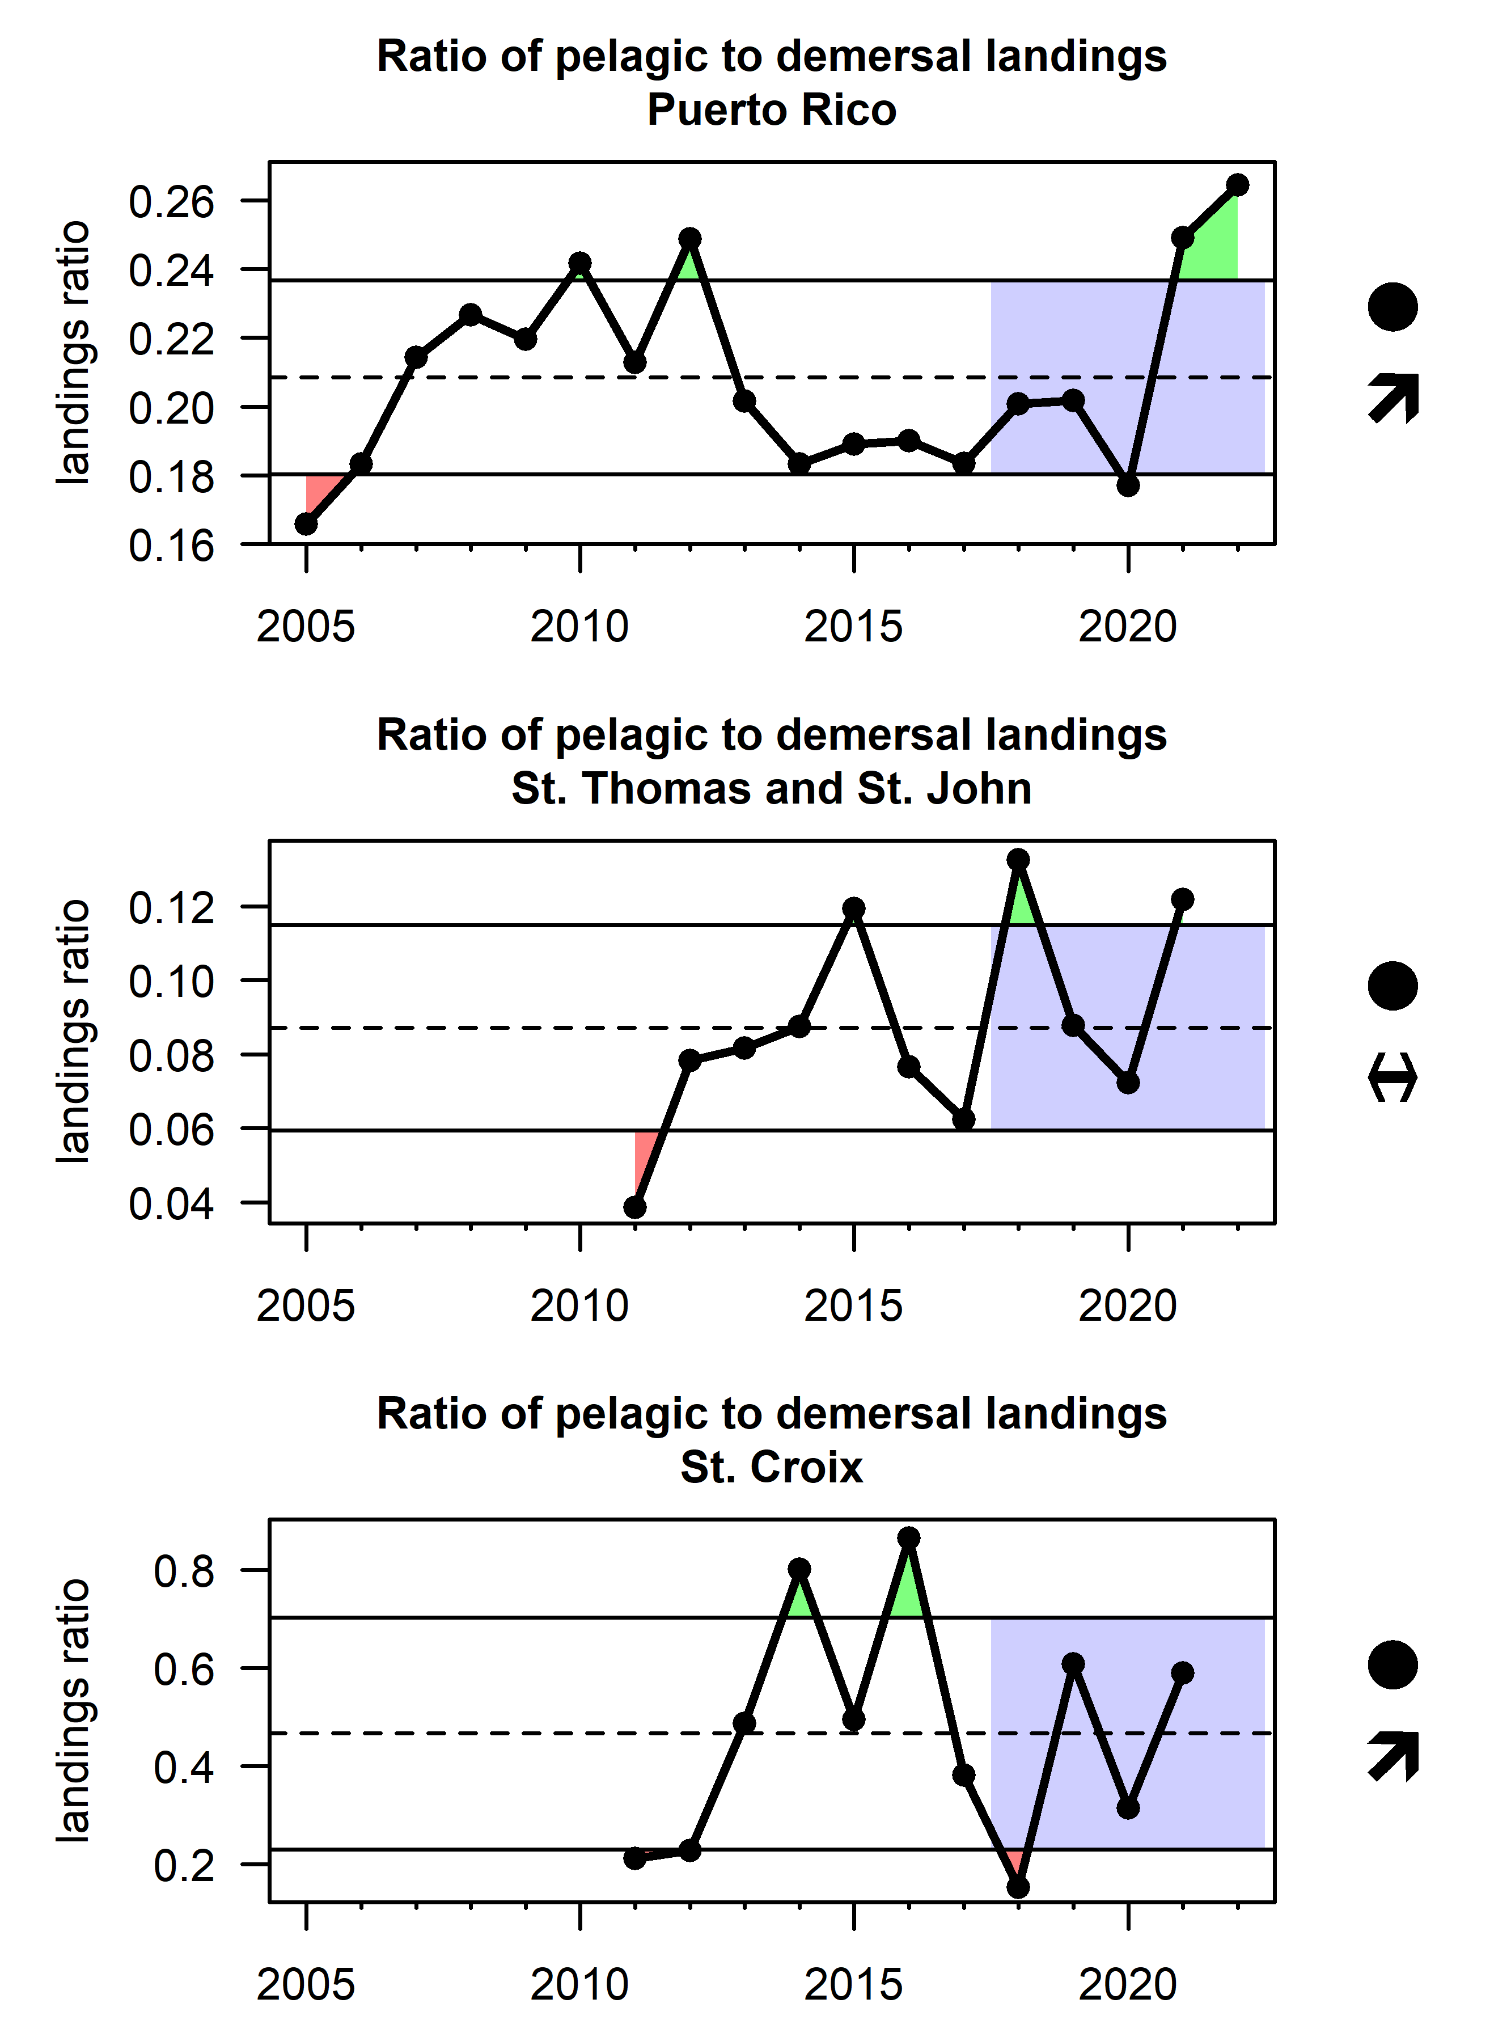
Figure 3.5: Ratios of pelagic to demersal landings, based on reported commercial landings data for Puerto Rico (top), St. Thomas and St. John (middle) and St. Croix (bottom). Note differences in scale of the y-axes; years in the USVI are fishing years (July 1st to June 30th of the following year).

3.1.3 Maximum length in the landings
The average maximum length of a species in the landings has been proposed as an indicator of whether large-bodies species have been depleted and are no longer fished (Rochet and Trenkel 2003). The Lmax indicator is derived by assigning a maximum body length for each species (as reported in FishBase) and then calculating the average body length for the landings in each year (based on the Caribbean Commercial Landings database). This analysis was limited to demersal species only, as pelagic species tend to be larger-bodied and the index would otherwise be highly correlated with the pelagic-demersal ratio. The average maximum length in the demersal landings decreased over time in Puerto Rico from 2005 - 2012, but has been relatively stable since (Figure 3.6). In the USVI, there has been no overall trend over time, though there was a sharp decline in St. Thomas and St. John in the 2017-18 fishing year and a sharp increase in St. Croix in the 2018-19 fishing year. These changes may reflect changes in fishing behavior tied to impacts from the 2017 hurricanes.
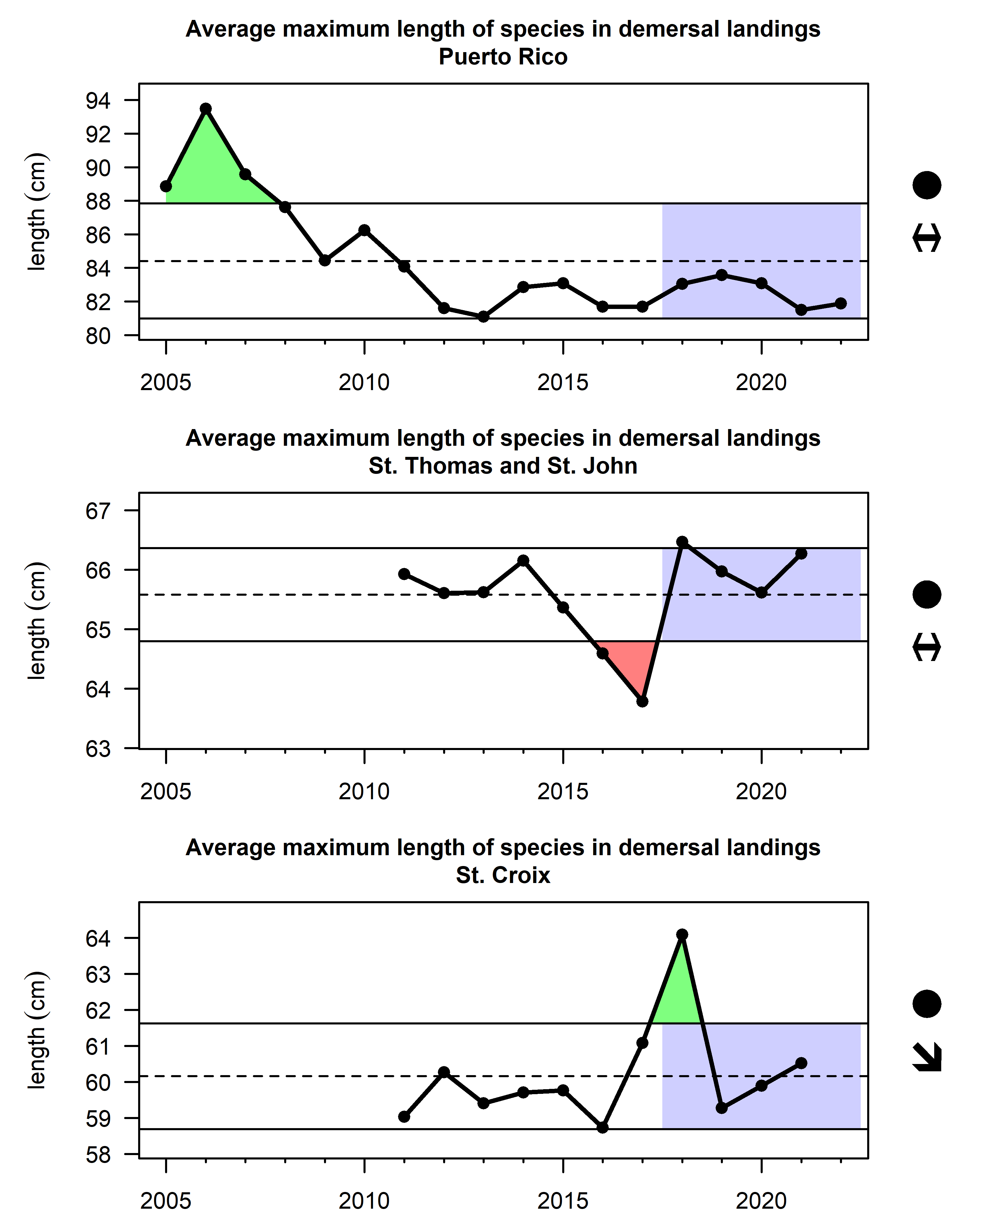
Figure 3.6: Average maximum length of demersal species in the reported landings for Puerto Rico (top), St. Thomas and St. John (middle) and St. Croix (bottom). Note that the years in the USVI are fishing years (July 1st to June 30th of the following year).
The proportion of landings within different Lmax classes can also be shown to better understand changes driving the average Lmax value. In Puerto Rico, there is a generally increasing trend of “plate-sized” fish in the 60-100cm category which is driven by increased landings of deepwater snapper species and yellowtail snapper, while a decrease in the 100-200cm Lmax group is driven by declining landings of large-bodies parrotfishes, snook, and some large groupers (Figure 3.7). Recent decreases in the 40-60cm Lmax group are driven by landings of lane snapper and queen triggerfish.
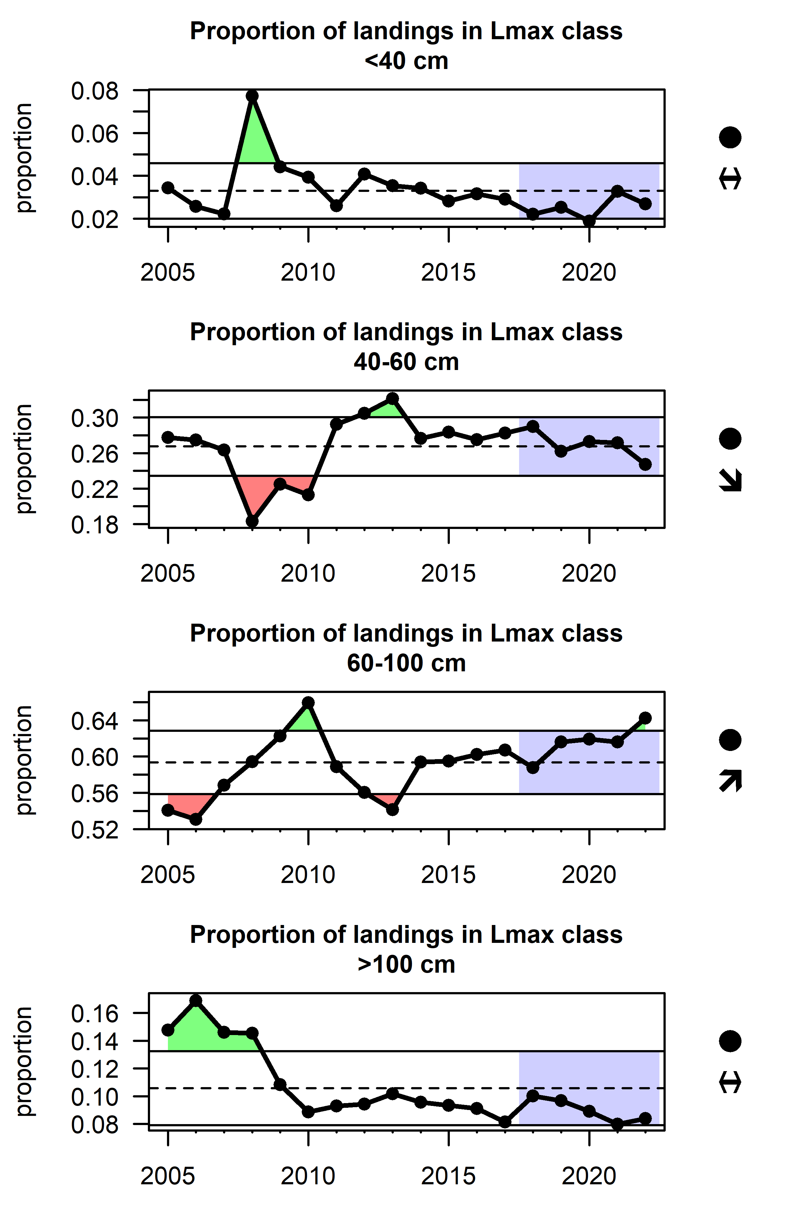
Figure 3.7: Proportion of commercial demersal landings in each of four maximum body length size classes in Puerto Rico.
In St. Thomas there is a notable decrease in the smallest size class (dominated by landings of surgeonfishes and longspine squirrelfish) as well as a recent decrease in the 40-60cm Lmax group, driven by landings of queen triggerfish, gray angelfish, and white grunt. Landings in the 60-100cm Lmax group have fluctuated over time and are influenced by landings of red hind, yellowtail snapper and blue runner (Figure 3.8).
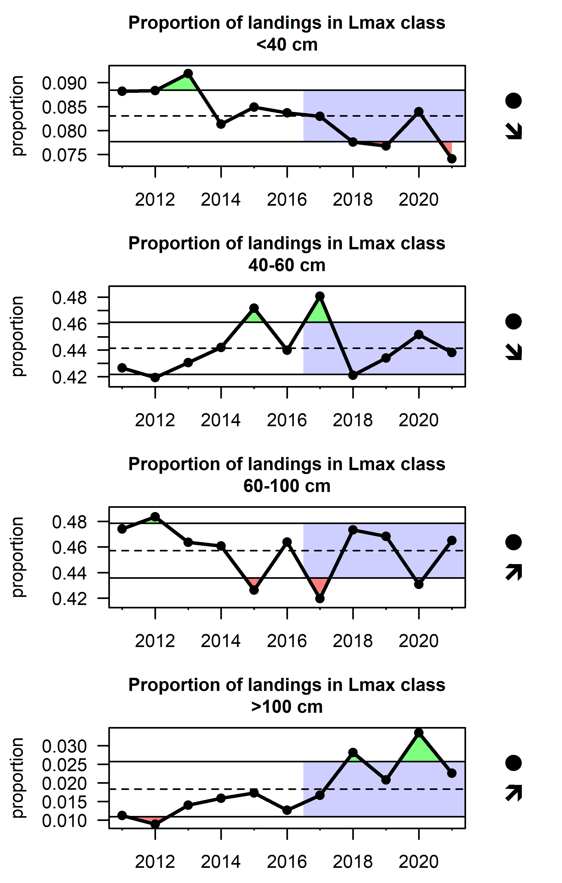
Figure 3.8: Proportion of commercial demersal landings in each of four maximum body length size classes in St. Thomas and St. John. Note that the years are fishing years (July 1st to June 30th of the following year).
In St. Croix, changes in the maximum body size of demersal species landings is being influenced primarily by changes in the targeting of parrotfishes. The <40cm Lmax group includes redband parrotfish and princess parrotfish and has increased in recent years, while the 40-60cm Lmax class, composed of redfin and redtail parrotfish, has decreased in recent years. The 60-100cm Lmax class has fluctuated over time and is driven by landings of stoplight and queen parrotfish (Figure 3.9).
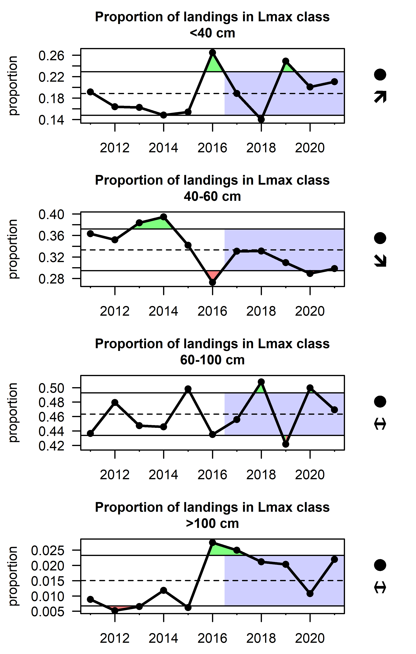
Figure 3.9: Proportion of commercial demersal landings in each of four maximum body length size classes in St. Croix. Note that the years are fishing years (July 1st to June 30th of the following year).

3.1.4 Commercial landings
Total landings of conch, lobster, and finfish indicate the ability of U.S. Caribbean fisheries to provide food and revenues, and may be driven by a combination of trends in underlying abundance, market demand, and fishing effort. Self-reported landings from the Caribbean Commercial Landings Data were compiled; data were originally compiled by paper logbooks, but starting in 2020 some trips in Puerto Rico were reported using electronic reporting (a telephone application). Since 2005, lobster landings have increased in Puerto Rico and decreased in the USVI, with particularly low values in 2017-18 for St. Thomas and 2018-19 for St. Croix. Conch landings have been more variable with little trend over time, though there was a sudden decrease in Puerto Rico conch landings in 2020. Landings of other species have decreased significantly over time, particularly starting in 2010 (Figure 3.10). This coincides with initial implementation of annual catch limits in U.S. Caribbean federal waters and may be caused by changes in reporting rather than true reductions in landings.
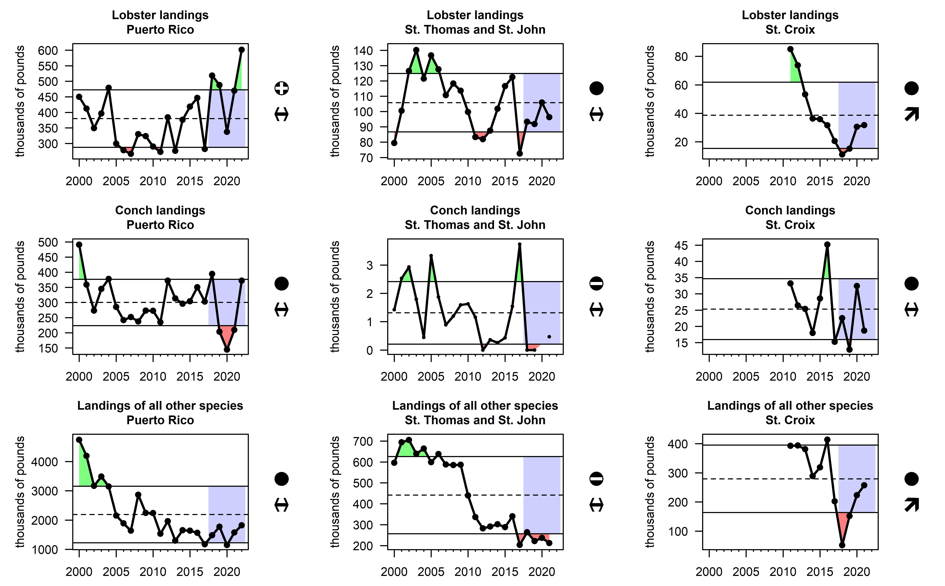
Figure 3.10: Total landings of lobsters (top row), conch (middle row), and all other commercial species (bottom row) from commercial landings data in Puerto Rico (left column), St. Thomas and St. John (middle column) and St. Croix (right column). Confidential landings appear as missing values. Note that the years in the USVI are fishing years (July 1st to June 30th of the following year).

3.2 Socioeconomic health

3.2.1 Commercial revenues
The relative revenue contribution to commercial fisheries by species conveys the changing reliance on different species across the U.S. Caribbean. Revenues were calculated from the Caribbean Commercial Landings data based on the weight of landings in each trip and the reported price; anomalously high prices and missing values were replaced by the overall average price for the given species group. In Puerto Rico, approximately a third of the revenues have consistently come from snapper species; this is followed by lobster and conch, which were both increasing in their revenue contribution up to 2017 (Figure 3.11). In St. Thomas and St. John, there has also been increasing dependence on lobster, which supplies roughly a third of the revenues for those islands (Figure 3.12). Revenues in St. Croix are not dominated by a single species group; parrotfishes, tunas and mackerels, lobsters, snappers, and dolphinfish make up approximately 75% of the revenues (Figure 3.13).
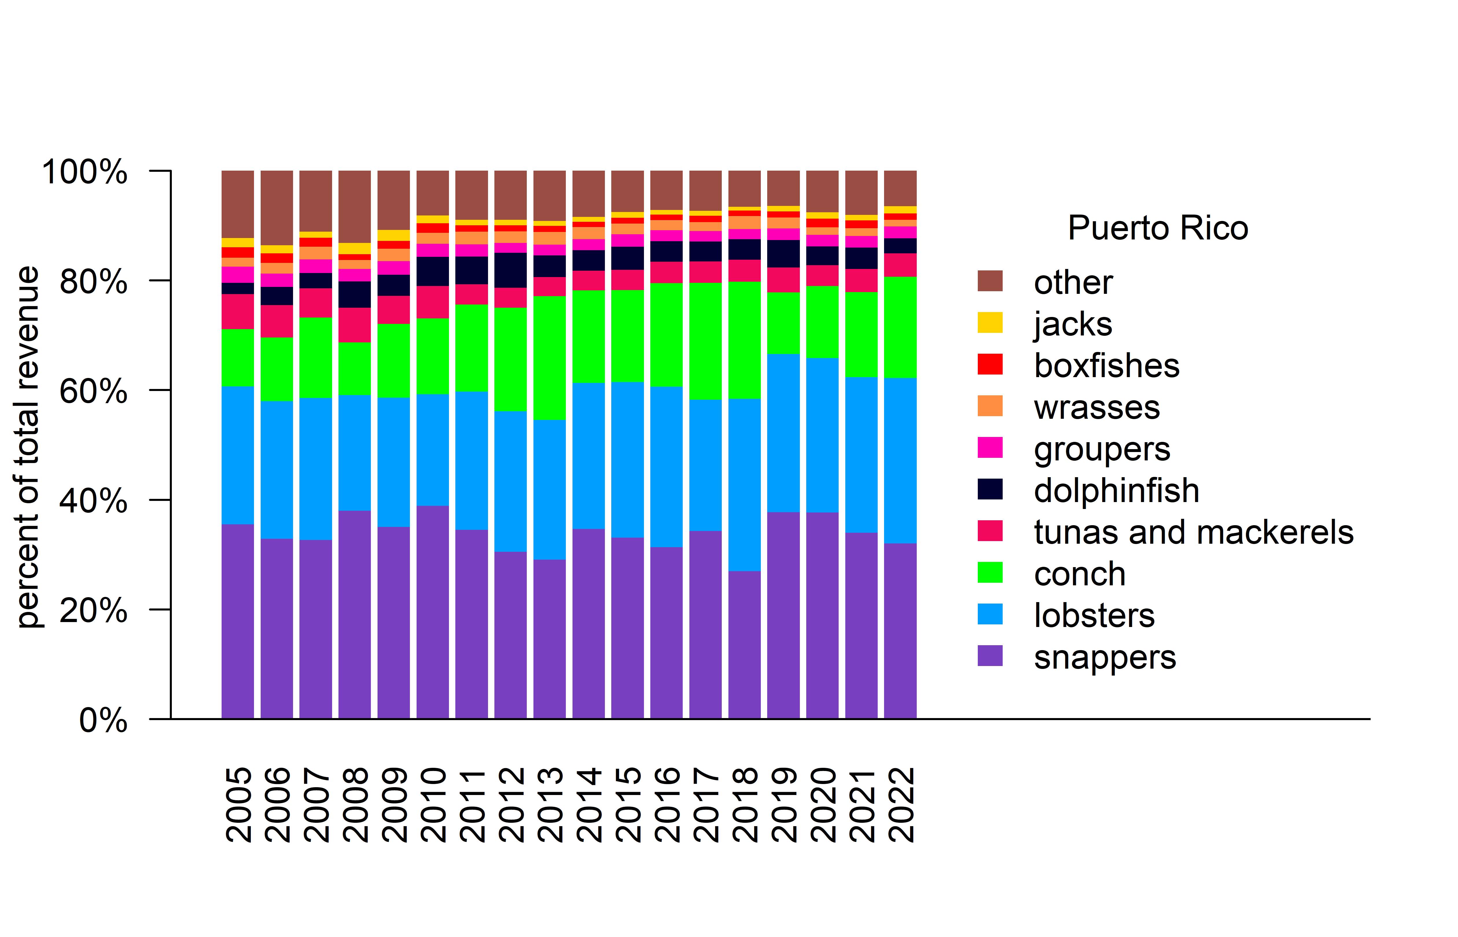
Figure 3.11: Percent revenue contribution for the top ten species groups, stacked by their order of overall importance, for commercial fisheries in Puerto Rico. Note that the years are fishing years (July 1st to June 30th of the following year).

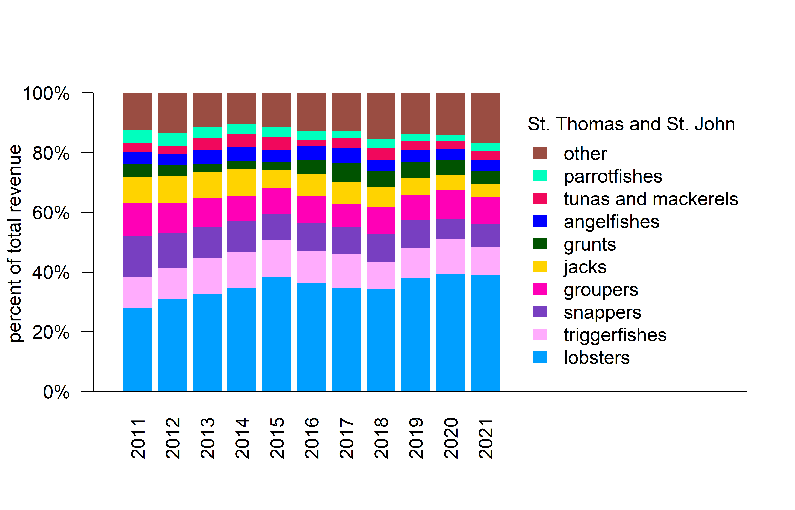
Figure 3.12: Percent revenue contribution for the top ten species groups, stacked by their order of overall importance, for commercial fisheries in St. Thomas and St. John. Note that the years are fishing years (July 1st to June 30th of the following year).

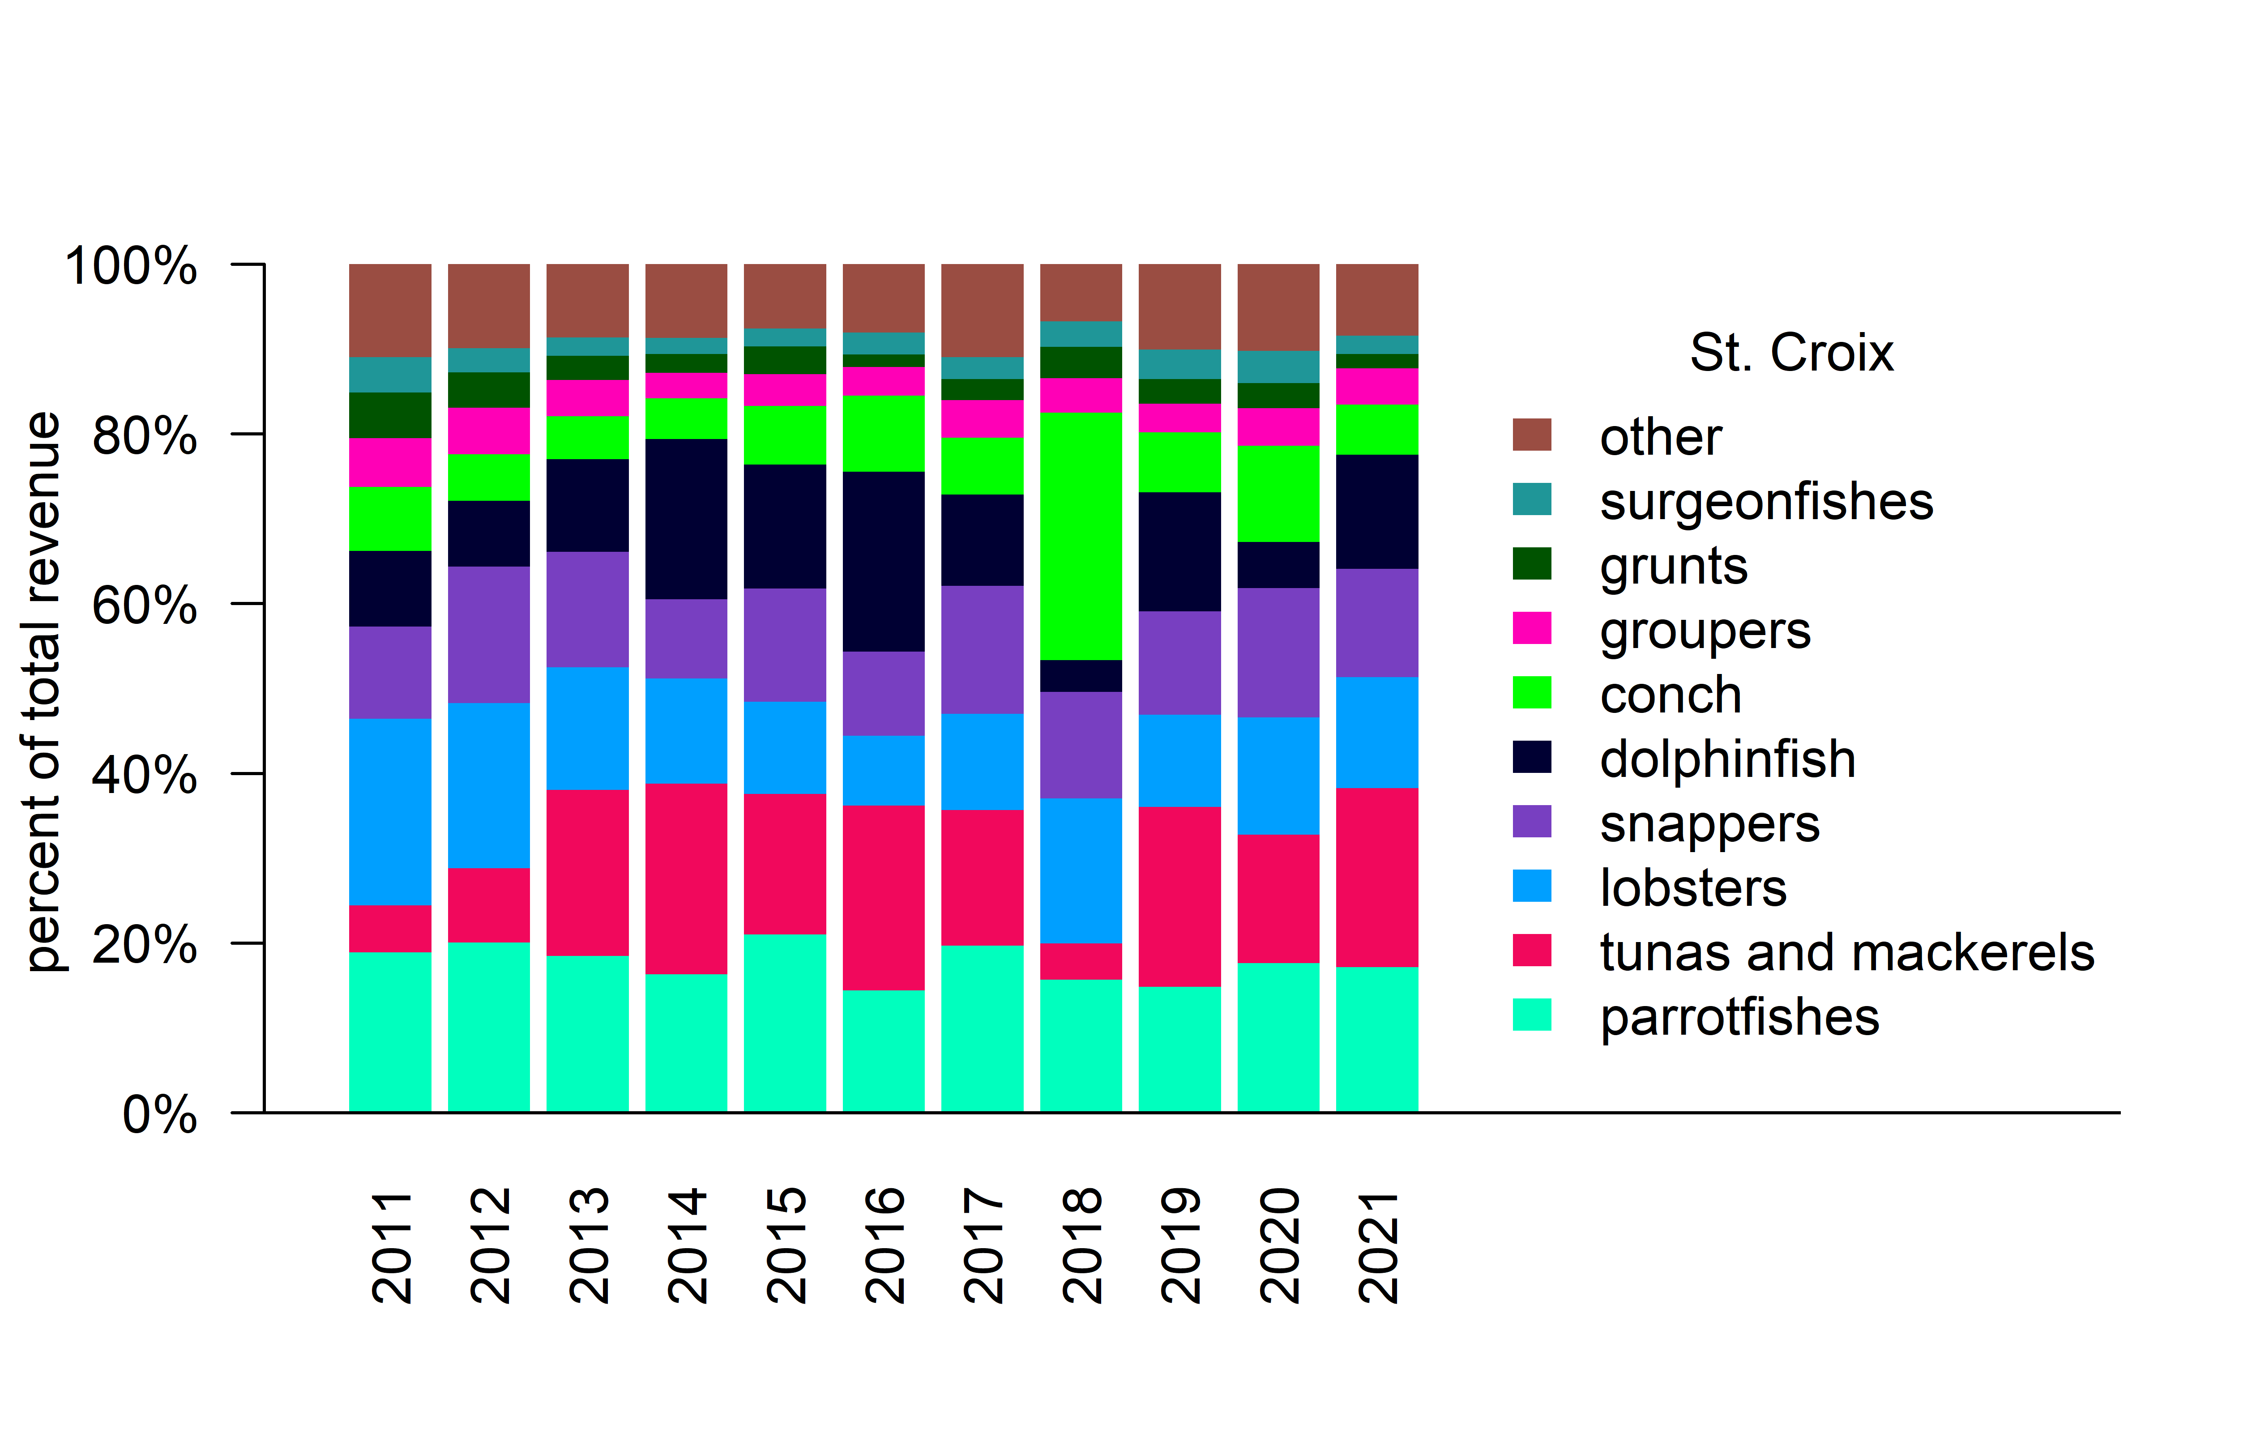
Figure 3.13: Percent revenue contribution for the top ten species groups, stacked by their order of overall importance, for commercial fisheries in St. Croix. Note that the years are fishing years (July 1st to June 30th of the following year).

3.2.2 Commercial fishing trips
Commercial fishing trips are a useful socioeconomic indicator because they capture the amount and type of effort which may be driven by market factors, regulations, and costs of entering the fishery. The total number of trips, broken down by gear type, was extracted from the Caribbean Commercial Landings database by identifying unique trips based on date and vessel number and extracting the primary reported gear used for each trip. In Puerto Rico, trip numbers have generally decreased over time, with marked decreases in 2017 and 2020; sudden changes in the hook and line fishing in 2012 are due to changes in reporting forms (Figure 3.14). Effort has similarly declined in St. Thomas and St. John; marked declines after 2010 are likely due to reduced reporting (Figure 3.15). Similarly, in St. Croix the number of trips has declined, with the 2018-19 fishing season reporting particularly low effort (Figure 3.16). Gears are plotted using the same order and color codes, to facilitate comparisons among the islands.
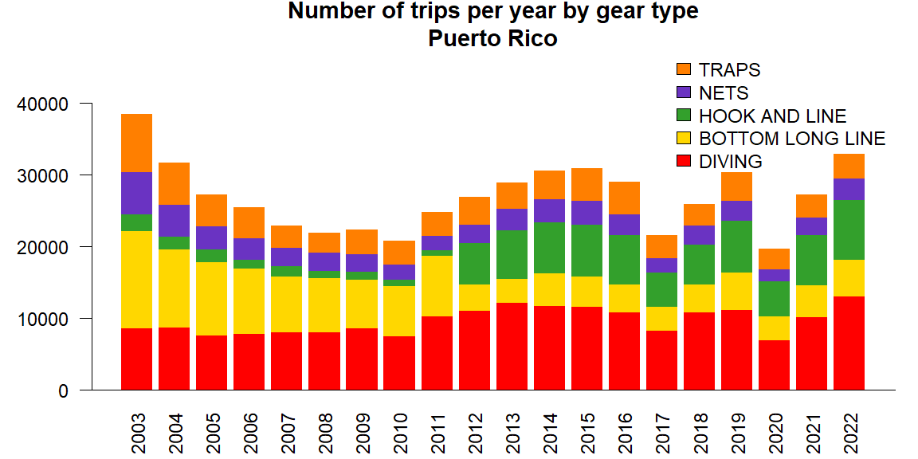
Figure 3.14: Total number of commercial fishing trips by gear type in Puerto Rico, separated by primary gear used on the trip.

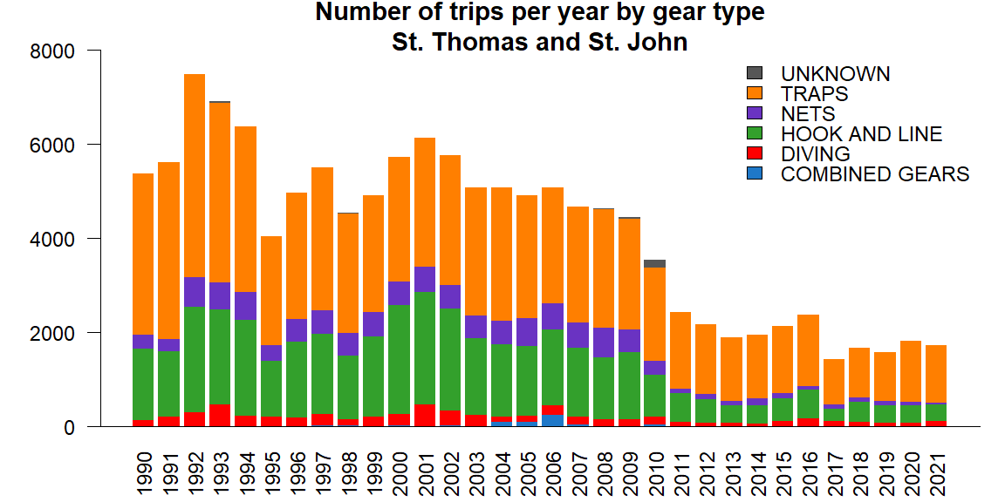
Figure 3.15: Total number of commercial fishing trips by gear type in St. Thomas and St. John, separated by primary gear used on the trip. Note that the years are fishing years (July 1st to June 30th of the following year).

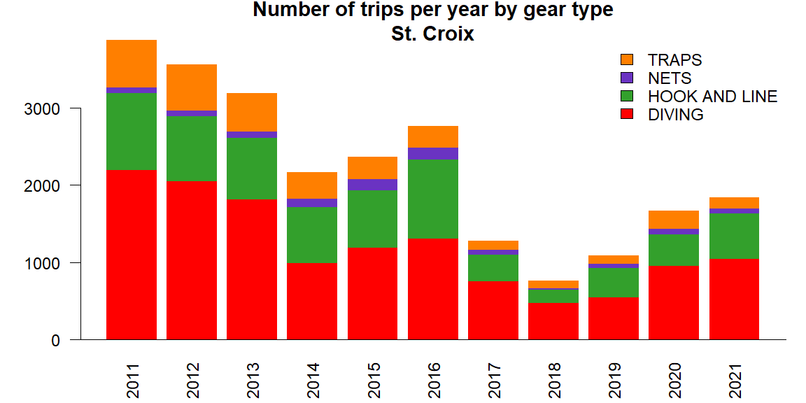
Figure 3.16: Total number of commercial fishing trips by gear type in St. Croix, separated by primary gear used on the trip. Note that the years are fishing years (July 1st to June 30th of the following year).
Given the potential for changes in reporting to impact trip numbers, it can more informative to look at the composition of gear types. In particular, diving is often a way of entry for new or part-time fishermen as it generally requires lower up-front investments. Peaks in the proportion diving trips in 2017 and 2018 could be a result of lost traps and infrastructure due to hurricanes (Figure 3.17).
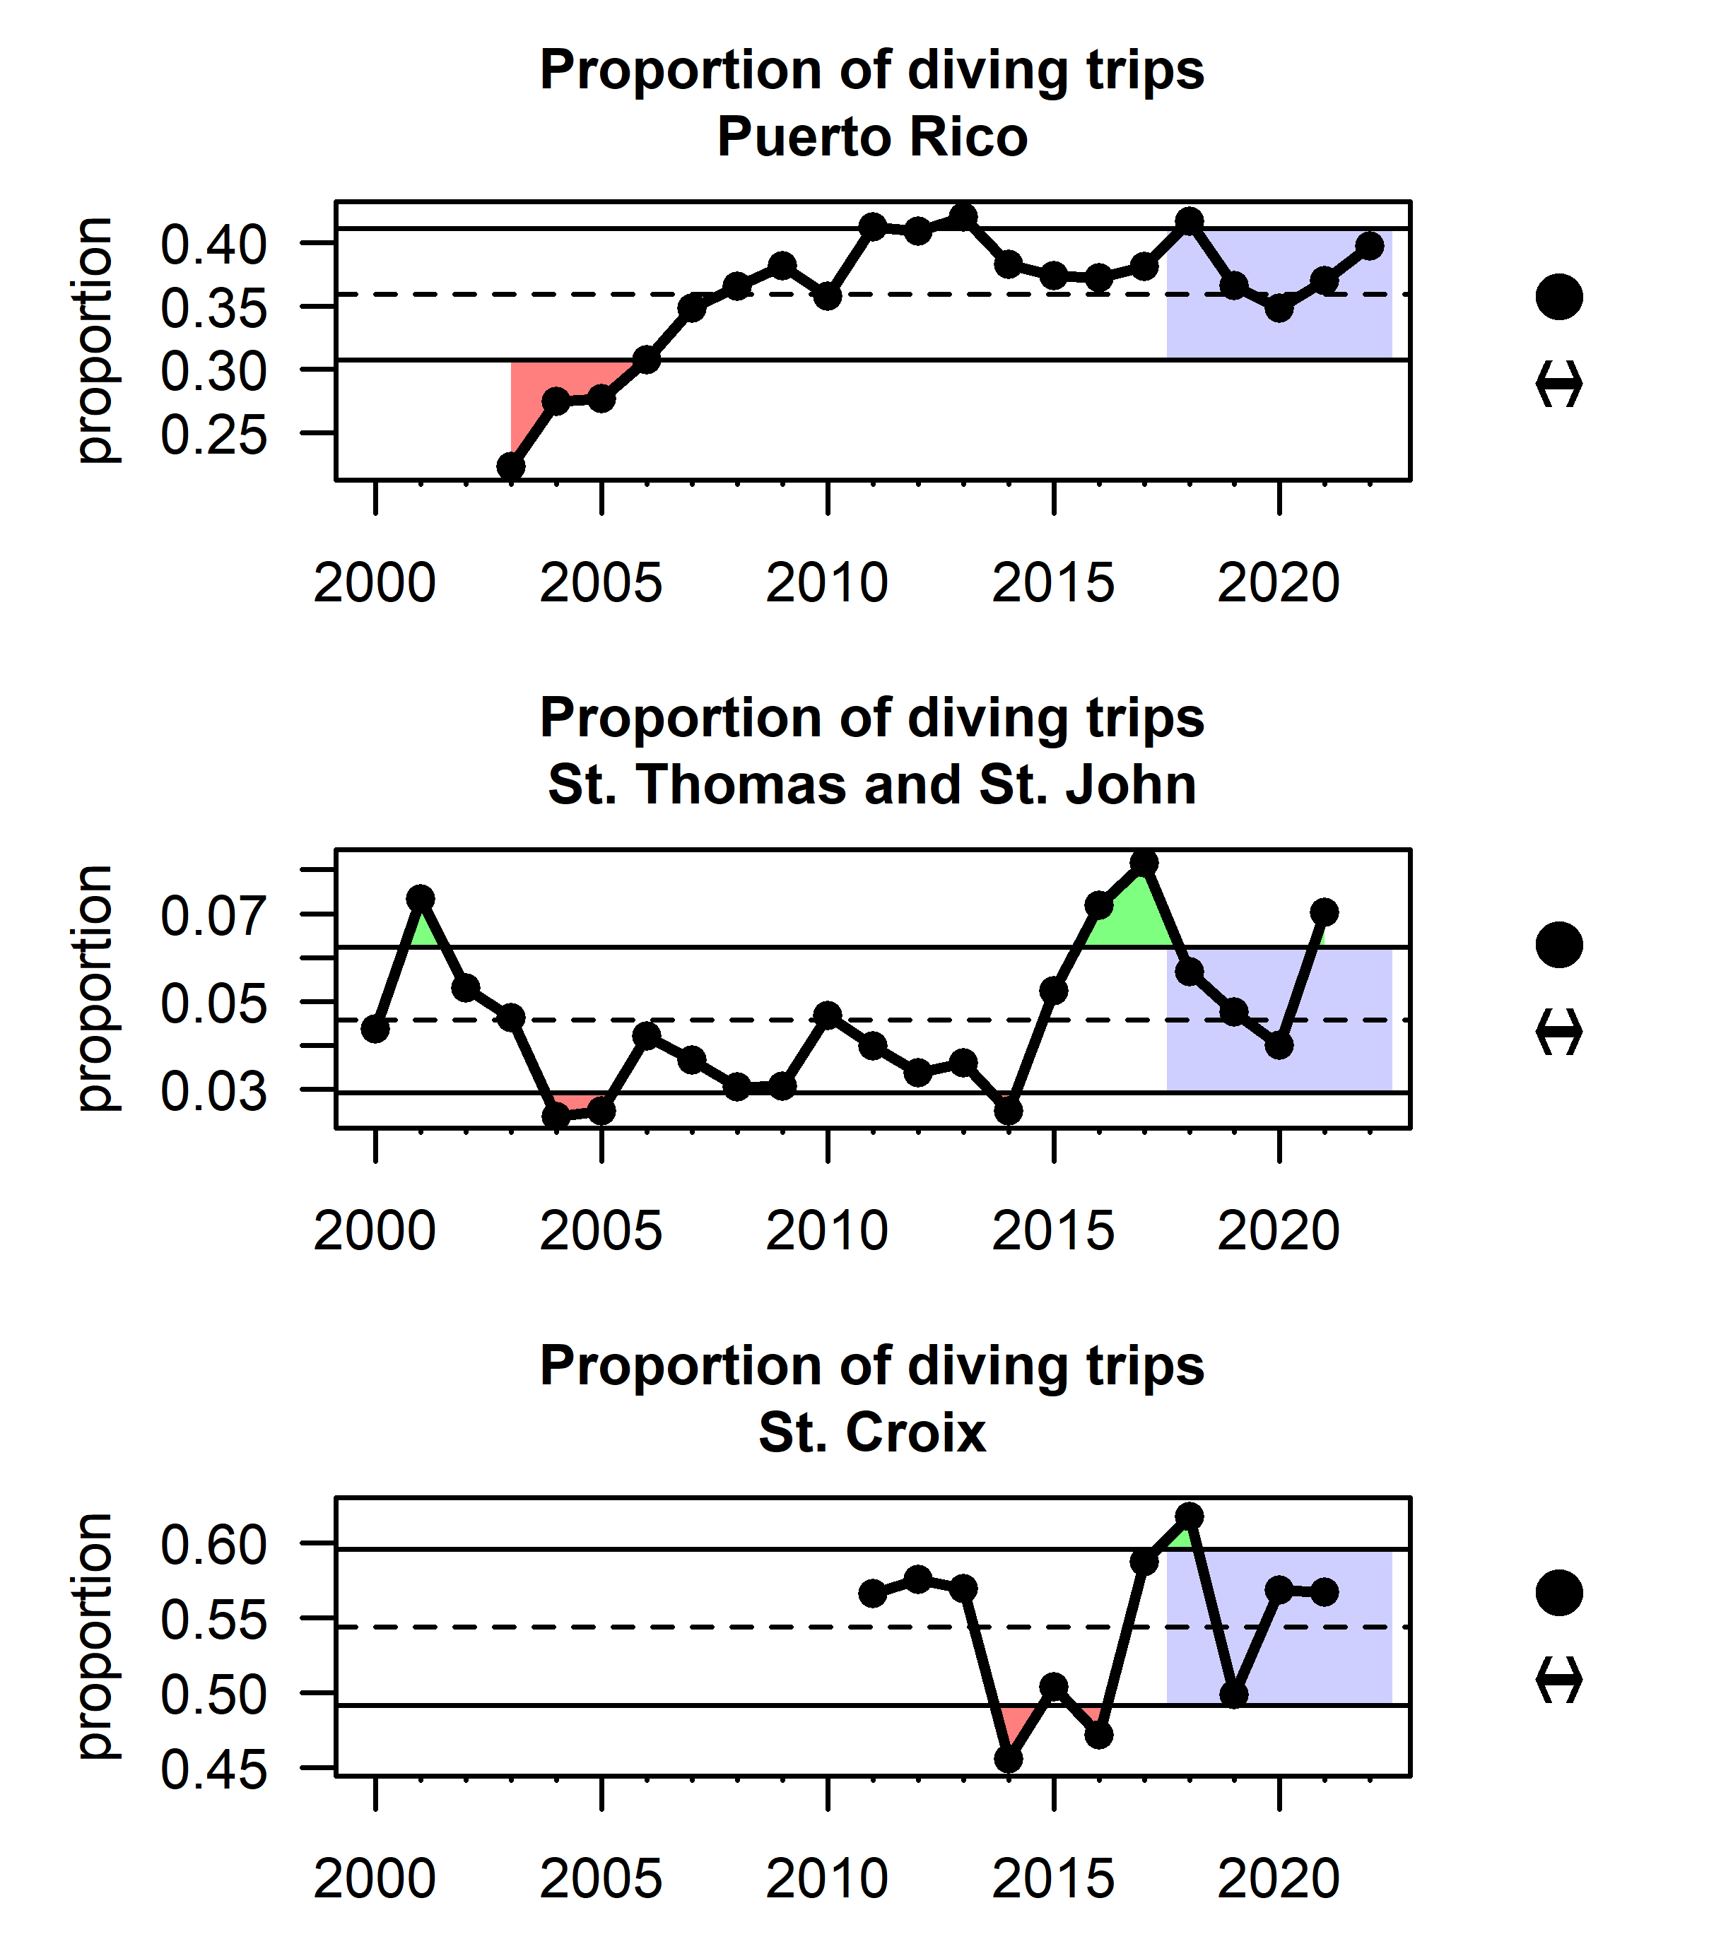
Figure 3.17: Proportion of commercial trips that are reported as diving trips for Puerto Rico (top), St. Thomas and St. John (middle) and St. Croix (bottom). Note that the years in the USVI are fishing years (July 1st to June 30th of the following year).
Ordination of gear types based on reporting landing sites conveys how different regions across the U.S. Caribbean depend on different methods of fishing. Ordinations were conducting using non-metric multidimensional scaling (NMDS) based on matrices representing the proportion of gears used by landing site. The NMDS algorithm seeks to place different sites in an X-dimensional space, such that the physical distances between each pair of sites best represents the differences in gear types employed. Thus, sites that appear more closely together in the figures are more similar in their gear usage, and the position of the gear type labels denote the relative importance of those gears in those sites. In Puerto Rico for example, hook and line and bottom long line are closely related and are particularly prevalent in the northern landing sites (in red), whereas nets and traps are more prevalent in the South (blue) (Figure 3.18). In St. Thomas and St. John, there is an association of traps and hook and line fishing (Figure 3.19), whereas in St. Croix, those gears are not associated with each other but nets and spearfishing are closely associated within landing sites (Figure 3.20).
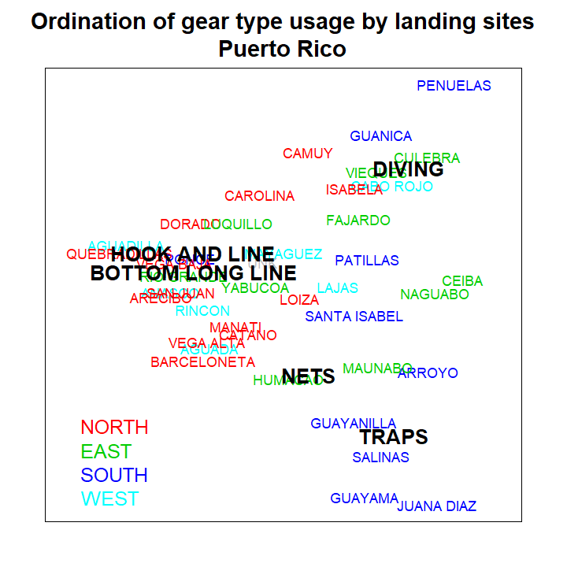
Figure 3.18: Ordination of gear type usage by landing site for Puerto Rico, color coded by region.

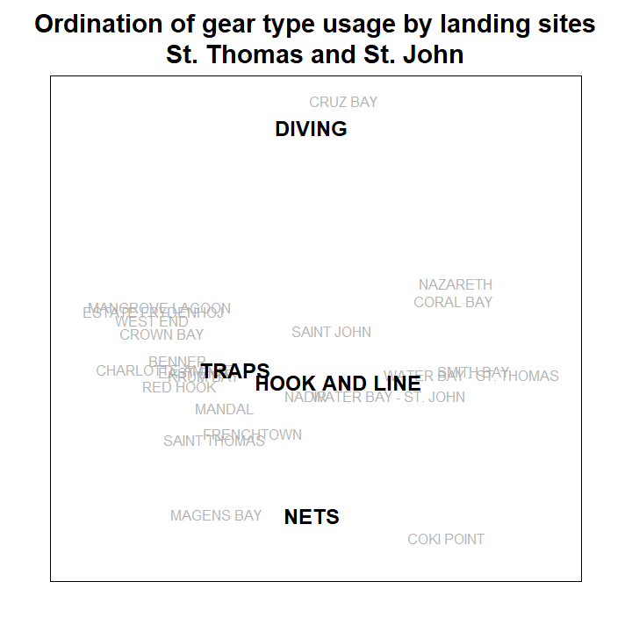
Figure 3.19: Ordination of gear type usage by landing site for St. Thomas and St. John.

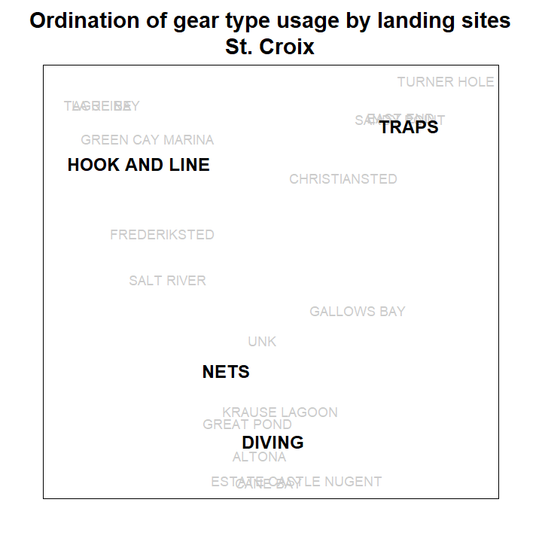
Figure 3.20: Ordination of gear type usage by landing site for St. Croix.

3.2.3 Economic activity
Some high level indicators of economic activity come in the form of GDP and employment trends. Gross Domestic Product (GDP) data come from the World Bank, and indicate an overall general economic expansion in Puerto Rico (World Bank 2024a). GDP in the USVI (World Bank 2024b) declined substantially from 2007-2014, but has been increasing steadily since (Figure 3.21).
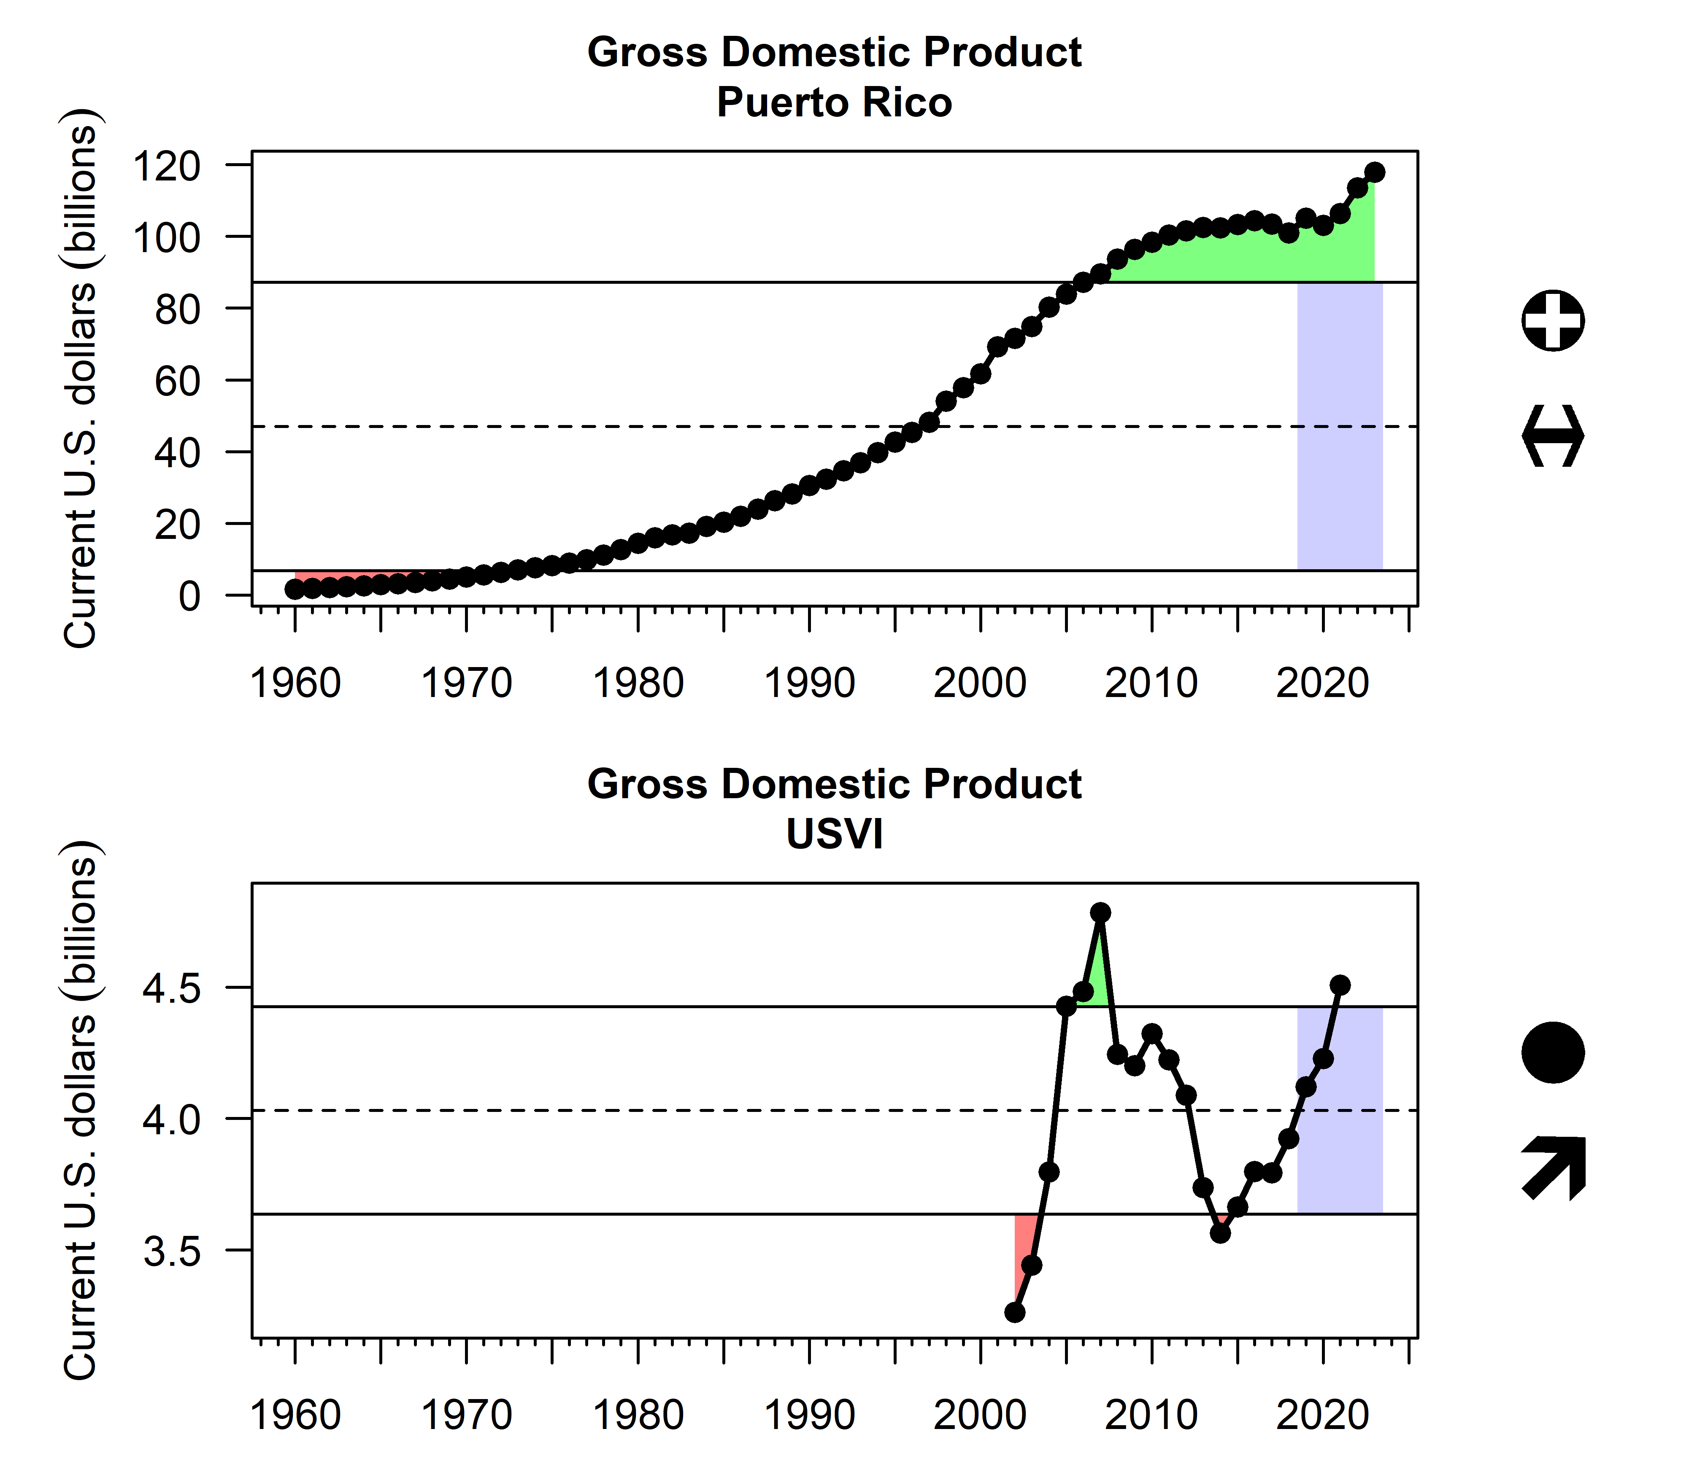
Figure 3.21: Overall Gross Domestic Product (GDP) in Puerto Rico (top) and the USVI (bottom).
GDP can sometimes underestimate the ocean-dependency of the regions’ local island economies; another indicator that is useful is employment/unemployment rate data, which come from the U.S. Bureau of Labor Statistics (U. S. Bureau of Labor Statistics 2024) and the U.S Employment and Training Administration (Employment and Training Administration 2024). Unemployment has shown a declining trend over time in Puerto Rico and the USVI. In the USVI, there were notable spikes in the unemployment rate in 2018 and 2020, following major hurricanes Irma and Maria and the COVID-19 pandemic.
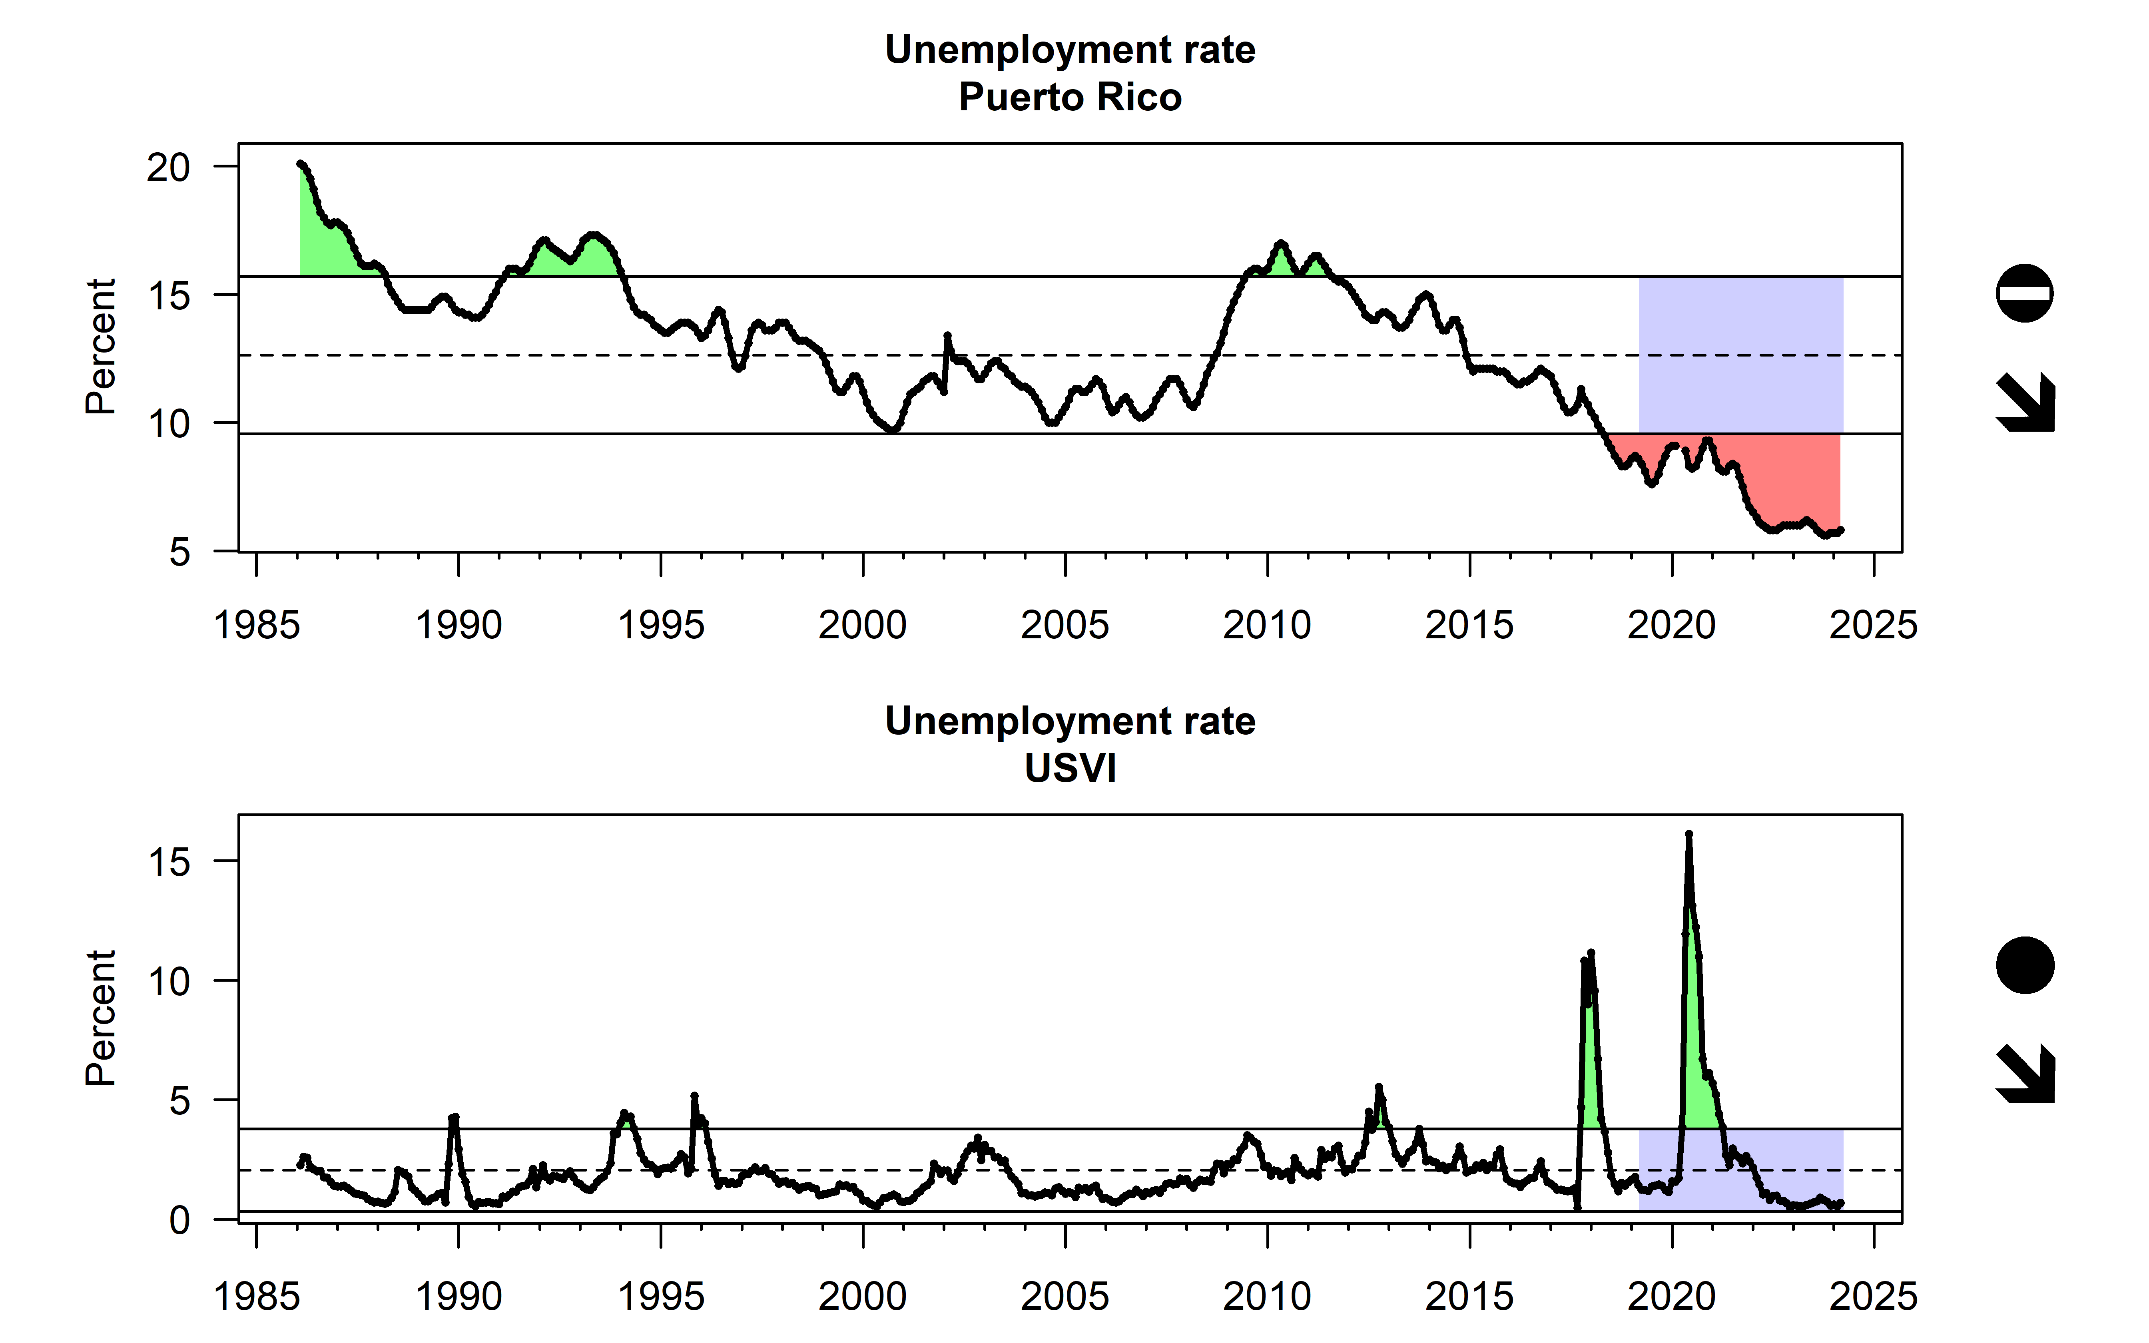
Figure 3.22: Monthly unemployment rate in Puerto Rico (top) and the USVI (bottom).

3.2.4 Ocean economy
Due to their unique geography, culture and setting, the islands of Puerto Rico and the U.S. Virgin Islands are more reliant on the surrounding ocean and marine environments than many parts of the continental United States. Data from the Bureau of Labor Statistics Quarterly Census of Employment and Wages (https://www.bls.gov/cew/downloadable-data-files.htm) provide data on the number of establishments, employees, and wages earned for each county by industry (as defined by NAICS code). These data underpin the Economics: National Ocean Watch (ENOW) methods created by NOAA OCM to track contributions of the ocean economy to the overall economy. There were significant changes to the way ocean economy metrics were calculated for the U.S. Territories in 2016 (Clements, Feliciano, and Colgan, n.d.), and revised metric data are only available from 2019-2021 through ENOW. It is therefore difficult to assess trends over time until additional data are collected (Figure 3.23).
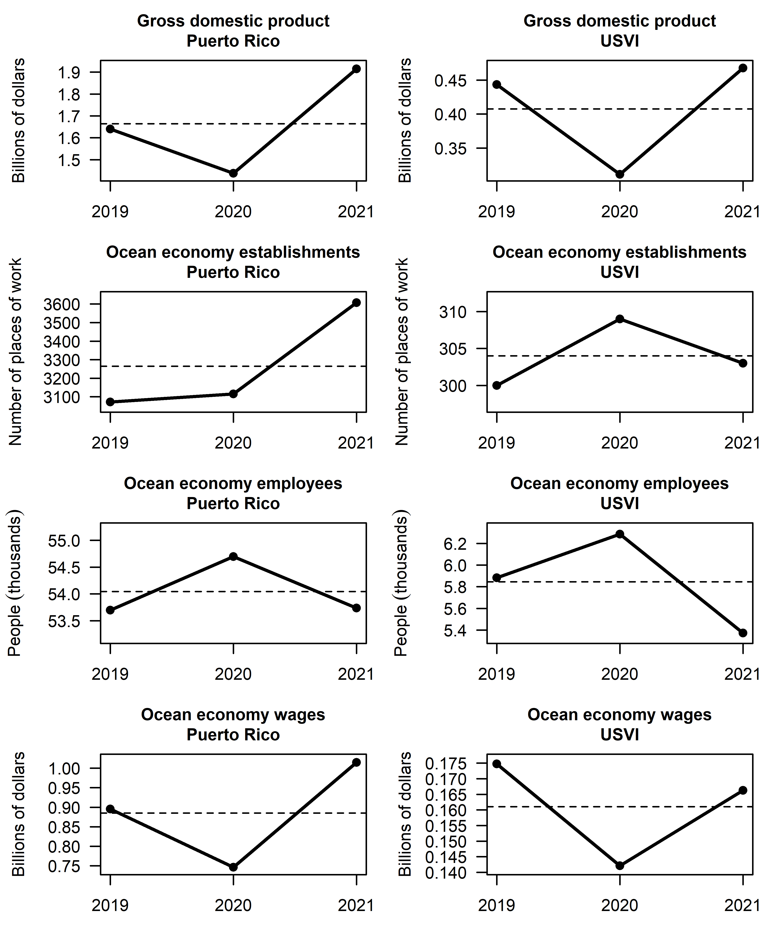
Figure 3.23: Ocean economy GDP, ocean economy establishments, ocean economy employment, and ocean economy wages (from top to bottom), for Puerto Rico (left column) and the USVI (right column).

3.3 Equity

3.3.1 Commercial revenue distribution
Equality in the distribution of revenues across the fishery can be represented by the Gini index which is a value ranging from zero to one, with zero representing perfect equality (revenues distributed equally among all participants) and a value of one representing maximum inequality (all revenues going to a single individual, Gini 1936). The Gini index was calculated based on reported revenues from the Caribbean Commercial Landings database, as they are distributed across the individual vessel or fisher permits (Figure 3.24). Overall, the Gini index values suggest that consolidation across U.S. Caribbean fisheries is high compared to other U.S. regions, though this may be an artifact of reporting if more experienced fishermen are more consistent in their reporting. In St. Thomas and St. John, the index shows a gradual increase throughout the time period, while there is no particular trend apparent in Puerto Rico and St. Croix. There are spikes in inequality in Puerto Rico in 2018 and in St. Croix in 2017-2018 which may be related to fishing industry impacts from hurricanes.
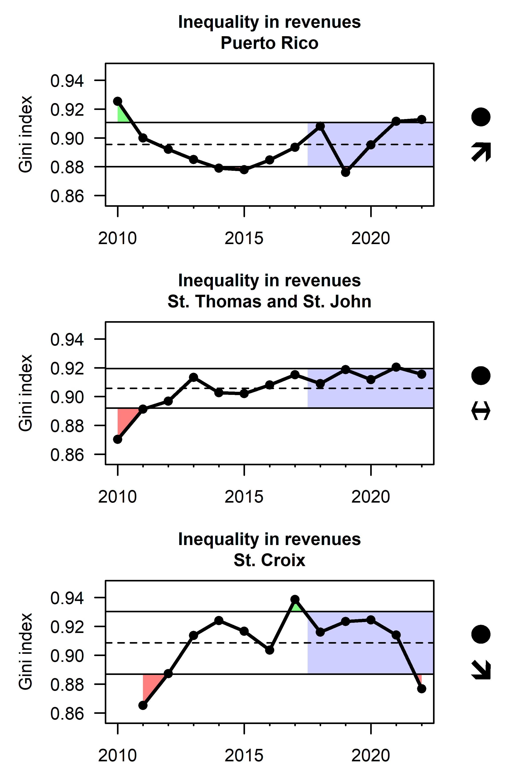
Figure 3.24: Equality in the distribution of revenues across the commercial fishery Puerto Rico (top), St. Thomas and St. John (middle) and St. Croix (bottom), as represented by the Gini index. Note that the years in the USVI are fishing years (July 1st to June 30th of the following year).

3.3.2 Environmental justice, economic, and gentrification pressure
NOAA Fisheries Community Social Vulnerability Indicators Toolbox (NOAA Fisheries 2024) has several social, economic, and climate change indicators that characterize and evaluate a community’s vulnerability and resilience to disturbances (regulations, extreme weather, oil spills, sea level rise, etc.) based on methodology by Jepson and Colburn (2013). In the U.S. Caribbean, housing characteristics evaluate factors related to housing accessibility and quality including median rent and mortgage, number of rooms, and presence of mobile homes. Labor force structure characterizes the availability of employment including females employed, population in the labor force, self-employment, and social security recipients. Personal disruption captures unemployment status, educational attainment, poverty, and marital status. Population composition corresponds to the demographic makeup of a community including race, marital status, age, and ability to speak English. Poverty is expressed as those receiving assistance, families below the poverty line, and individuals older than 65 and younger than 18 in poverty. All of these indicators were developed using census data for 2010 and 2020. Census data for 2020 only was used to develop a retiree migration indicator (key indicator for understanding the degrees of gentrification), which characterizes communities with a higher concentration of retirees and elderly people in the population including households with inhabitants over 65 years, population receiving social security or retirement income, and level of participation in the work force.
All communities in Puerto Rico experienced a decrease in social vulnerability between 2010 and 2020, with scores changing from high vulnerability (scores of 3 or 4) to low vulnerability (scores of 0, 1, or 2). Personal disruption was somewhat of an exception (Figure 3.25). In the USVI, indicators show stability in most areas, except population composition, where all communities analyzed show a decrease in vulnerability (Figure 3.26, Figure 3.27). Particularly dramatic are the decreases in Tutu and Charlotte Amalie.
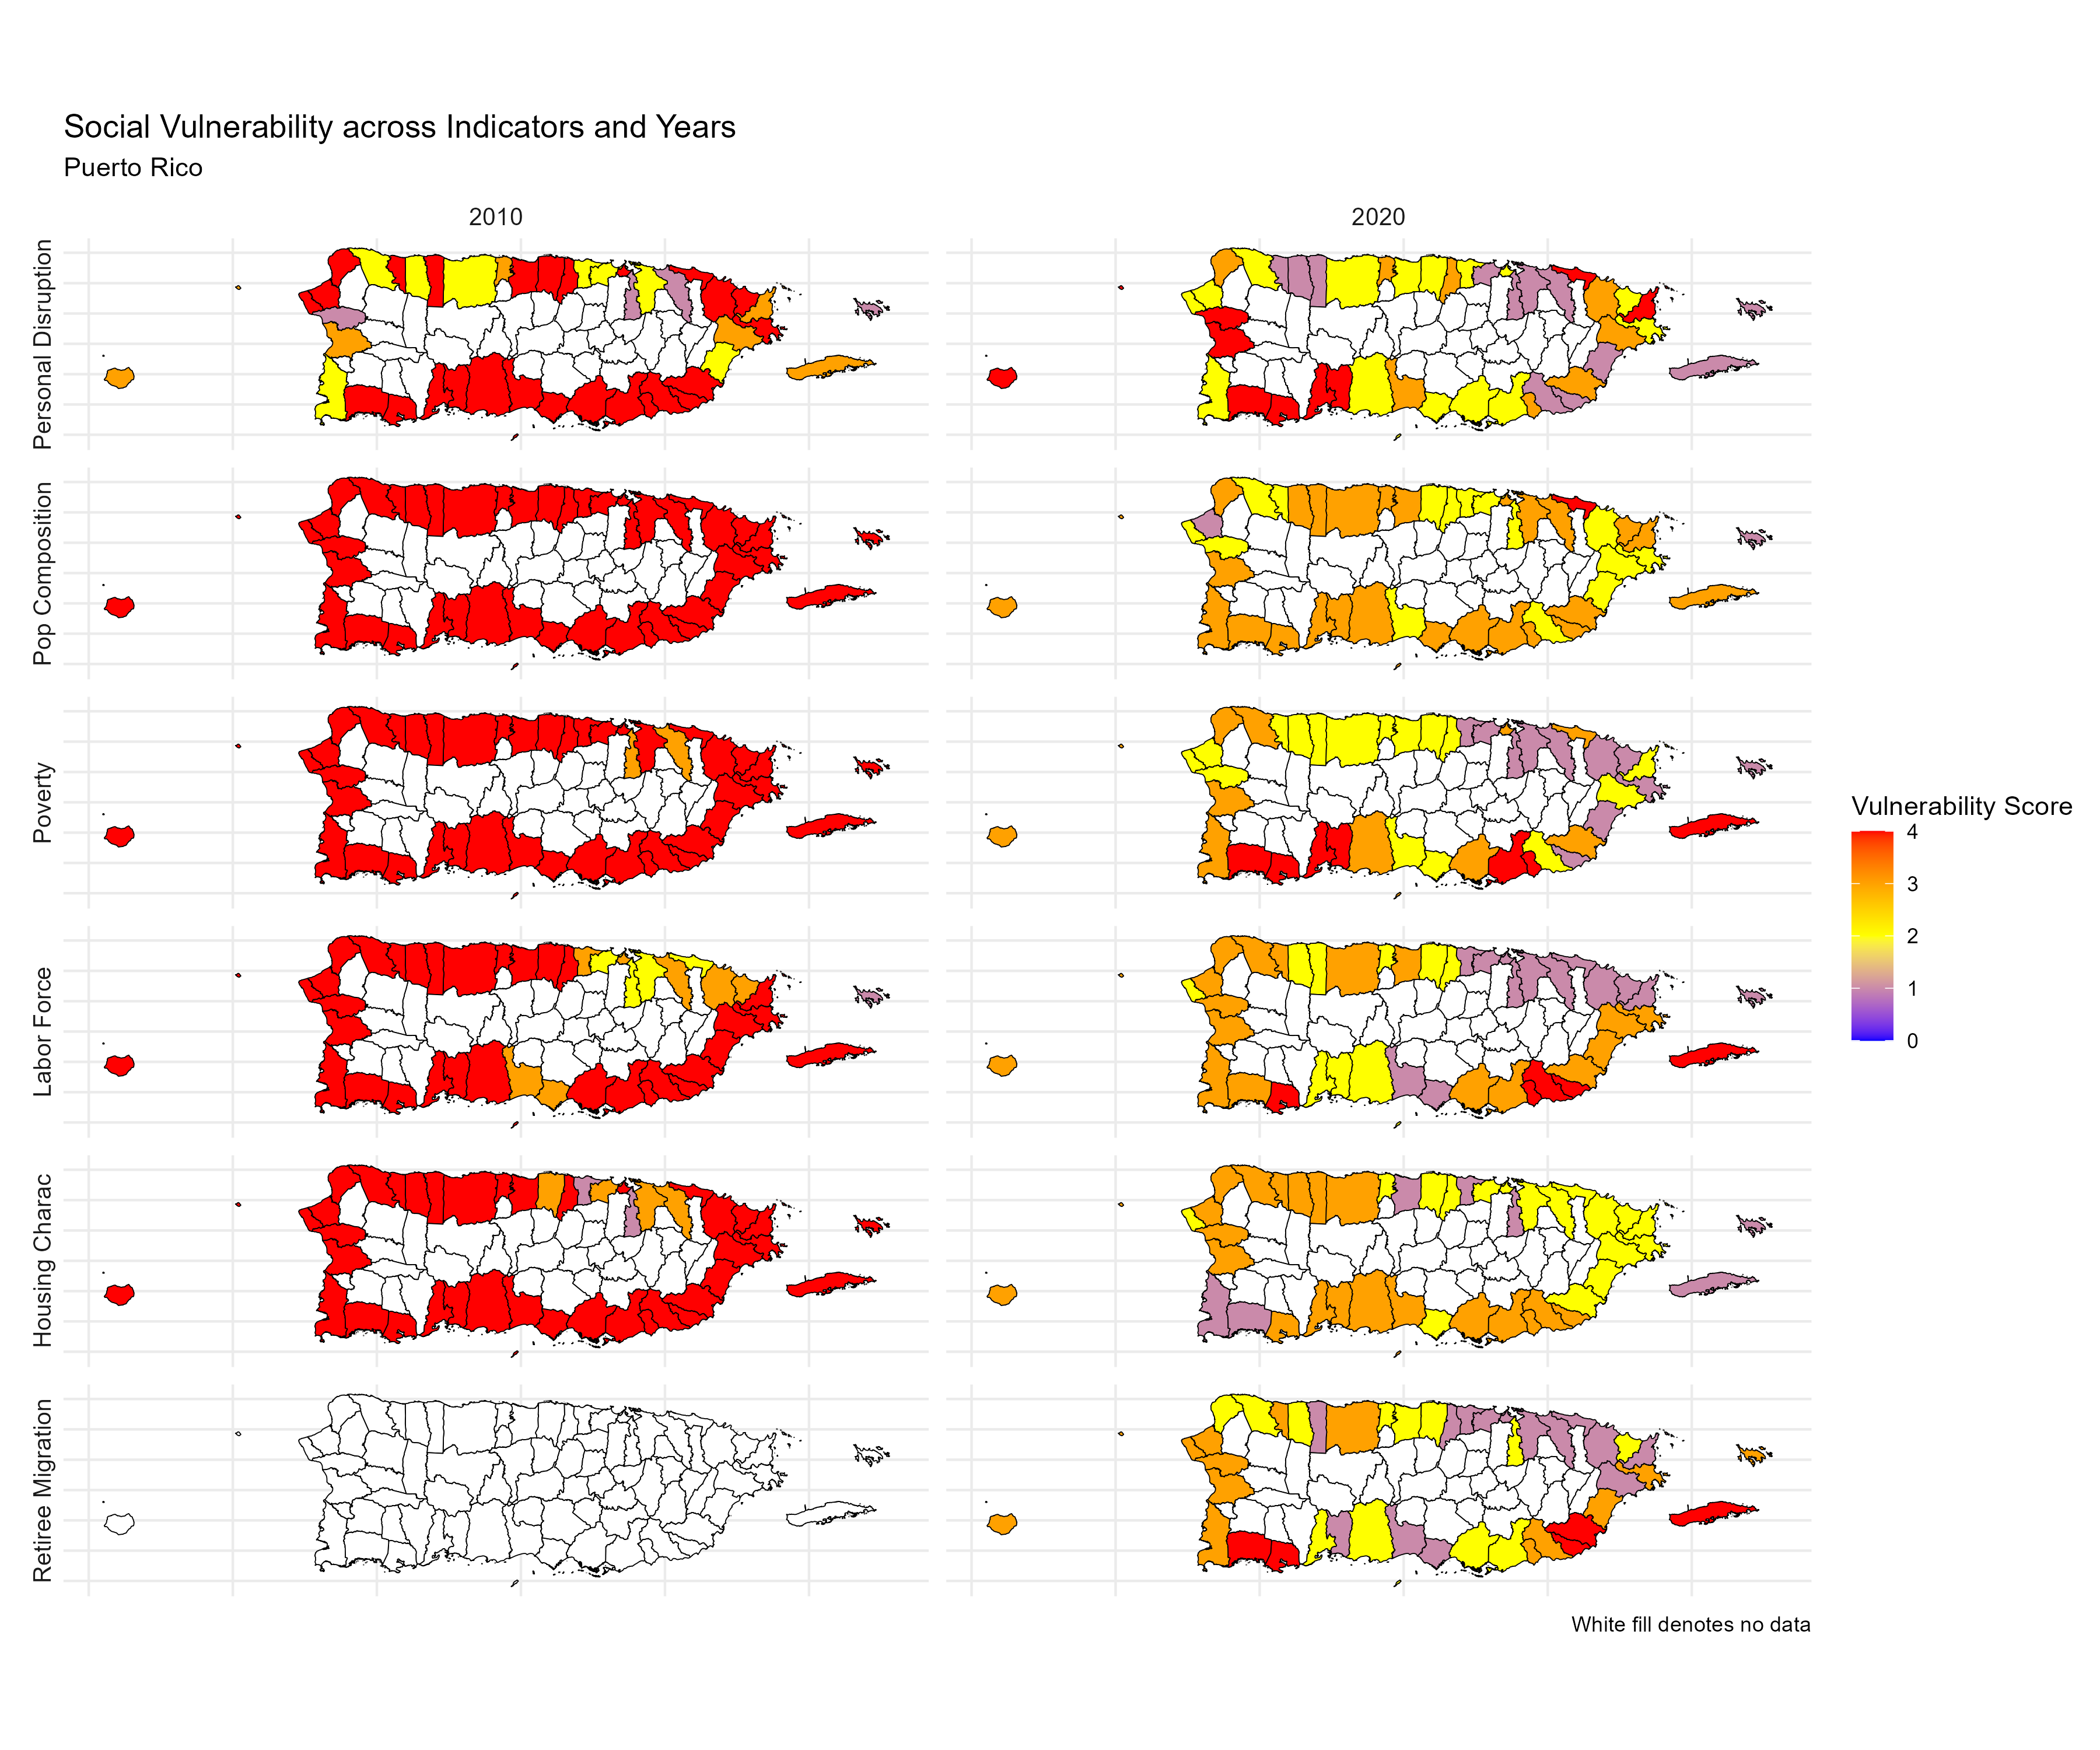
Figure 3.25: CSVI plots PR

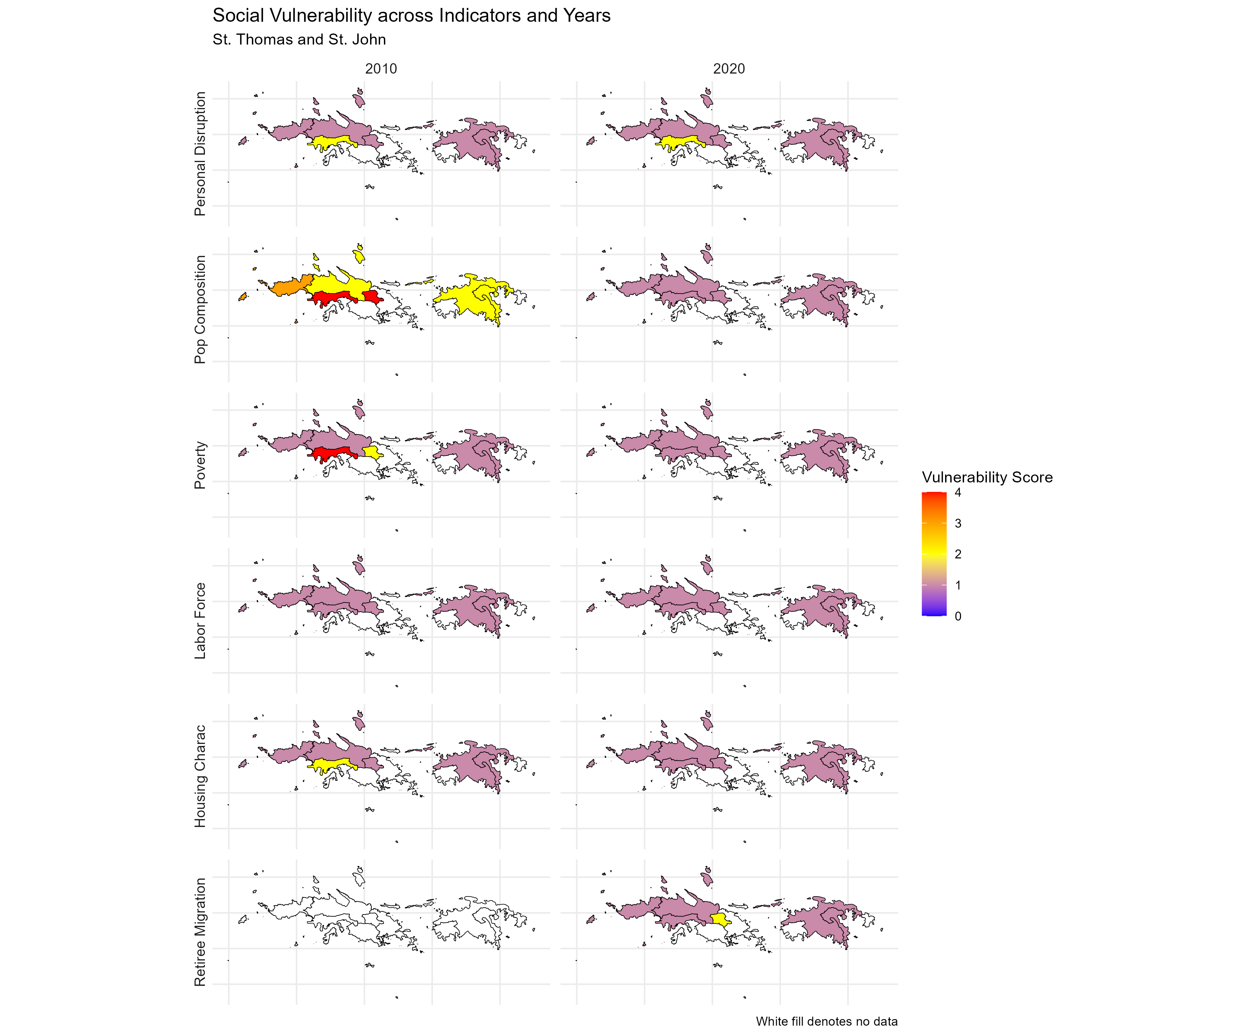
Figure 3.26: CSVI plots St. Thomas and St. John

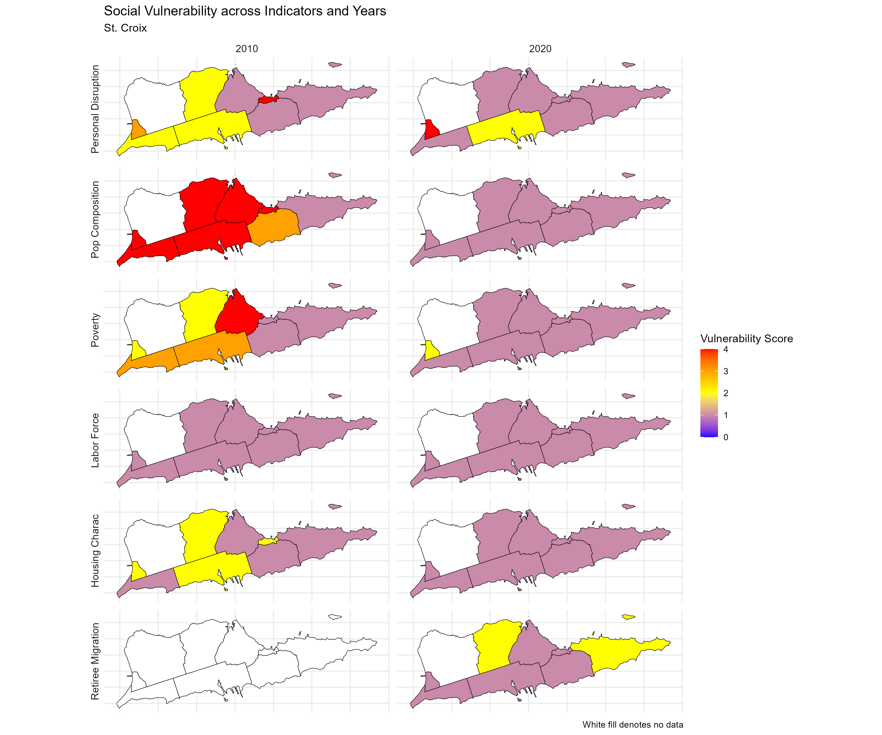
Figure 3.27: CSVI plots St. Croix

3.4 Engagement and participation

3.4.1 Recreational landings
Recreational catch and effort is a major data gap in the U.S. Caribbean. The Marine Recreational Intercept Program collected data in Puerto Rico up until 2016, and in the USVI there are no regular monitoring programs. The Sea Around Us database esimtates reported catches based on imputations and assumptions (Pauly and Zeller 2015). In Puerto Rico, catch was reconstructed by supplementing the MRIP survey with a variety of other studies conducted at various points in time. In the USVI, catch was reconstructed based on a telephone survey conducted by the USVI Division of Fish and Wildlife to estimate resident participation and catch rates, and adding a conservative estimate of tourist catches. These reconstructed estimates suggest that recreational catch has been declining over the last several decades in Puerto Rico, whereas catch has increased over the same period in the USVI (Figure 3.28).
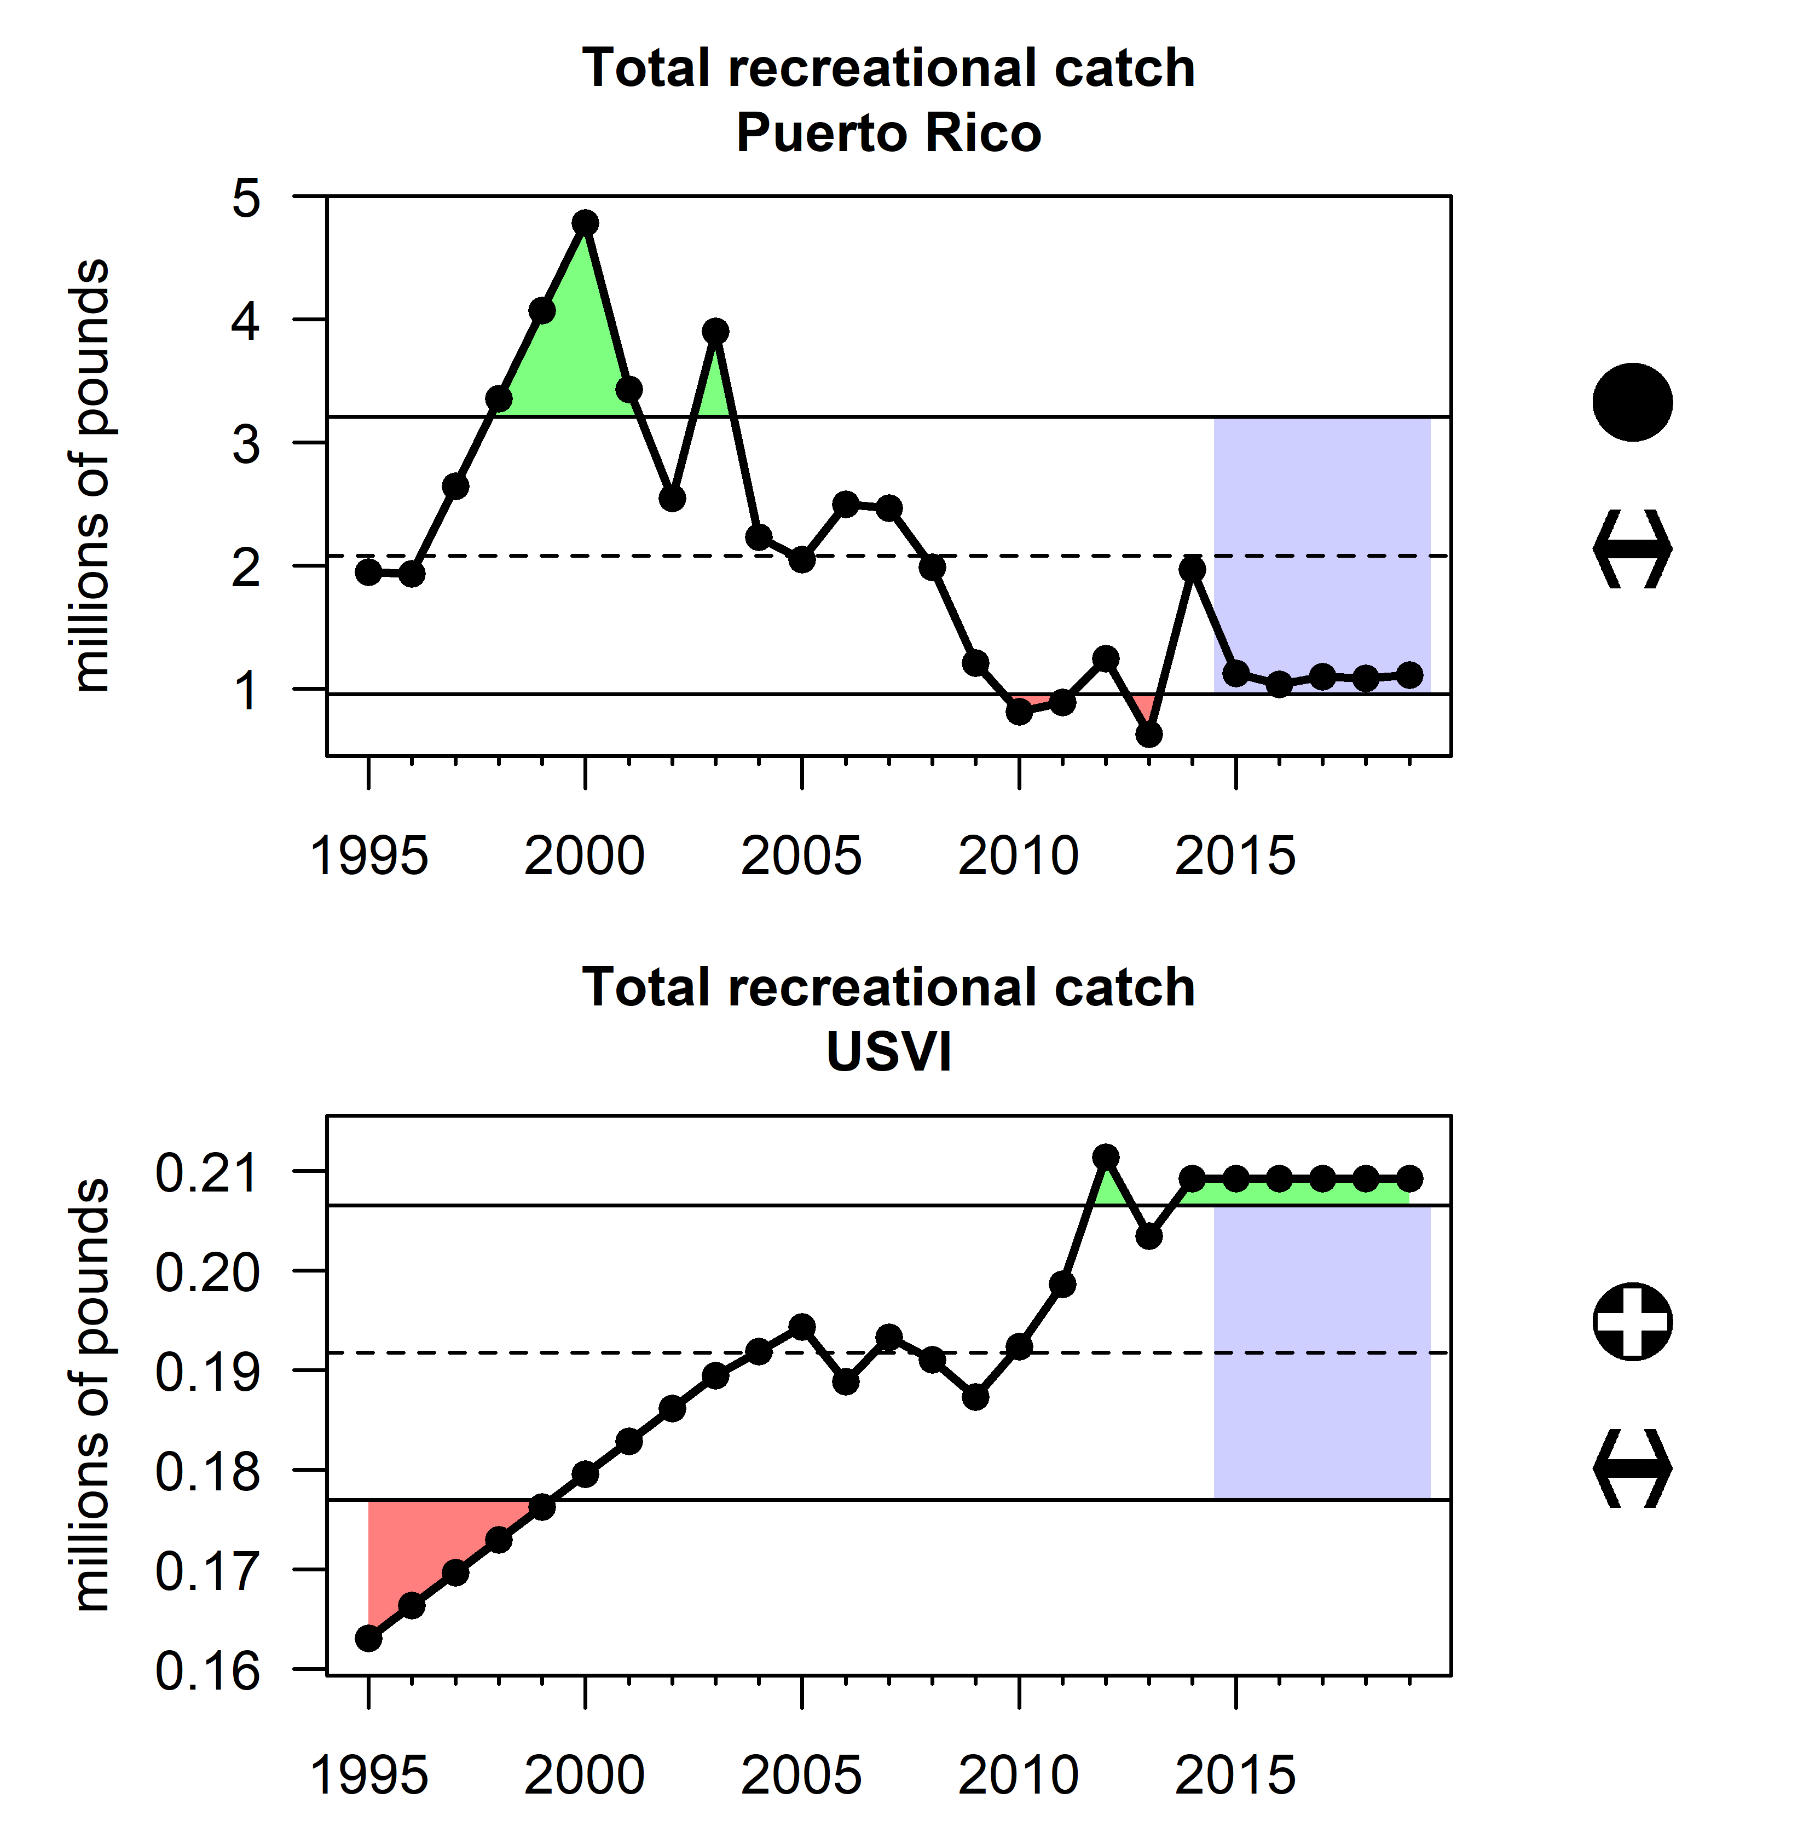
Figure 3.28: Total recreational catch in millions of pounds as estimated by the Sea Around Us database for Puerto Rico (top) and the USVI (bottom).

3.4.2 Commercial fishing engagement and reliance
Fishing engagement and reliance indices measure the importance and level of dependence on commercial or recreational fishing for coastal communities (NOAA Fisheries 2024). They are used in National Environmental Policy Act, Magnuson-Stevens Act, and climate change related assessments. Commercial fishing engagement measures the presence of commercial fishing through fishing activity as shown through permits, fish dealers, and vessel landings. A high rank indicates more engagement. Commercial fishing reliance measures the presence of commercial fishing in relation to the population size of a community through fishing activity. A high rank indicates more reliance. Coastal communities on the west and east coasts of Puerto Rico, the northside of St. Thomas, and the southwest of St. Croix had particularly high commercial engagement and reliance for 2016-2020 (Figure 3.29, Figure 3.30, Figure 3.31, Figure 3.32).
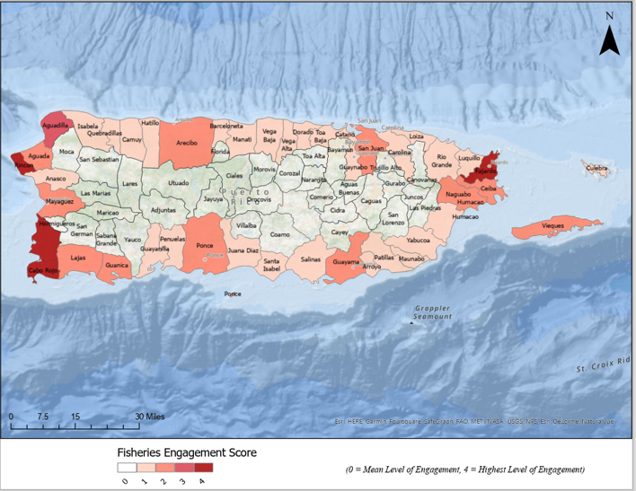
Figure 3.29: Commercial fishing engagement in Puerto Rico based on NOAA Fisheries Databases: commercial landings 5-year average for 2016-2020 and permit numbers.

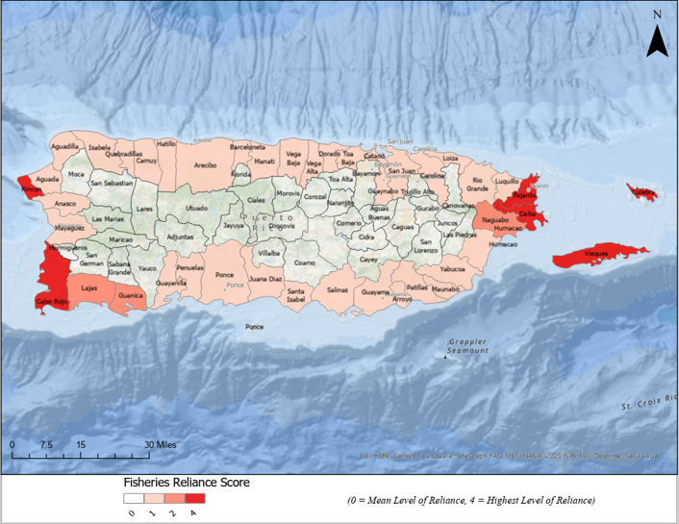
Figure 3.30: Reliance on commercial fishing in Puerto Rico based on NOAA Fisheries Databases: Commercial landings 5-year average for 2016-2020 and permit numbers; and Census data: Population by municipality/sub-district.

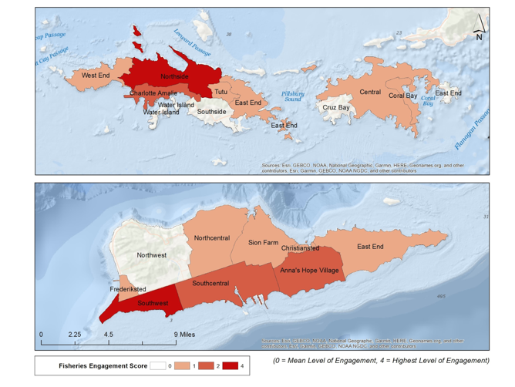
Figure 3.31: Commercial fishing engagement in USVI based on NOAA Fisheries Databases: commercial landings 5-year average for 2016-2020 and permit numbers.

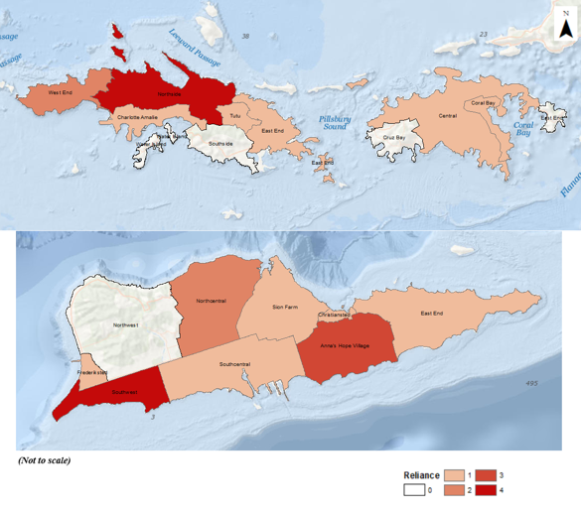
Figure 3.32: Reliance on commercial fishing in USVI based on NOAA Fisheries Databases: Commercial landings 5-year average for 2016-2020 and permit numbers; and Census data: Population by municipality/sub-district.

3.5 Bycatch reduction

3.5.1 Changes in gear type
Data on bycatch in the U.S. Caribbean are lacking; there are no bycatch reporting requirements in the logbook and the region has no observer programs. The selectivity of gears can be considered as some gear types are highly selective (e.g. spearfishing and diving) while other gears capture a wide range of target and non-target species. We calculated the proportion of non-selective gears (traps and nets) from the Caribbean Commercial Landings database as a proxy for bycatch in the fisheries. Overall the use of these gear types is decreasing in Puerto Rico and St. Croix while it is increasing in St. Thomas and St. John (Figure 3.33).
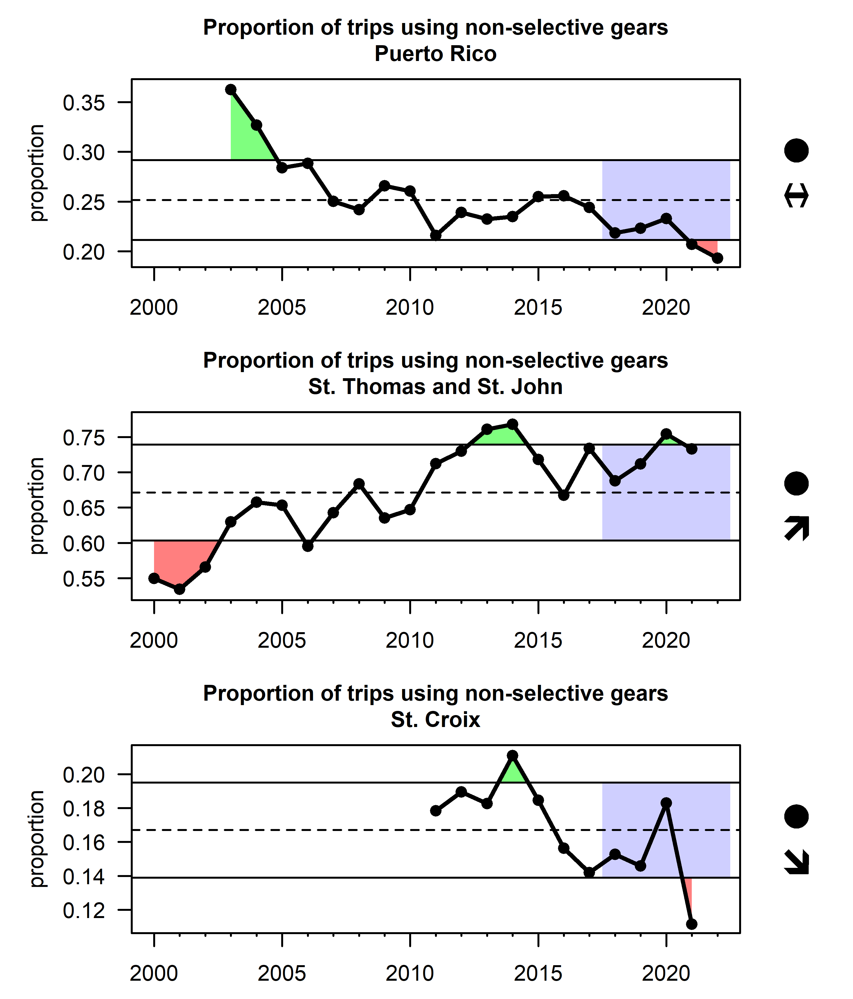
Figure 3.33: Indicator of bycatch prevalence as measured by the proportion of commercial trips using non-selective fishing gears for Puerto Rico (top), St. Thomas and St. John (middle) and St. Croix (bottom). Note that the years in the USVI are fishing years (July 1st to June 30th of the following year).

3.6 Governance

3.6.1 Efficacy of management
The number of new management actions over time can be indicative of the efficacy of fisheries management. Federal register (FR) notices were used to sum the number of new regulations that were imposed in the U.S. Caribbean region on an annual basis. Specifically, the number of unique FR sections within each FR notice were summed. The FR section is the part, chapter, and section in which a specific regulation is contained within an FR notice. Management actions have occurred in waves, often increasing with changes to Fishery Management Plans, like the establishment of the first reef fish FMP in 1985, the establishment of the Queen Conch FMP in 1997, and a major amendment to the FMPs of the Caribbean region in 2005.
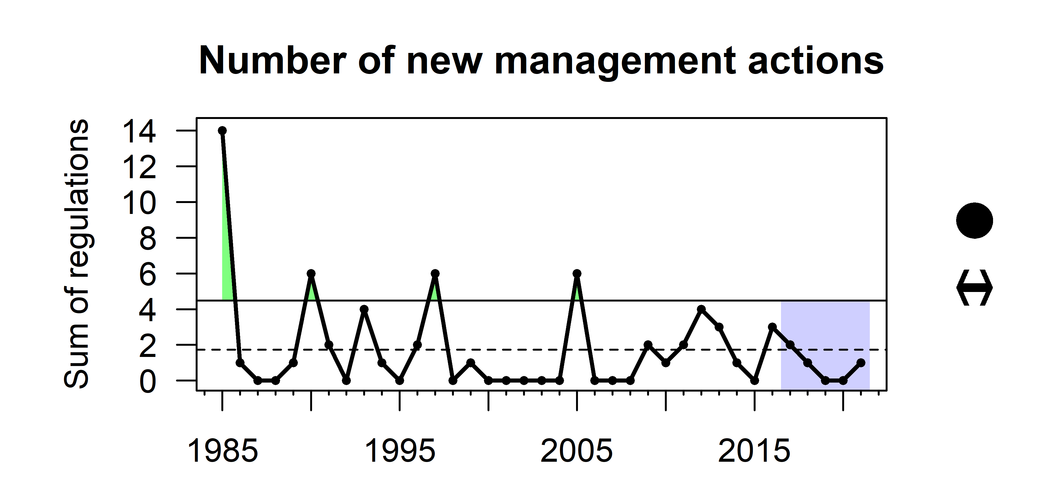
Figure 3.34: The number of new management actions implemented in the U.S. Caribbean region based on the annual count of unique Federal Register sections within all Federal Register notices.

3.6.2 Species with informative catch limits
U.S. Caribbean fisheries are highly diverse; over 300 individual species have been recorded in the landings database and there are 54 stocks or complexes within the three Island-based Fishery Management Plans. At the same time, the region is extremely data-limited, with high uncertainty in landings data and lacking reliable indices of abundance, and most annual catch limits are derived using Tier 3 control rules (based on average landings). The percentage of stocks or complexes with annual catch limits informed by stock assessments is a useful indicator for tracking progress toward more robust management advice in the region. In recent years, progress has been made and several stock assessments have been accepted for management advice (Figure 3.35).
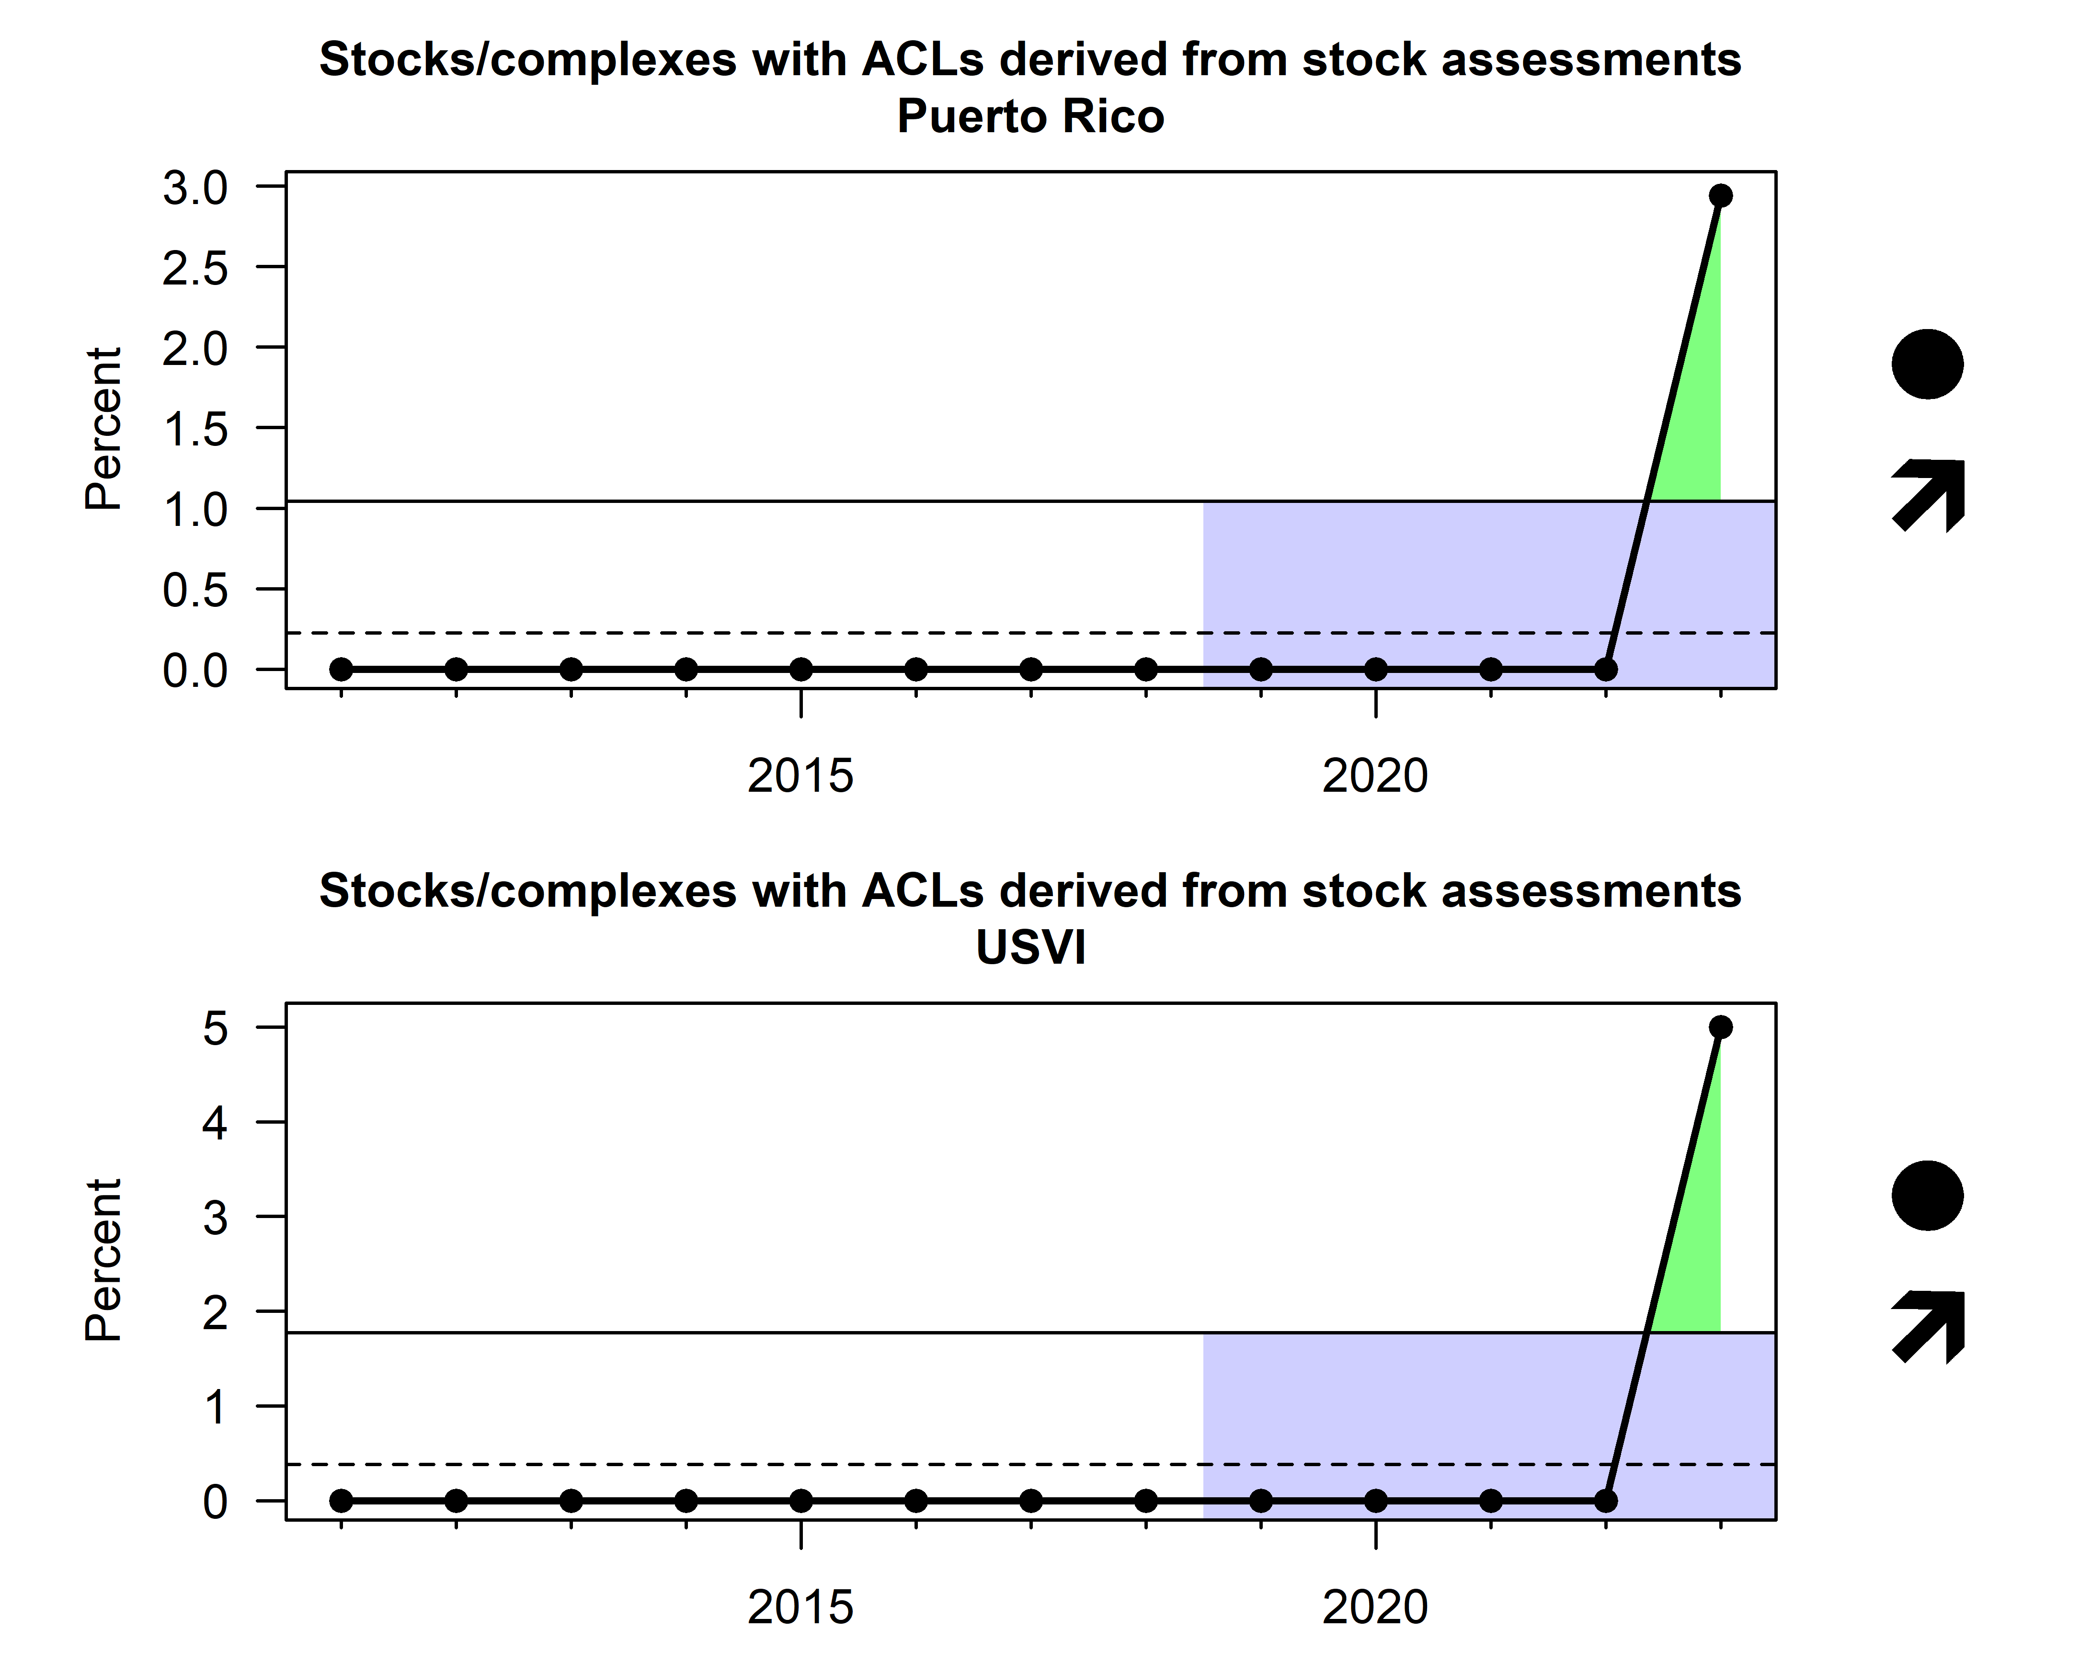
Figure 3.35: Percent of stocks/complex with informative annual catch limits as measured by stock assessments in Puerto Rico (top) and the USVI (bottom).

3.6.3 Education and outreach events
Programs such as MREP (Marine Resource Education Program) and NOAA SeaGrant have made substantial gains in outreach and education in the U.S. Caribbean region. MREP is a program developed for fishermen, by fishermen, and is widely recognized as a key venue for engaging industry members and building trust. Sea Grant is a federal-academic collaboration that supports research, education and extension to support coastal resource conservation, conducting outreach in the form of workshops and meetings. The number of participants benefitting from MREP and SeaGrant programs has increased rapidly in recent year. Cumulative numbers of graduates and attendees are reported because once knowledge is gained it remains in the fishing community and is also spread by word-of-mouth (Figure 3.36).
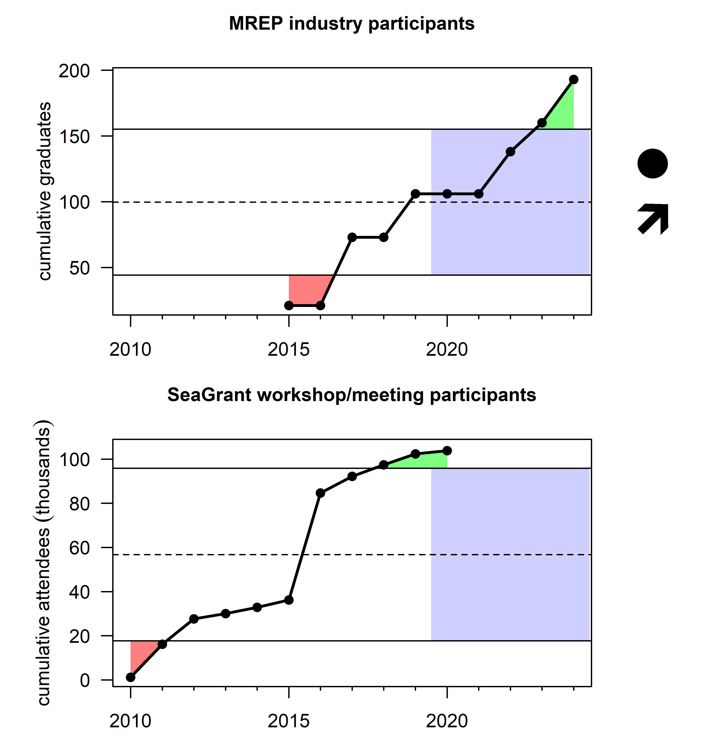
Figure 3.36: Cumulative count of Marine Resource Education Program industry participants (top) and cumulative number of SeaGrant workshop or meeting participants in the Caribbean region (bottom).

3.6.4 Enforcement actions
The number of recorded law enforcement incidents may be indicative of changes in the efficacy of law enforcement effort. Data on law enforcement incidents where the investigating officer was from the St. Thomas, USVI or San Juan, PR field offices or the word “Caribbean” was mentioned in the brief synopsis were pulled from the NOAA Office of Law Enforcement NOAA Enforcement Information System (NEIS). Total incidents have been fairly stable, with some inter-annual variability. Specifically, incidents increased each year in the spring and summer months (Figure 3.37).
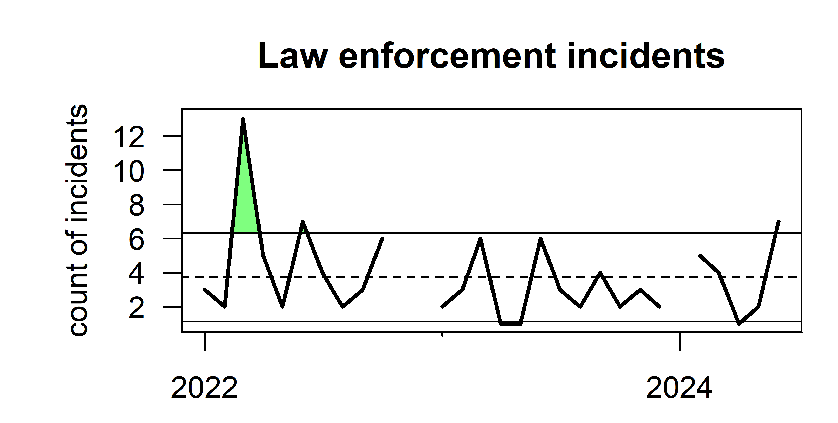
Figure 3.37: Monthly count of law enforcement incidents in the U.S. Caribbean region by date of incident creation.

3.7 Protection of ecosystems

3.7.1 Coral cover and coral species diversity
Coral reef ecosystem integrity is a major concern for stakeholders in the U.S. Caribbean region (Seara et al. 2024). The PRCRMP and TRCMP have measured benthic cover at fixed transects for over two decades, allowing for a comparison over time. The fixed transects Coral species richness was calculated based on the average number of hard coral species per 10-m long transect, and percent coral cover is measured by assigning substrate type to randomly assigned points within still images of the benthic transects (TCRMP) or using the continuous intercept method over a fixed transect line (PRCRMP). Trends in species richness for both Puerto Rico and the USVI fluctuate over time with no clear trend, although there has been a sudden decline in recent years. Percent coral cover has dropped significantly throughout the 25-year time period with large declines occurring in 2005 and 2019, coinciding with major bleaching events (Figure 3.38).
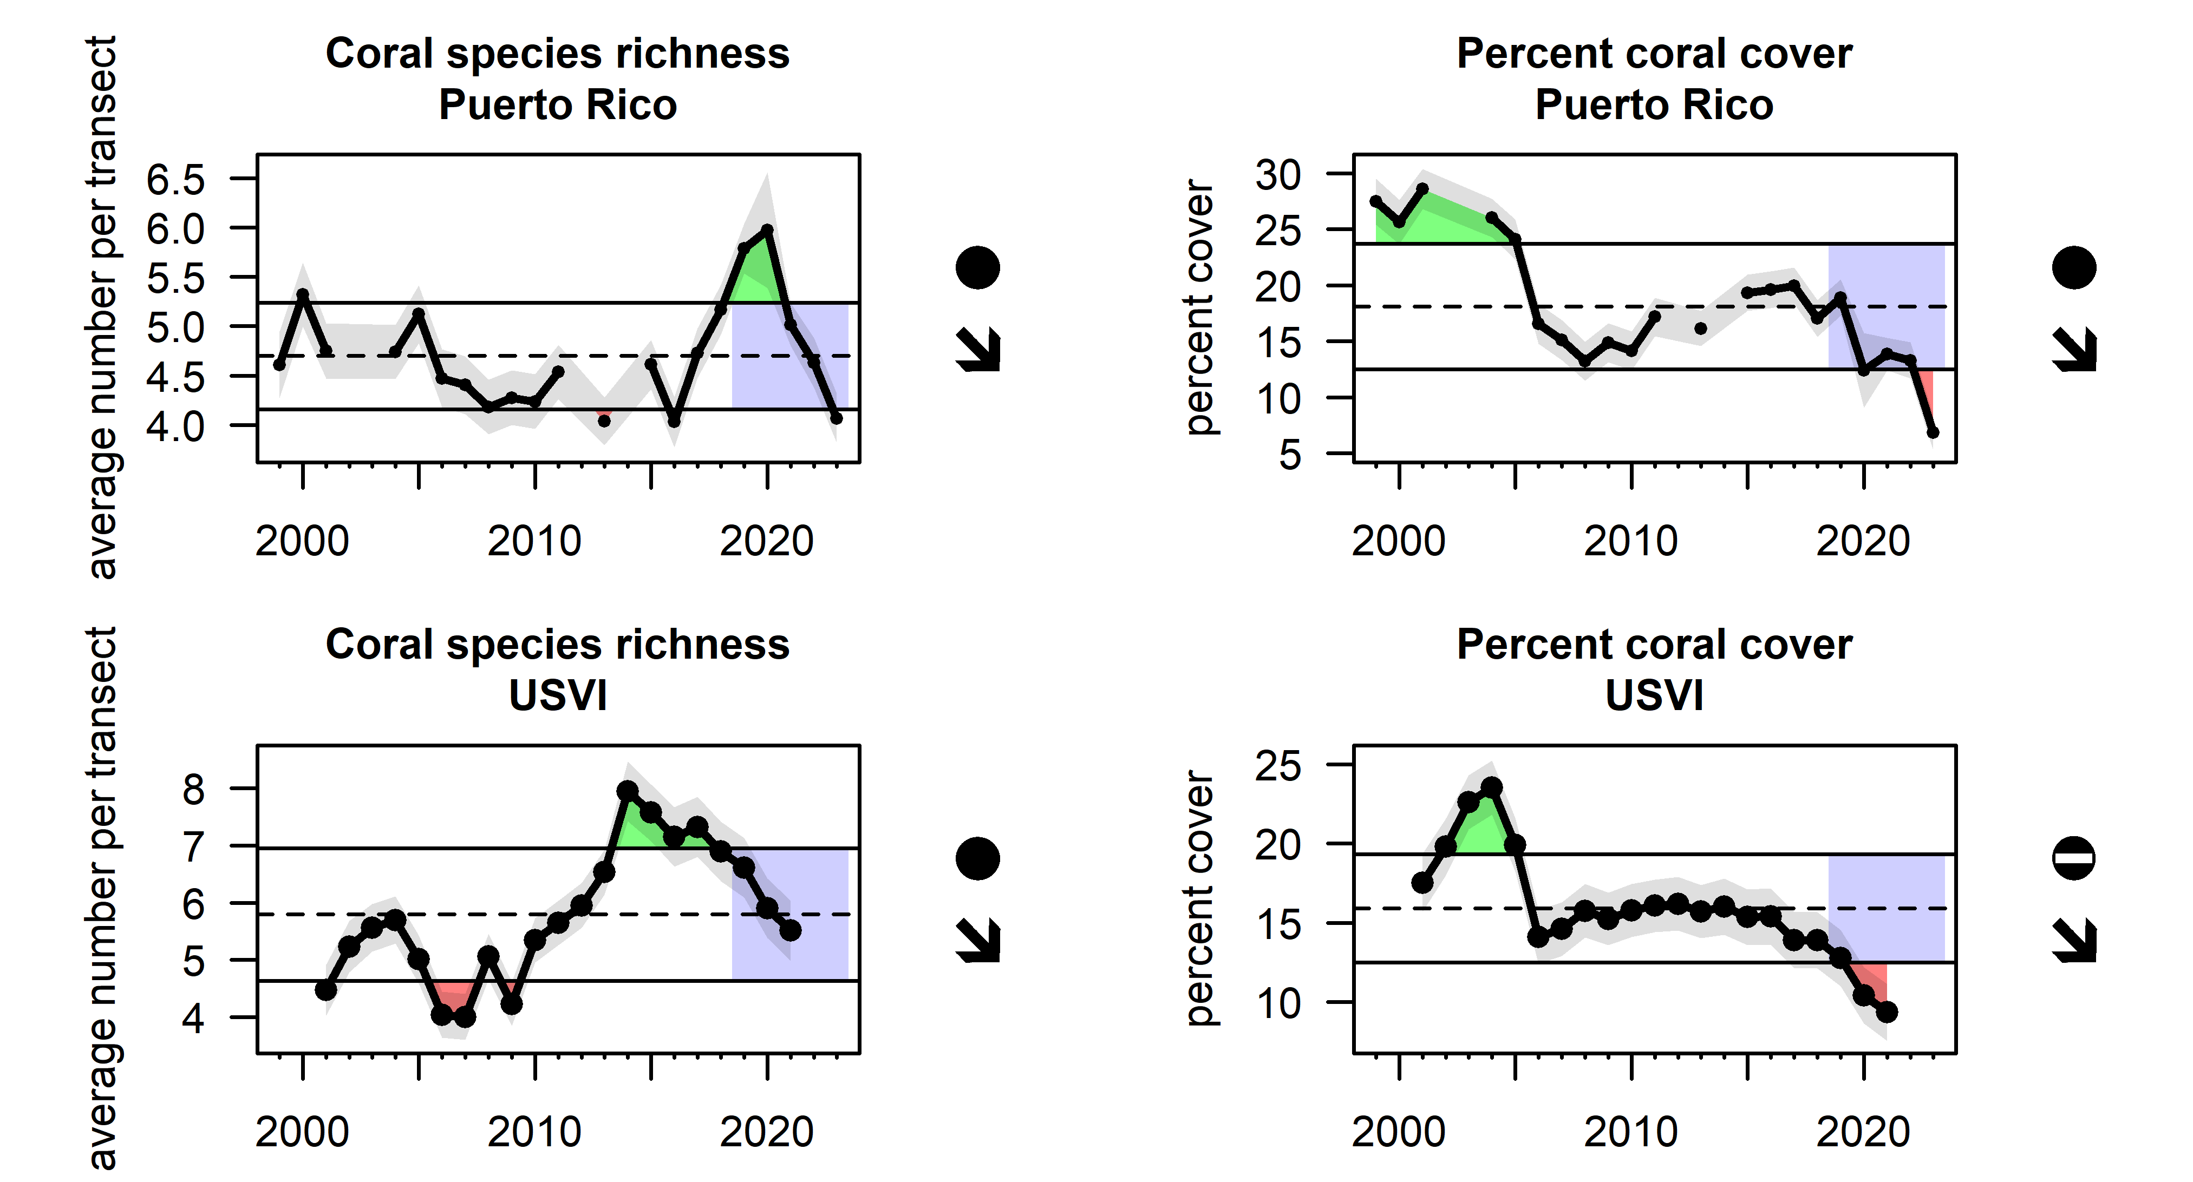
Figure 3.38: Percent coral cover and coral species richness (average number of species per transect) from TCRMP and PRCRMP biological surveys.

4. Integrated ecosystem perspectives

For the purpose of synthesizing the information contained in the full suite of indicators presented in this report, we analyze the full indicator suite using multivariate methods. Principal components analysis (PCA) is a statistical method that distills a large number of potentially related indicators into a smaller number of indices representing most of the variability in the data set. We analyze the indicator suite separately by category: 1) risks to meeting management objectives, 2) management objective indicators based on fishery-independent data, 3) management objective indicators based on fishery-dependent data, and 4) other management objective indicators. A traffic light plot of the indicator suite is presented for the purpose of comprehensively viewing changes in the different parts of the ecosystem over time (Figure 4.1). A biplot of the principal components analysis is presented to convey temporal patterns in the progression of ecosystem status (Figure 4.2). PCA was carried out on a scaled matrix for all indicators with at least 12 years of data; any missing values were imputed with means of the time series. In the biplot, the labels represent time (years 2011 – 2023), the rainbow line represents chronology between adjacent years, and the distance between points conveys how different the indicator values were in those years.
Figure 4.1: Traffic light plot representing the value of the indicator each year according to quintiles; colors from red to yellow to blue show that the indicator moving between below, at, and above average, respectively (see legend). Indicators are grouped by category, and appear on the plot sorted by their loading (i.e., their influence) from a principal components analysis. In this way, indicators showing similar patterns across time are grouped more closely together.

Figure 4.2: Left: Yearly scores of the first two components of a principal components analysis (PCA) for three groups of indicators, based on indicator values from 2011 – 2023. Right: Loadings plots show the relative influence of each indicator in driving the temporal trends observed on the left panel. Loadings with an absolute value greater than 0.2 are considered to be significant.
Many indicators are based on time series of limited extent or contain data gaps, which makes it challenging to elucidate overall trends. However, the traffic plot conveys that many indicator values undergo rapid change in the period 2017-2021, and the PCA biplots confirm these patterns as there are larger two-dimensional shifts between these years. These shifts are most likely driven by several major stressor events in this time period, including the major hurricanes Maria and Irma (2017) and the COVID pandemic (2020-2021). Together, the multivariate analyses suggest that these events have had some destabilizing impacts on the U.S. Caribbean fishery ecosystem.

5. Research recommendations

5.1 Include data gaps, other discussion material
This section still needs to be filled out. Please type in some suggestions here if you have any research recommendations, things you would have liked to see in this report, or any gaps you’ve noticed.

6. Acknowledgments

6.1 Contributions
This report would like to acknowledge the efforts and contributions of: The National Coral Reef Monitoring Program- NOAA Coral Reef Conservation Program, project number 743, as well as the Caribbean Fishery Management Council’s District Advisory Panels for their conceptual model work, the Caribbean Fishery Management Council Technical Advisory Panels, the Caribbean Fishery Management Council Science and Statistical Committee, the Caribbean Fishery Management Council staff, and the NOAA Southeast Fisheries Science Center Social Science team and the Caribbean Branch staff as well as the NOAA Fisheries Southeast Regional Office.

6.2 Resources
This repo and GitHub Action was based on the Openscapes tutorial quarto-website-tutorial by Julia Lowndes and Stefanie Butland.

7. Contributors

7.1 Editors
Mandy Karnauskas, Carissa Gervasi

7.2 Contributors
Kelly Montenero, Seann Regan, Amy Freitag, Andrea Chan, Chuanmin Hu, Erica K. Towle, Laura Jay Grove, Jeremiah Blondeau, Sarah Groves, Shay Viehman, Nicole Besemer, Juan Agar, Kevin McCarthy, Manoj Shivlani, Mike Jepson, Adyan Rios, Matt McPherson, Miguel Figuerola, Nicole Angeli, Sennai Habtes, Dione Swanson, Liajay Rivera, Leigh Fletcher, Tarsila Seara, Suzana Blake, Carolyn Sramek, Fabian Gomez, Silene Prentice
We realize we are likely missing people in this list. We will revisit it but if you notice anyone is missing please use track changes and add in names

References
Agar, J., B. Stoffle, M. Shivlani, D. Matos-Caraballo, A. Mastitski, and F. Martin. 2022. “One-Year COVID-19 Pandemic Impacts on U.S. Caribbean Small-Scale Fisheries with a Note on the Puerto Rican Earthquake Swarm of 2020 and 2021. NOAA Technical Memorandum NMFS-SEFSC-759.” https://repository.library.noaa.gov/view/noaa/47711.
Clements, Janet, Vicente Feliciano, and Charles Colgan. n.d. “Describing the Ocean Economies of the U.S. Virgin Islands and Puerto Rico.” https://repository.library.noaa.gov/view/noaa/20724.
Employment, U. S., and Training Administration. 2024. “U.s. Employment and Training Administration, Insured Unemployment Rate in the u.s. Virgin Islands [VIRINSUREDUR], Retrieved from FRED, Federal Reserve Bank of St. Louis; Https://Fred.stlouisfed.org/Series/VIRINSUREDUR, May 16, 2024.”
Froese, R, and D Pauly. 2024. “FishBase.” www.fishbase.org.
Gini, C. 1936. “On the Measure of Concentration with Special Reference to Income and Statistics, Colorado College Publication, General Series No. 208, 73-79.” https://cir.nii.ac.jp/crid/1370861704783841681.
Hu, Chuanmin, Zhongping Lee, and Bryan Franz. 2012. “Chlorophyll Aalgorithms for Oligotrophic Oceans: A Novel Approach Based on Three-Band Reflectance Difference.” Journal of Geophysical Research: Oceans 117 (C1). https://doi.org/10.1029/2011JC007395.
Jepson, Michael, and Lisa L. (Lisa Lynne) Colburn. 2013. “Development of Social Indicators of Fishing Community Vulnerability and Resilience in the U.S. Southeast and Northeast Regions. U.S. Dept. Of Commerce., NOAA Technical Memorandum NMFS-F/SPO-129, 64 p.” https://repository.library.noaa.gov/view/noaa/4438.
Knapp, Kenneth R., Michael C. Kruk, David H. Levinson, Howard J. Diamond, and Charles J. Neumann. 2010. “The International Best Track Archive for Climate Stewardship (IBTrACS),” March. https://doi.org/10.1175/2009BAMS2755.1.
Leiva Moreno, J. I. de, V. N. Agostini, J. F. Caddy, and F. Carocci. 2000. “Is the Pelagic-Demersal Ratio from Fishery Landings a Useful Proxy for Nutrient Availability? A Preliminary Data Exploration for the Semi-Enclosed Seas Around Europe.” ICES Journal of Marine Science 57 (4): 1091–1102. https://doi.org/10.1006/jmsc.2000.0705.
Natural, Puerto Rico Department of, and Environmental Resources. 2019. “Puerto Rico Long-Term Coral Reef Monitoring Program Database Compilation: Substrate Cover Percent, Octocoral Colony Counts, Macro Invertebrate Densities, Fish Densities, and Fish Biomass from 1999 to 2023 (NCEI Accession 0204647). NOAA National Centers for Environmental Information. Dataset. Https://Www.ncei.noaa.gov/Archive/Accession/0204647. Accessed 2/6/2024.”
NOAA Coral Reef Watch. 2019. NOAA Coral Reef Watch 5km Regional Virtual Stations Degree Heating Weeks V3.1 Jan 1, 1985 - Dec 31, 2023. Silver Spring, MD. USA: NOAA Coral Reef Watch. Data Set Accessed 2024-10-31 at Https://Coralreefwatch.noaa.gov/Product/Vs/Data.php.
NOAA Fisheries. 2024. “Social Indicators Supporting Information.” https://www.fisheries.noaa.gov/national/socioeconomics/social-indicators-supporting-information.
Pauly, D, and D Zeller. 2015. Sea Around Us Concepts, Design and Data. Sea Around Us, Institute for the Oceans; Fisheries, University of British Columbia, Vancouver, Canada. www.seaaroundus.org.
Reynolds, Richard W., Thomas M. Smith, Chunying Liu, Dudley B. Chelton, Kenneth S. Casey, and Michael G. Schlax. 2007. “Daily High-Resolution-Blended Analyses for Sea Surface Temperature,” November. https://doi.org/10.1175/2007JCLI1824.1.
Rochet, Marie-Joëlle, and Verena M Trenkel. 2003. “Which Community Indicators Can Measure the Impact of Fishing? A Review and Proposals.” Canadian Journal of Fisheries and Aquatic Sciences 60 (1): 86–99. https://doi.org/10.1139/f02-164.
Seara, Tarsila, Stacey M. Williams, Kiara Acevedo, Graciela Garcia-Molliner, Orian Tzadik, Michelle Duval, and Juan J. Cruz-Motta. 2024. “Development and Analyses of Stakeholder Driven Conceptual Models to Support the Implementation of Ecosystem-Based Fisheries Management in the U.S. Caribbean.” PLOS ONE 19 (5): e0304101. https://doi.org/10.1371/journal.pone.0304101.
Smith, Steven G., Jerald S. Ault, James A. Bohnsack, Douglas E. Harper, Jiangang Luo, and David B. McClellan. 2011. “Multispecies Survey Design for Assessing Reef-Fish Stocks, Spatially Explicit Management Performance, and Ecosystem Condition.” Fisheries Research 109 (1): 25–41. https://doi.org/10.1016/j.fishres.2011.01.012.
Sumy, Danielle F., Russ Welti, and Michael Hubenthal. 2020. “Applications and Evaluation of the IRIS Earthquake Browser: A Web-Based Tool That Enables Multidimensional Earthquake Visualization.” Seismological Research Letters 91 (5): 2922–35. https://doi.org/10.1785/0220190386.
U. S. Bureau of Labor Statistics. 2024. “U.s. Bureau of Labor Statistics, Unemployment Rate in Puerto Rico [PRUR], Retrieved from FRED, Federal Reserve Bank of St. Louis; Https://Fred.stlouisfed.org/Series/PRUR, May 16, 2024.”
United States Environmental Protection Agency. 2024. “Indicators: Enterococci.” https://www.epa.gov/national-aquatic-resource-surveys/indicators-enterococci.
Wang, Menghua, Chuanmin Hu, Brian B. Barnes, Gary Mitchum, Brian Lapointe, and Joseph P. Montoya. 2019. “The Great Atlantic Sargassum Belt.” Science 365: 83–87. https://www.science.org/doi/10.1126/science.aaw7912.
Wang, Menghua, SeungHyun Son, and Lawrence W. Harding Jr. 2009. “Retrieval of Diffuse Attenuation Coefficient in the Chesapeake Bay and Turbid Ocean Regions for Satellite Ocean Color Applications.” Journal of Geophysical Research: Oceans 114 (C10). https://doi.org/10.1029/2009JC005286.
World Bank. 2024a. “Gross Domestic Product for Puerto Rico [NYGDPMKTPCDPRI], Retrieved from FRED, Federal Reserve Bank of St. Louis; Https://Fred.stlouisfed.org/Series/NYGDPMKTPCDPRI, May 16, 2024.”
———. 2024b. “Gross Domestic Product for u.s. Virgin Islands [MKTGDPVIA646NWDB], Retrieved from FRED, Federal Reserve Bank of St. Louis; Https://Fred.stlouisfed.org/Series/MKTGDPVIA646NWDB, May 16, 2024.”

